- Log into https://eastmonttyler.schooldata.net/homeroom/login and Authenticate with District
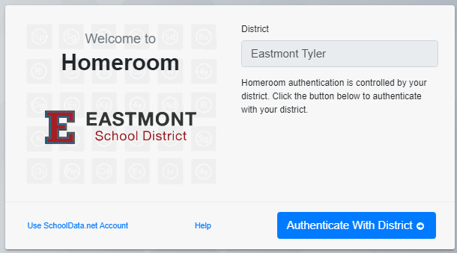
- Click the waffle in the grey bar at the top of the page, and click the Chart Manager
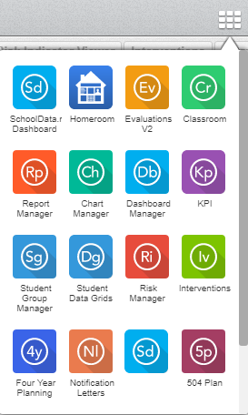

- Click Create New Chart

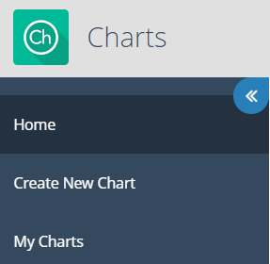

- Click Browse Category in the By Purpose box
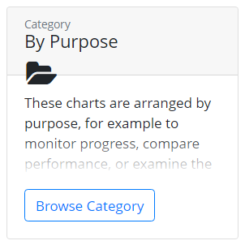

- Click Browse Category in the Monitor Progress box.
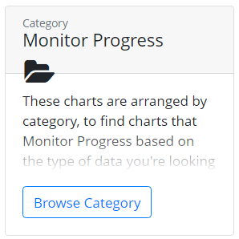

- Click Browse Category in the of a Student Group box
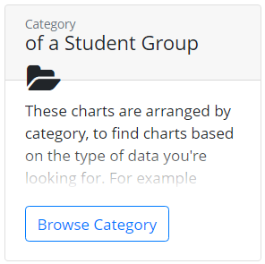

- Click Browse Category in the on Assessments box
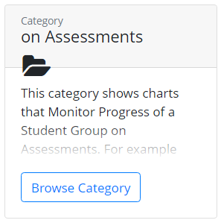

- Click Build Chart in the Student Growth box
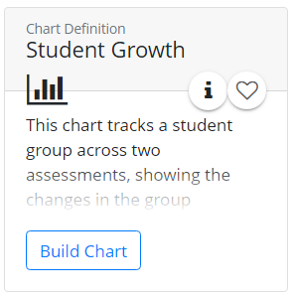

- Click Configure and select a Student Group
- Click select Assessment 1 and Filter Assessment
- Type in STAR Early Literacy or Math or Reading and hit Set.
- Hit the + next to STAR Fall SS Bmark
- Click select Assessment 2 and Filter Assessment
- Type in STAR Early Literacy or Math or Reading and hit Set.
- Hit the + next to STAR Winter SS Bmark
- Hit Render Chart
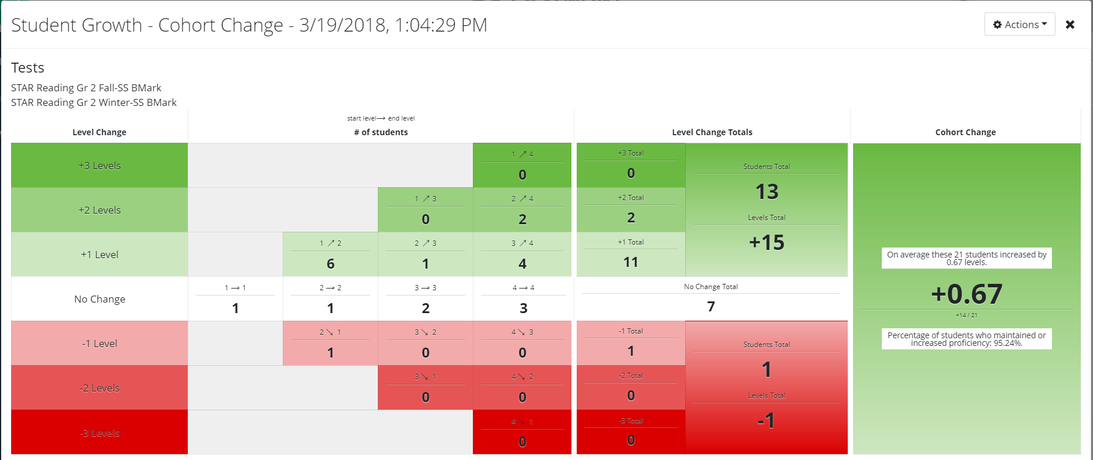
Click the numbers in the chart to get student names.

