- Log into https://eastmonttyler.schooldata.net/homeroom/login and Authenticate with District
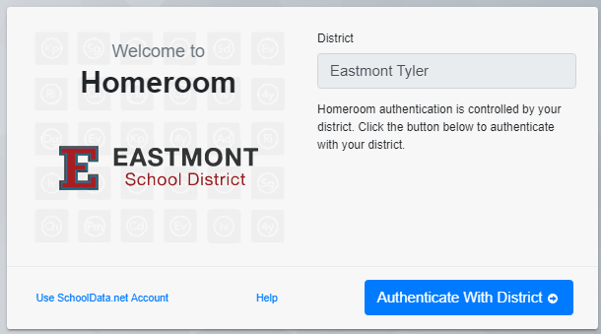
- Click the waffle in the grey bar at the top of the page, and click the Chart Manager
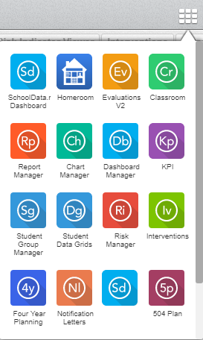

- Click Create New Chart

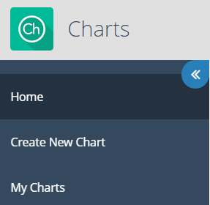

- Click Browse Category in the By Purpose box
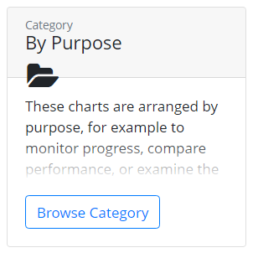

- Click Browse Category in the Compare Performance box.
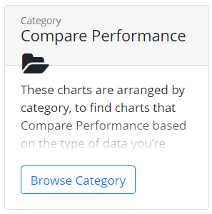

- Click Browse Category in the of a Student Group box
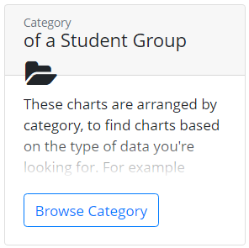

- Click Browse Category in the on Assessments box
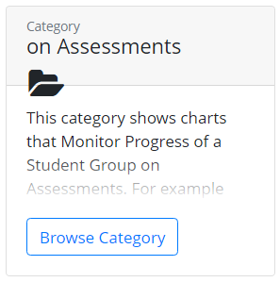

- Click Build Chart in the Performance Level Percentages box
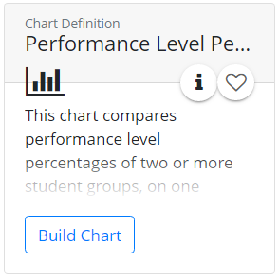

- Click Configure and select a Student Group
  - School
  - Grade Level
  - Teachers
  - Hit 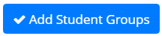
- Click Select under Assessment
- Click Filter Assessment and type in STAR Early Literacy or Math or Reading and hit .
- Hit the + next to the Assessment you want to compare
- Hit 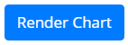
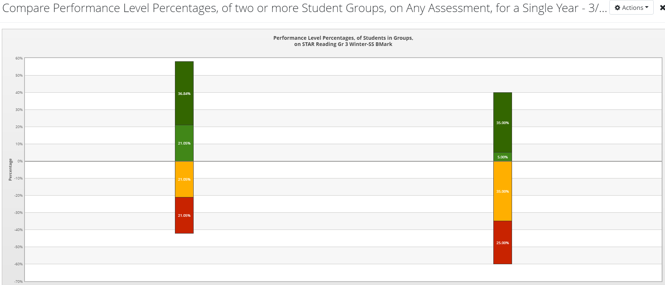
Click the percentages in the chart to get student names.

