Clock Hour Instructions
Step by Step procedure on searching and registering for training; and purchasing clock hours

Log in: https://www.pdenroller.org/
*From this screen, you can log in to PDEnroller if you have an established account, if not, you can also create an account.
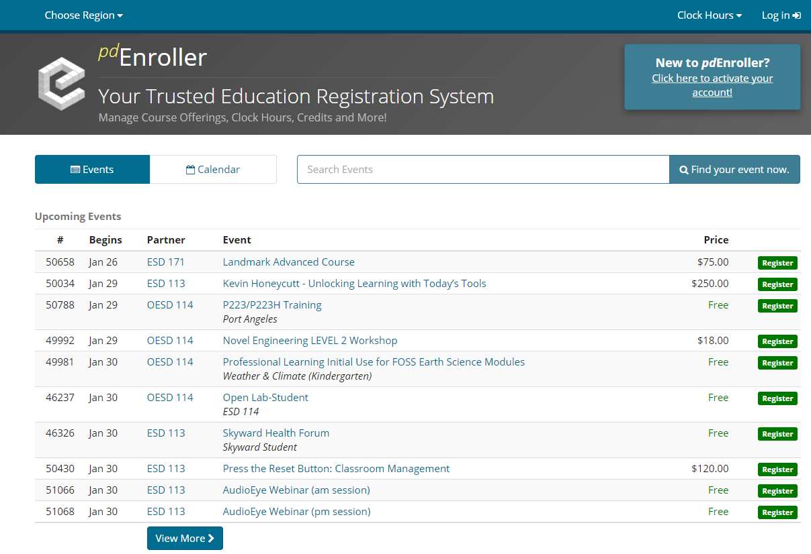

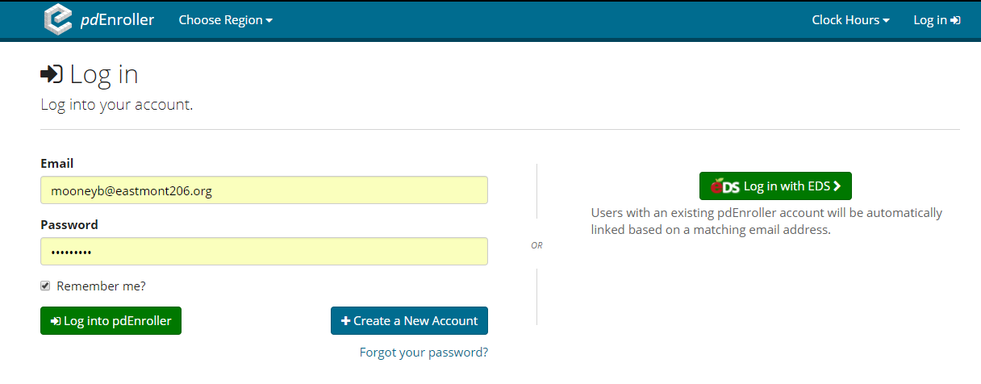
Searching for a clock hour event: You can either search by clock hour session number if you have it, or search by the name of an event. Below is an example:

In the search box put in session number: 48600

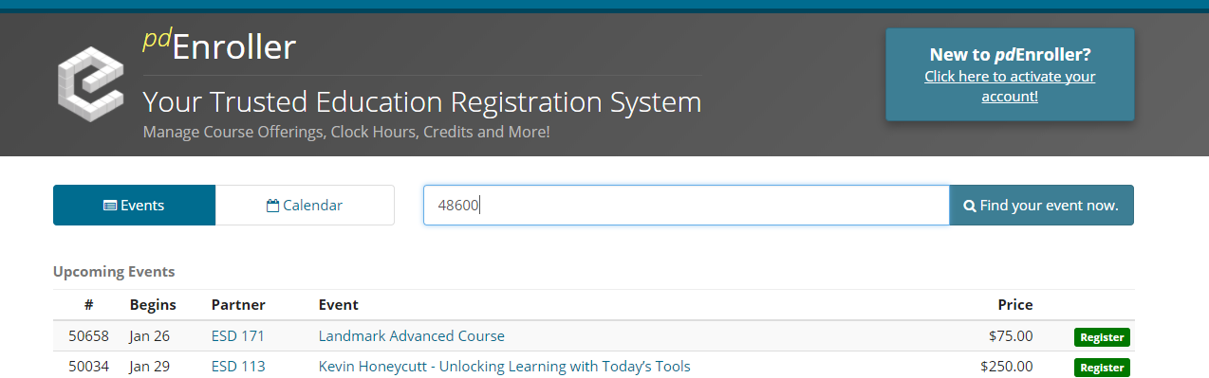

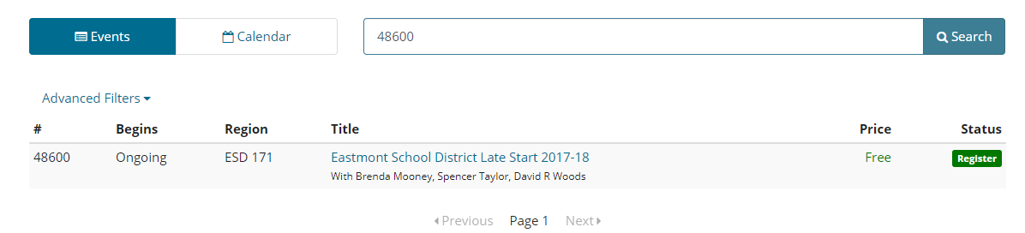

The session you are looking for will pop up and look like the screen above.
Click on the event and it will take you to the registration page:

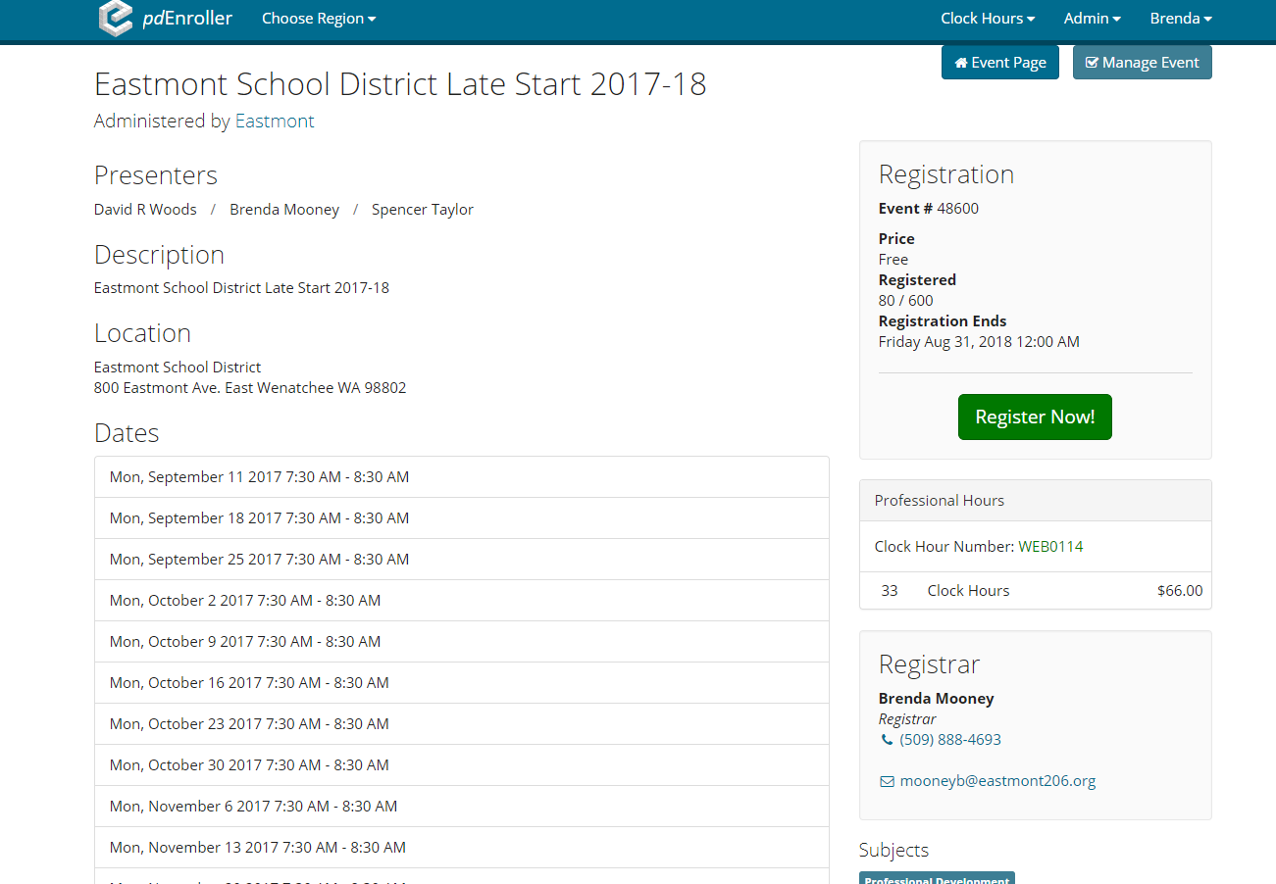

Click on the green “Register Now” button and it will take you to a screen to register for the event. Once you are registered, you wait until the event has taken place and the registrar will check your name off as attending. If there is any documentation to turn in showing proof that you attended the event, you will need to forward this documentation to the registrar so that you may be checked off for attending the event. Upon verification of completion, an email will be sent to you that you can now take a survey and purchase clock hours.

Please note: There are registration deadlines for each clock hour session. You need to ensure that you register for the event before the registration deadline so you do not miss out on clock hour opportunities. Once the registration deadline ends, the event cannot be reopened.

Under the clock hour tab at the top of the page, you can go to “My Clock Hours”, and it will take you to the screen below, where you can see the events you have signed up for as well as the number of hours the session is and the fee that is due for the clock hour session you attended.

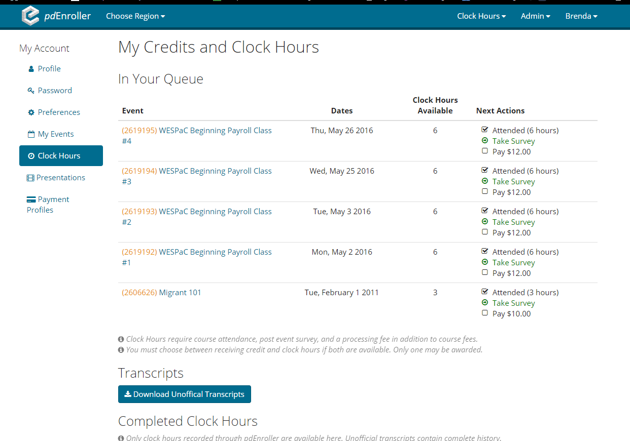

After you take the survey and make the clock hour payment, you can print the clock hour form. Date it, sign it and send it to Payroll for salary movement and/or tuition reimbursement. For tuition reimbursement send the clock hour form along with a Tuition Reimbursement Request form to HR/Payroll to be processed.

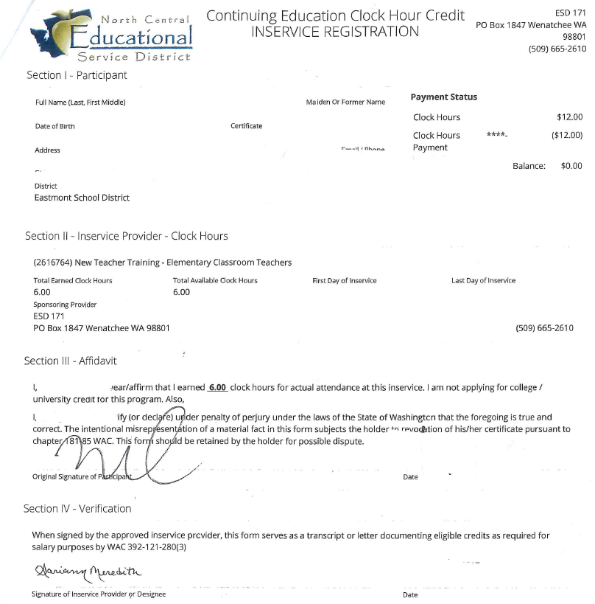

Note: It is your personal responsibility to register, attend, sign-in and purchase clock hours for training/professional development. If you need any further assistance with the clock hour process, please do not hesitate to contact me: Brenda Mooney, mooneyb@eastmont206.org, or direct phone extension: 888-4693

