Emergency Substitute Certificate Instructions
Go to the OSPI website: http://www.k12.wa.us/
Click on Certification, Teacher Certification

Or go to https://www.k12.wa.us/certification-teacher-0/emergency-substitute-certification-state-applicants
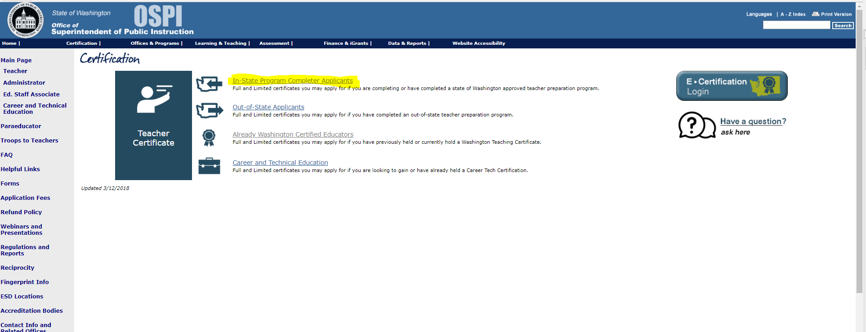

Then click on In-State Program Completer Applicants
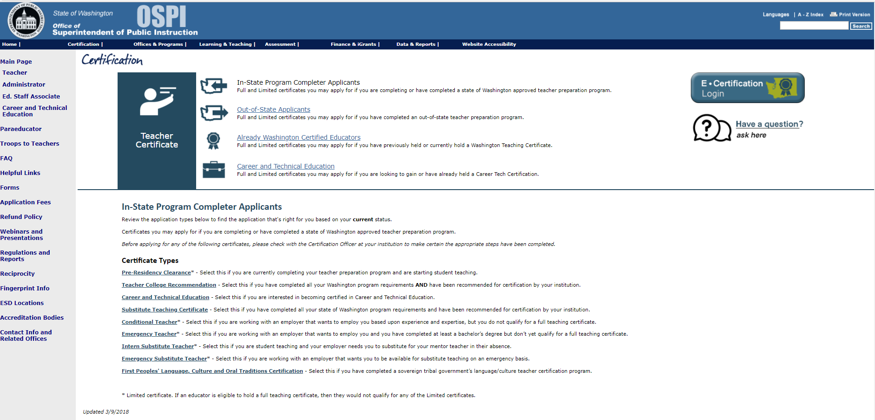

Then on Emergency Substitute Teacher
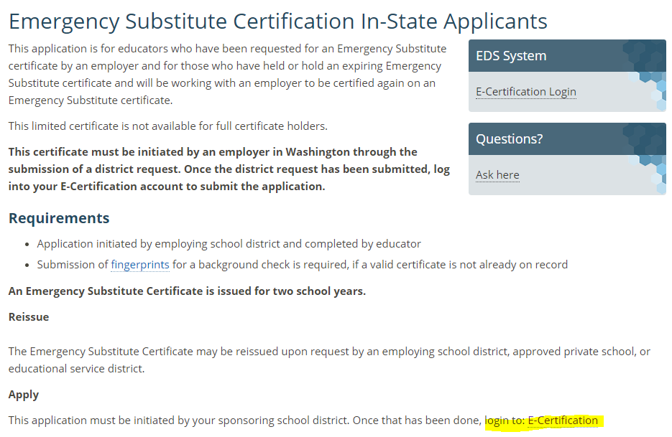

You must first create an account before applying:
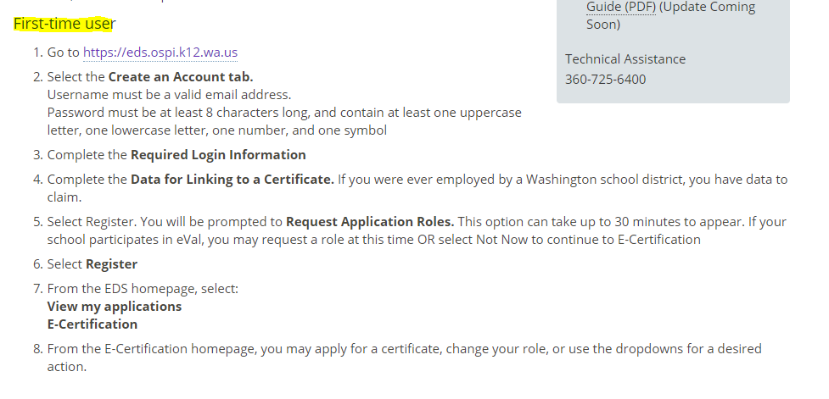
Once you complete your profile, please call Human Resources at 509-884-7169 as there a section for the district to complete. We will ask for your last name and the last four digits of your social security number. It takes just a few minutes for us to complete our portion of the request. When you log back in you will have a few more steps to complete, including paying the certificate fee.

