We are Paperless!
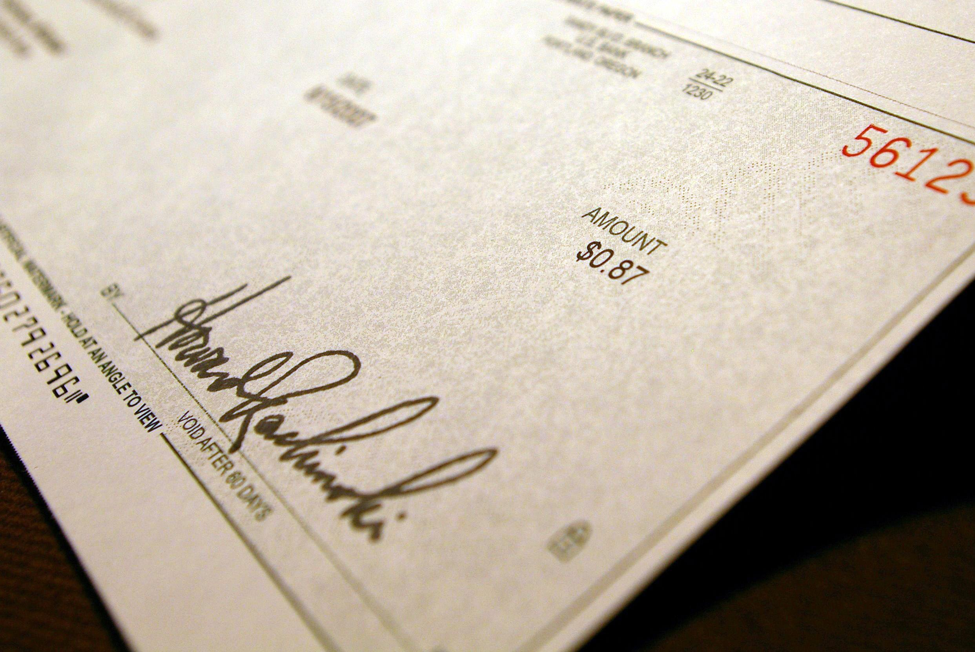
We are pleased to announce Eastmont School District has gone Payroll Paperless. The Payroll Department has provided access to Employee Access, our online payroll system that allows individuals to view and print pay statements and W-2’s online, 24 hours per day, 7 days a week.

For instructions on how to use Employee Access, click here.

Questions? E-mail our HR/Payroll staff at payroll@eastmont206.org

