TalentEd Records Sign-In

You will receive an email from TalentEd notifying you of your new contract

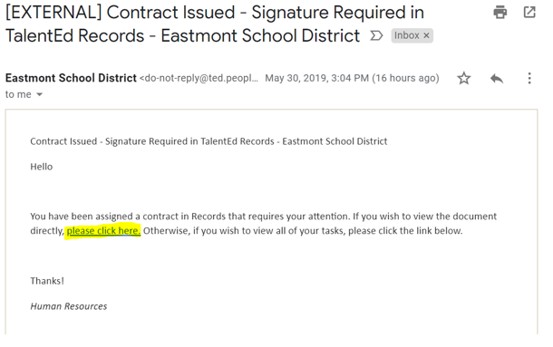
Click here to proceed and create your account

After you click on the link, you will be taken to the website.

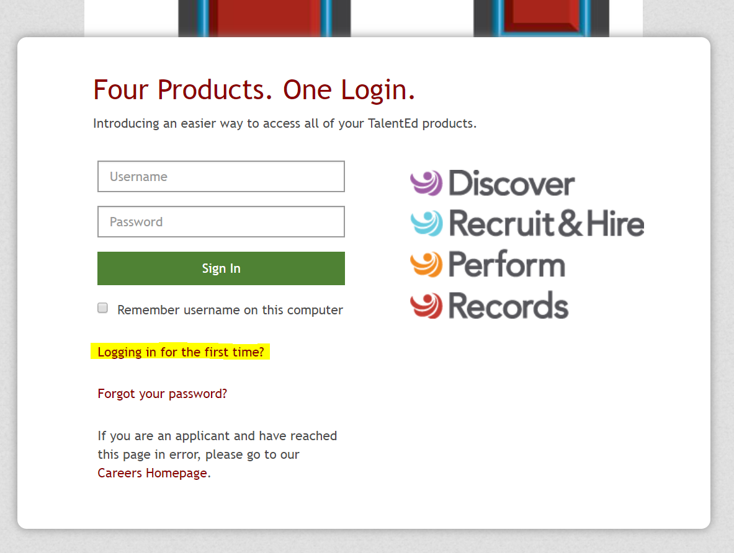
Click the link “Logging in for the first time” to obtain your username and set your password.
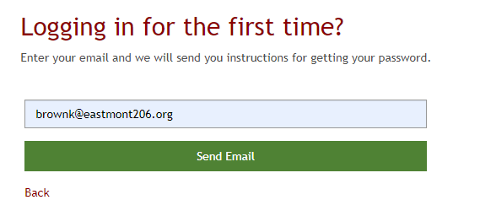
Enter your full Eastmont email address

You will then receive another email with your username and a link to set your password.
The email will be from:
[EXTERNAL] Set Password
TalentEd <do_not_reply@talentedk12.com>
Take note of your username (Eastmont email address), you will use that every time you login to the TalentEd system.
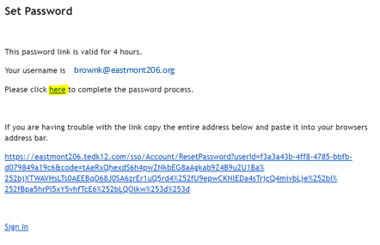
After clicking on the link, you will be given the chance to set your own password.
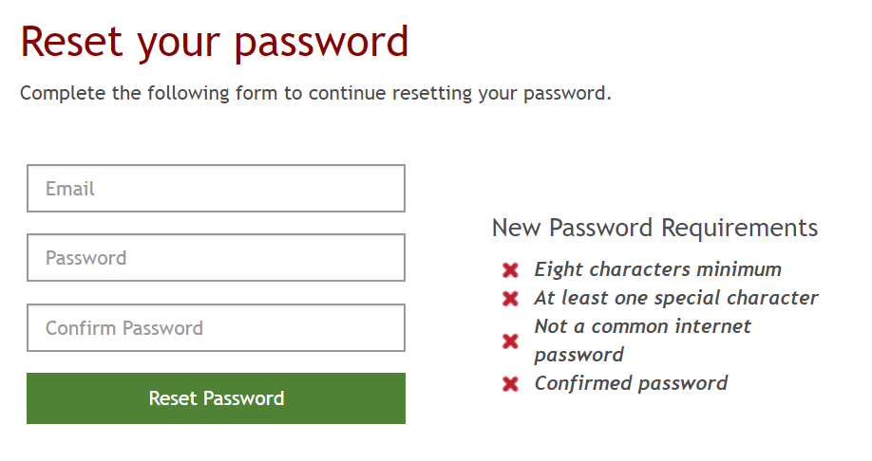

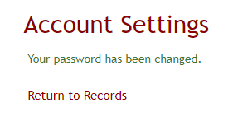
Once you have created your account, simply click Return to Records

You will be given the opportunity to review and sign your new contract after Human Resources has approved it.

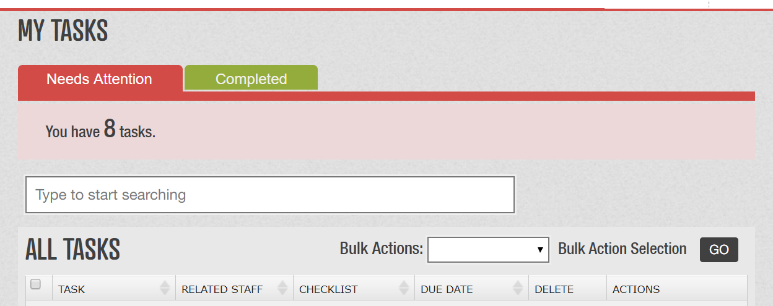
Your contract will be listed as a Task that Needs Attention. Click on your contract that needs to be signed

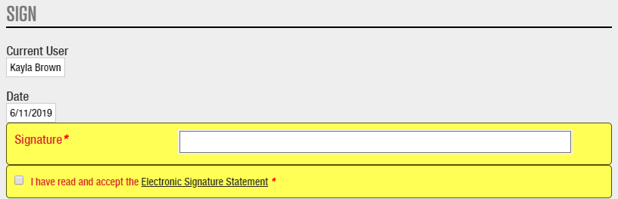
Review your contract details then sign at the bottom by typing your name and accepting.

Once Human Resources has signed/approved your contract after your submittal, you can view it along with print it at any time.
To view your contract log in to Records, click on “Files” tab (in the upper right hand corner)

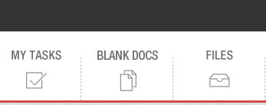

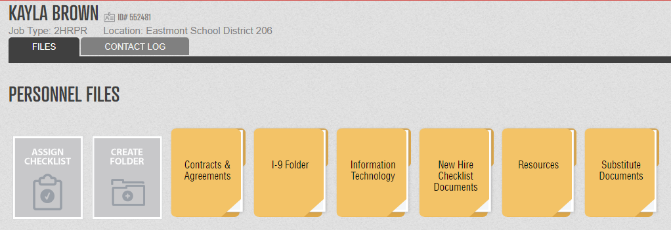
Click “Contracts & Agreements”

Click on the Contract you wish to view. You can print the contact from here anytime. When you print your contract, it will include the date that you signed it along with the date that Human Resources signed the contract.

