Eastmont Math Challenge
Week of 4/20-4/24
This handout is for all Eastmont Intermediate students. Each week a handout similar to this one
will be available to students. As you work through the problems, work independently but feel
free to use online resources if you need help (khan academy or google). This handout is one
component of your math activities. The other component is Freckle math. You are encouraged
to progress through the Freckle activities as well. Check your google classroom daily for possible updates from your teachers. *Answer keys for handouts will be available the following week.
__________________________________________________________________________
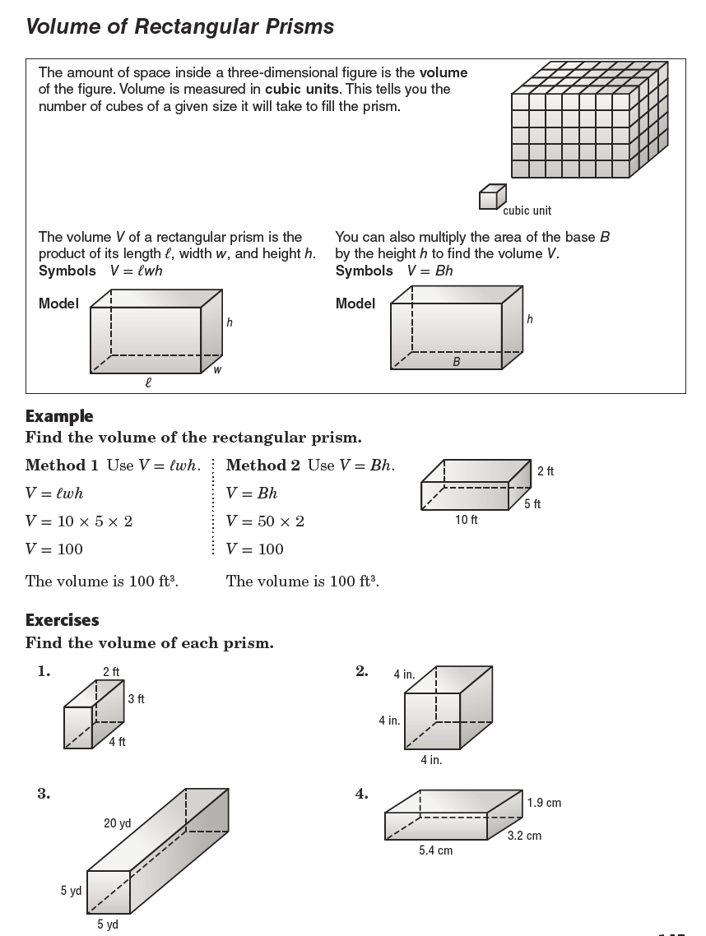

Record Answers Here: 1. _____ ${ft}^{3}$ 2. _____${in}^{3}$ 3. ______${yd}^{3}$ 4. ______${cm}^{3}$
What is our weight? What is the weight of all three animals in the fourth image?
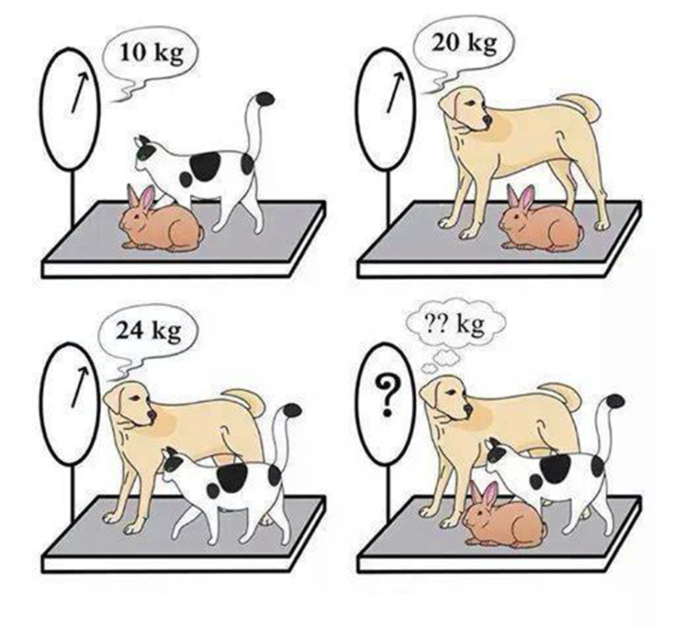
What is the weight of the animals? cat & rabbit ______ + dog ______ = total _______

___________________________________________________________________________

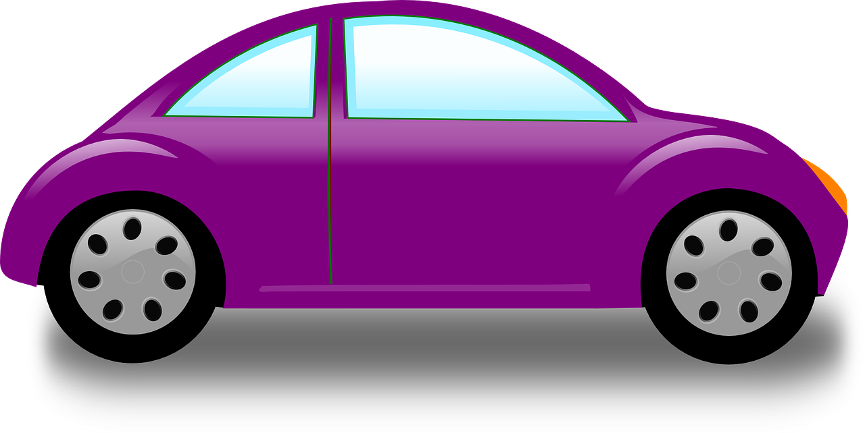
Sean, Brandon, Christian, and Zachary each own a car. One has a gray car, one has a blue car, one has a purple car, and one has a brown car.

Figure out the color of each person's car.
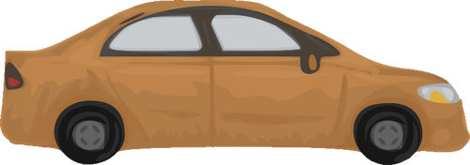
1. Christian's favorite colors are purple and brown. His car is one of his favorite colors.

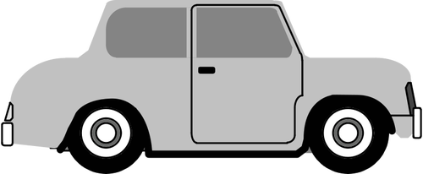
2. Brandon borrowed the purple car, because Christian was using his car.

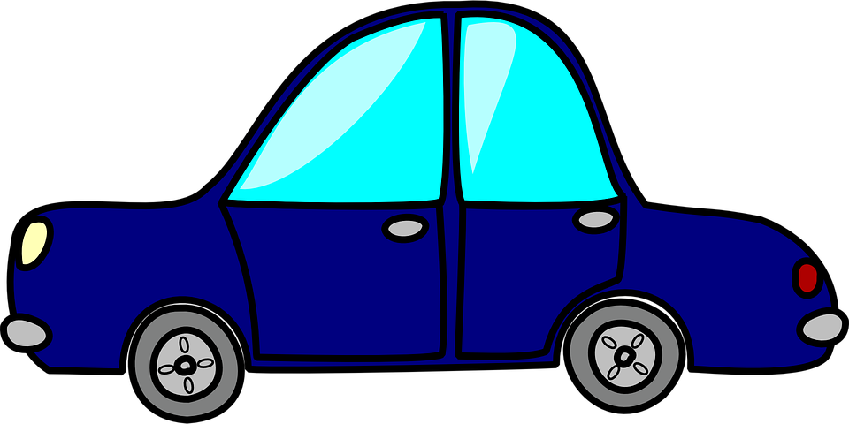
3. Brandon doesn't like gray cars.

4. Christian borrowed the gray car, because Zachary was using his car.

5. Sean borrowed the blue car, because Brandon was using his car.

6. Sean's favorite colors are brown and purple. His car is one of his favorite colors.

7. Christian doesn't like gray cars.

8. Christian doesn't like purple cars.

Sean has a(n)_________car. Brandon has a(n) __________car.
Christian has a(n)_________ car. Zachary has a(n)_________car.
**Helpful Hints:**

Volume of Rectangluar Prisms: Look at the examples given above or the examples below.

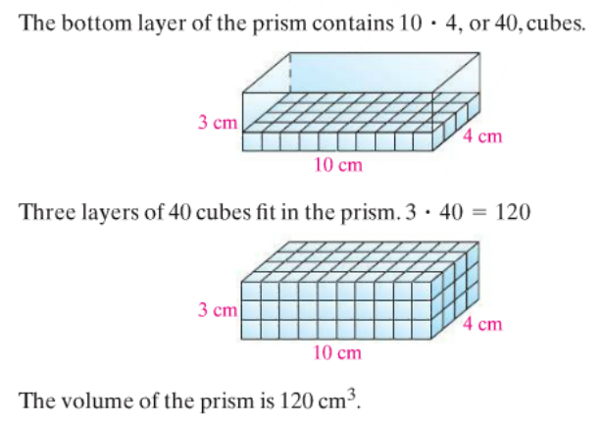
Volume = Length x Width x Height or Volume = Base x Height.
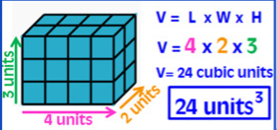

What is our weight?:
Pay attention to each animal's weight. Make sure to look closely at the pictures.

*Try adding “Dog & Cat” plus “Dog & Rabbit”, then subtract “Cat and Rabbit”
… how many dogs does that leave you with? How much would just 1 dog be?

Figure out the color of each person's car.

- Write the list of people’s names first.
- Write a seperate list of all the colors that are mentioned.
- Read and reread the sentences to figure out which colors you can or can’t be used for each person.

