Eastmont Science Challenge Week 3: Earth Day Science Challenge
April 22, 2020

Make Earth Day Everyday!

One of the biggest impacts on Earth’s ecosystems is feeding all humans. In preparation of Earth Day on April 22, you are challenged to explore your own impact on our food system.

What is food waste?
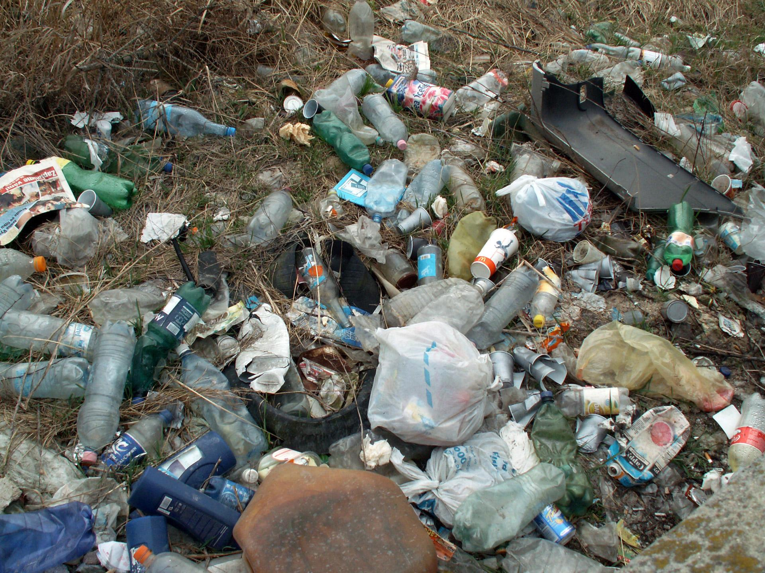
Food waste is a problem that affects natural resources, humans, and landfills. The Environmental Protection Agency, a Federal organization provides information to the public on food waste and how to reduce its negative impacts on the environment.

Examples of Food Waste are unsold food from retail stores; plate waste, uneaten prepared food, or kitchen trimmings from restaurants, cafeterias, and households; or by-products from food and beverage processing facilities.

Sustainable Management of Food is a systematic approach that seeks to reduce wasted food and its associated impacts over the entire life cycle, starting with the use of natural resources, manufacturing, sales, and consumption and ending with decisions on recovery or final disposal.

Food waste is a problem because it ends up in landfills, it increases energy and labor costs, and wastes money when the food you purchase is not eaten.

The website: Sustainable Management of Food Basics is available if you want to learn more!

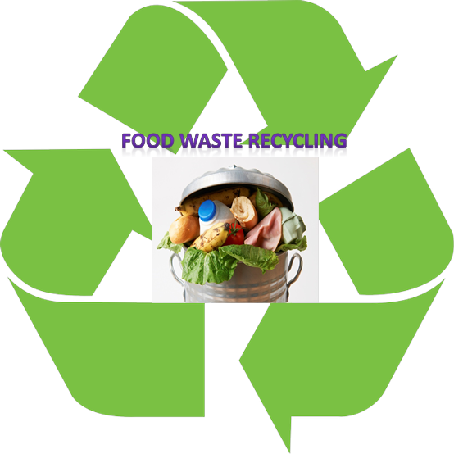
Level 1:
Food Waste Audit
You will be collecting data to learn about your own food waste after a meal.
- Step 1: Pick a meal. Pick either lunch or dinner for your food audit. Each day, use the Food Waste Audit Worksheet to document your data.
- Step 2: Write in the reason why the food was wasted. Examples of reasons include “I don’t like it,” “I didn’t have to time to eat it,” “Food was damaged or looked bruised,” or “I was full.”

Food Waste Audit
Date | What food did I throw away? | Why?
You won’t be able to type an X in the box. Just put your X next to the word.
- Meat
- Veggies
- Milk/dairy
- Fruit
- Bread
- Other ____________
- No food wasted
- Meat
- Veggies
- Milk/dairy
- Fruit
- Bread
- Other ____________
- No food wasted
- Meat
- Veggies
- Milk/dairy
- Fruit
- Bread
- Other ____________
- No food wasted
- Meat
- Veggies
- Milk/dairy
- Fruit
- Bread
- Other ____________
- No food wasted
- Step 3: Identify Patterns. Write down patterns you notice in the foods that were wasted and the reasons why the food was thrown away.
What patterns do you notice in the foods that were wasted and the reasons why the food was thrown away?

Level 2:

Analyze and Interpret Your Data
Answer the following questions:
- Did you identify any patterns with the kinds of food you wasted? Select one of the patterns below or add one of your own.
  - I don’t tend to waste food - I eat it all!
  - I don’t eat vegetables, so I pick them out
  - I wasted different kinds of foods each day, such as…
  - Other

- What are some solutions to each of the reasons food was wasted?

- What was challenging about doing the Food Waste Audit?

- What are some ways you can waste less food?

- Why is it important to not waste food?

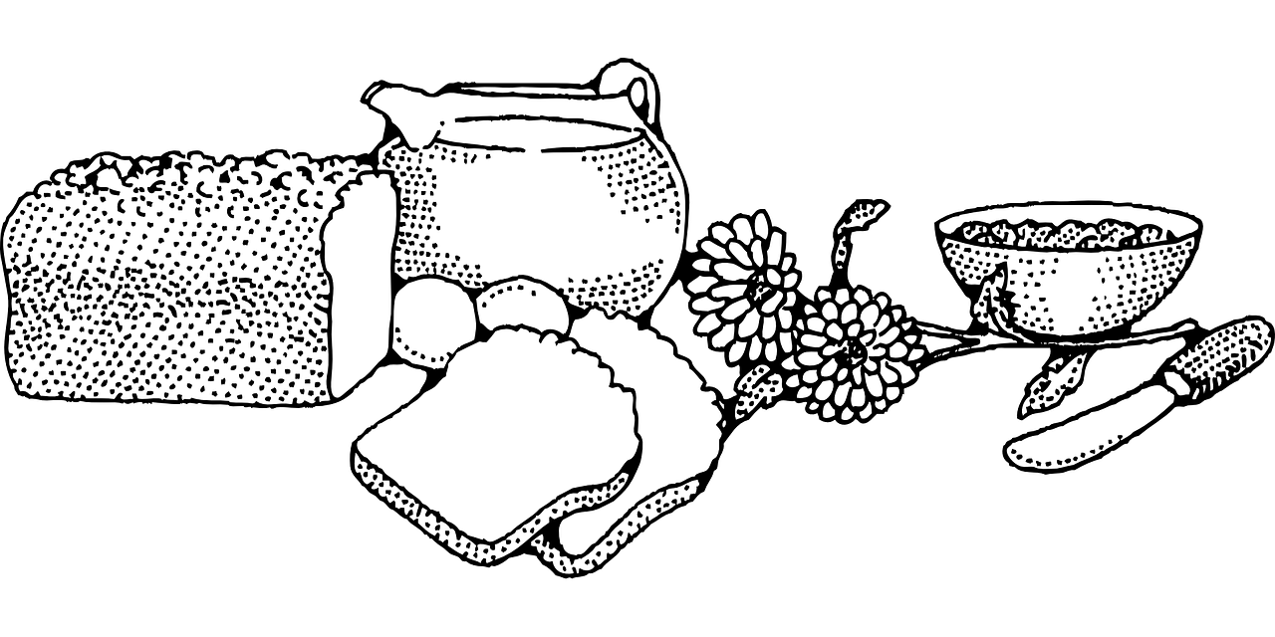

Level 3:

Make a Plan
Make a plan for your family so that less food gets wasted.

