Students, get ready to be challenged! Teachers will be providing you with weekly challenges including an activity each day from each of your classes! All challenges will have 3 different level options. Start by choosing the level that you feel comfortable with and then continue to challenge yourself by going up to another level! When you are finished, feel free to share on your school's Facebook page, with your teacher on google classroom, or to family members and friends.
Option 1

- To get started, play the landform match the pictures with name of landform on purposegames.com
- For more practice, try this word search:
- Now try a game on Setera: See if you can get 100%! Let your teacher know when you do

Option 2
Landform video

- Using blank paper or notecards to make separate flashcards of the landforms shown in the picture. If using paper, first fold the paper in half lengthwise, then crosswise. After you unfold the paper, cut or carefully tear along the folds to make individual cards. Next, draw a picture of that landform and color it, one on each page and write a definition on the other side. Practice with your family.
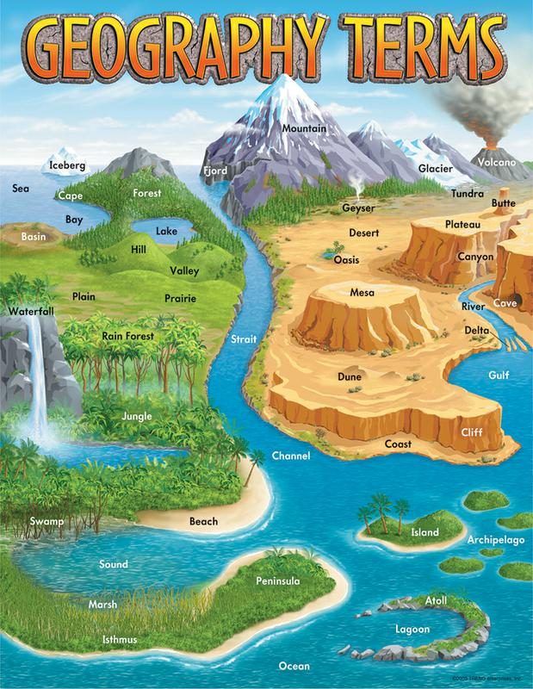

Option 3
- Use Google Slides to complete a digital flipbook then share it with your teacher. Have 10 slides with each slide having a picture of the landform, a definition in your own words. Don’t forget a cover slide with what the slides are about and who made the digital flipbook. Bonus: Can you find a real-world example of the landslide in the State of Washington?

Example of a flipbook:
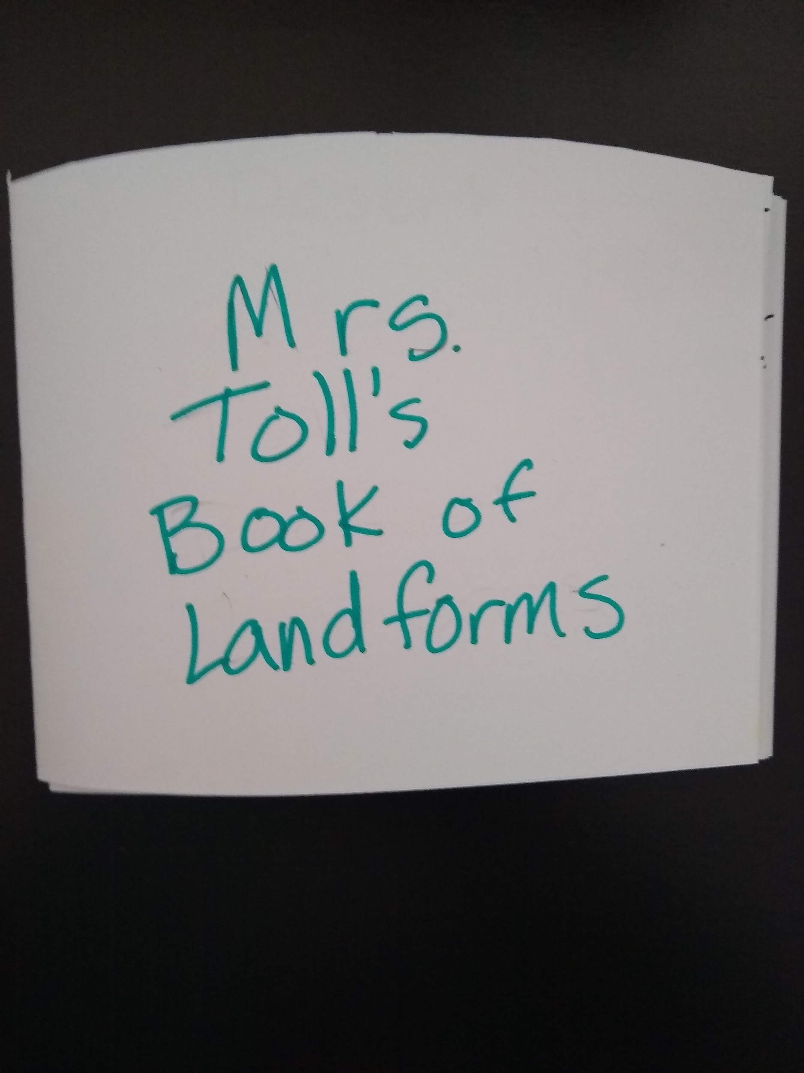
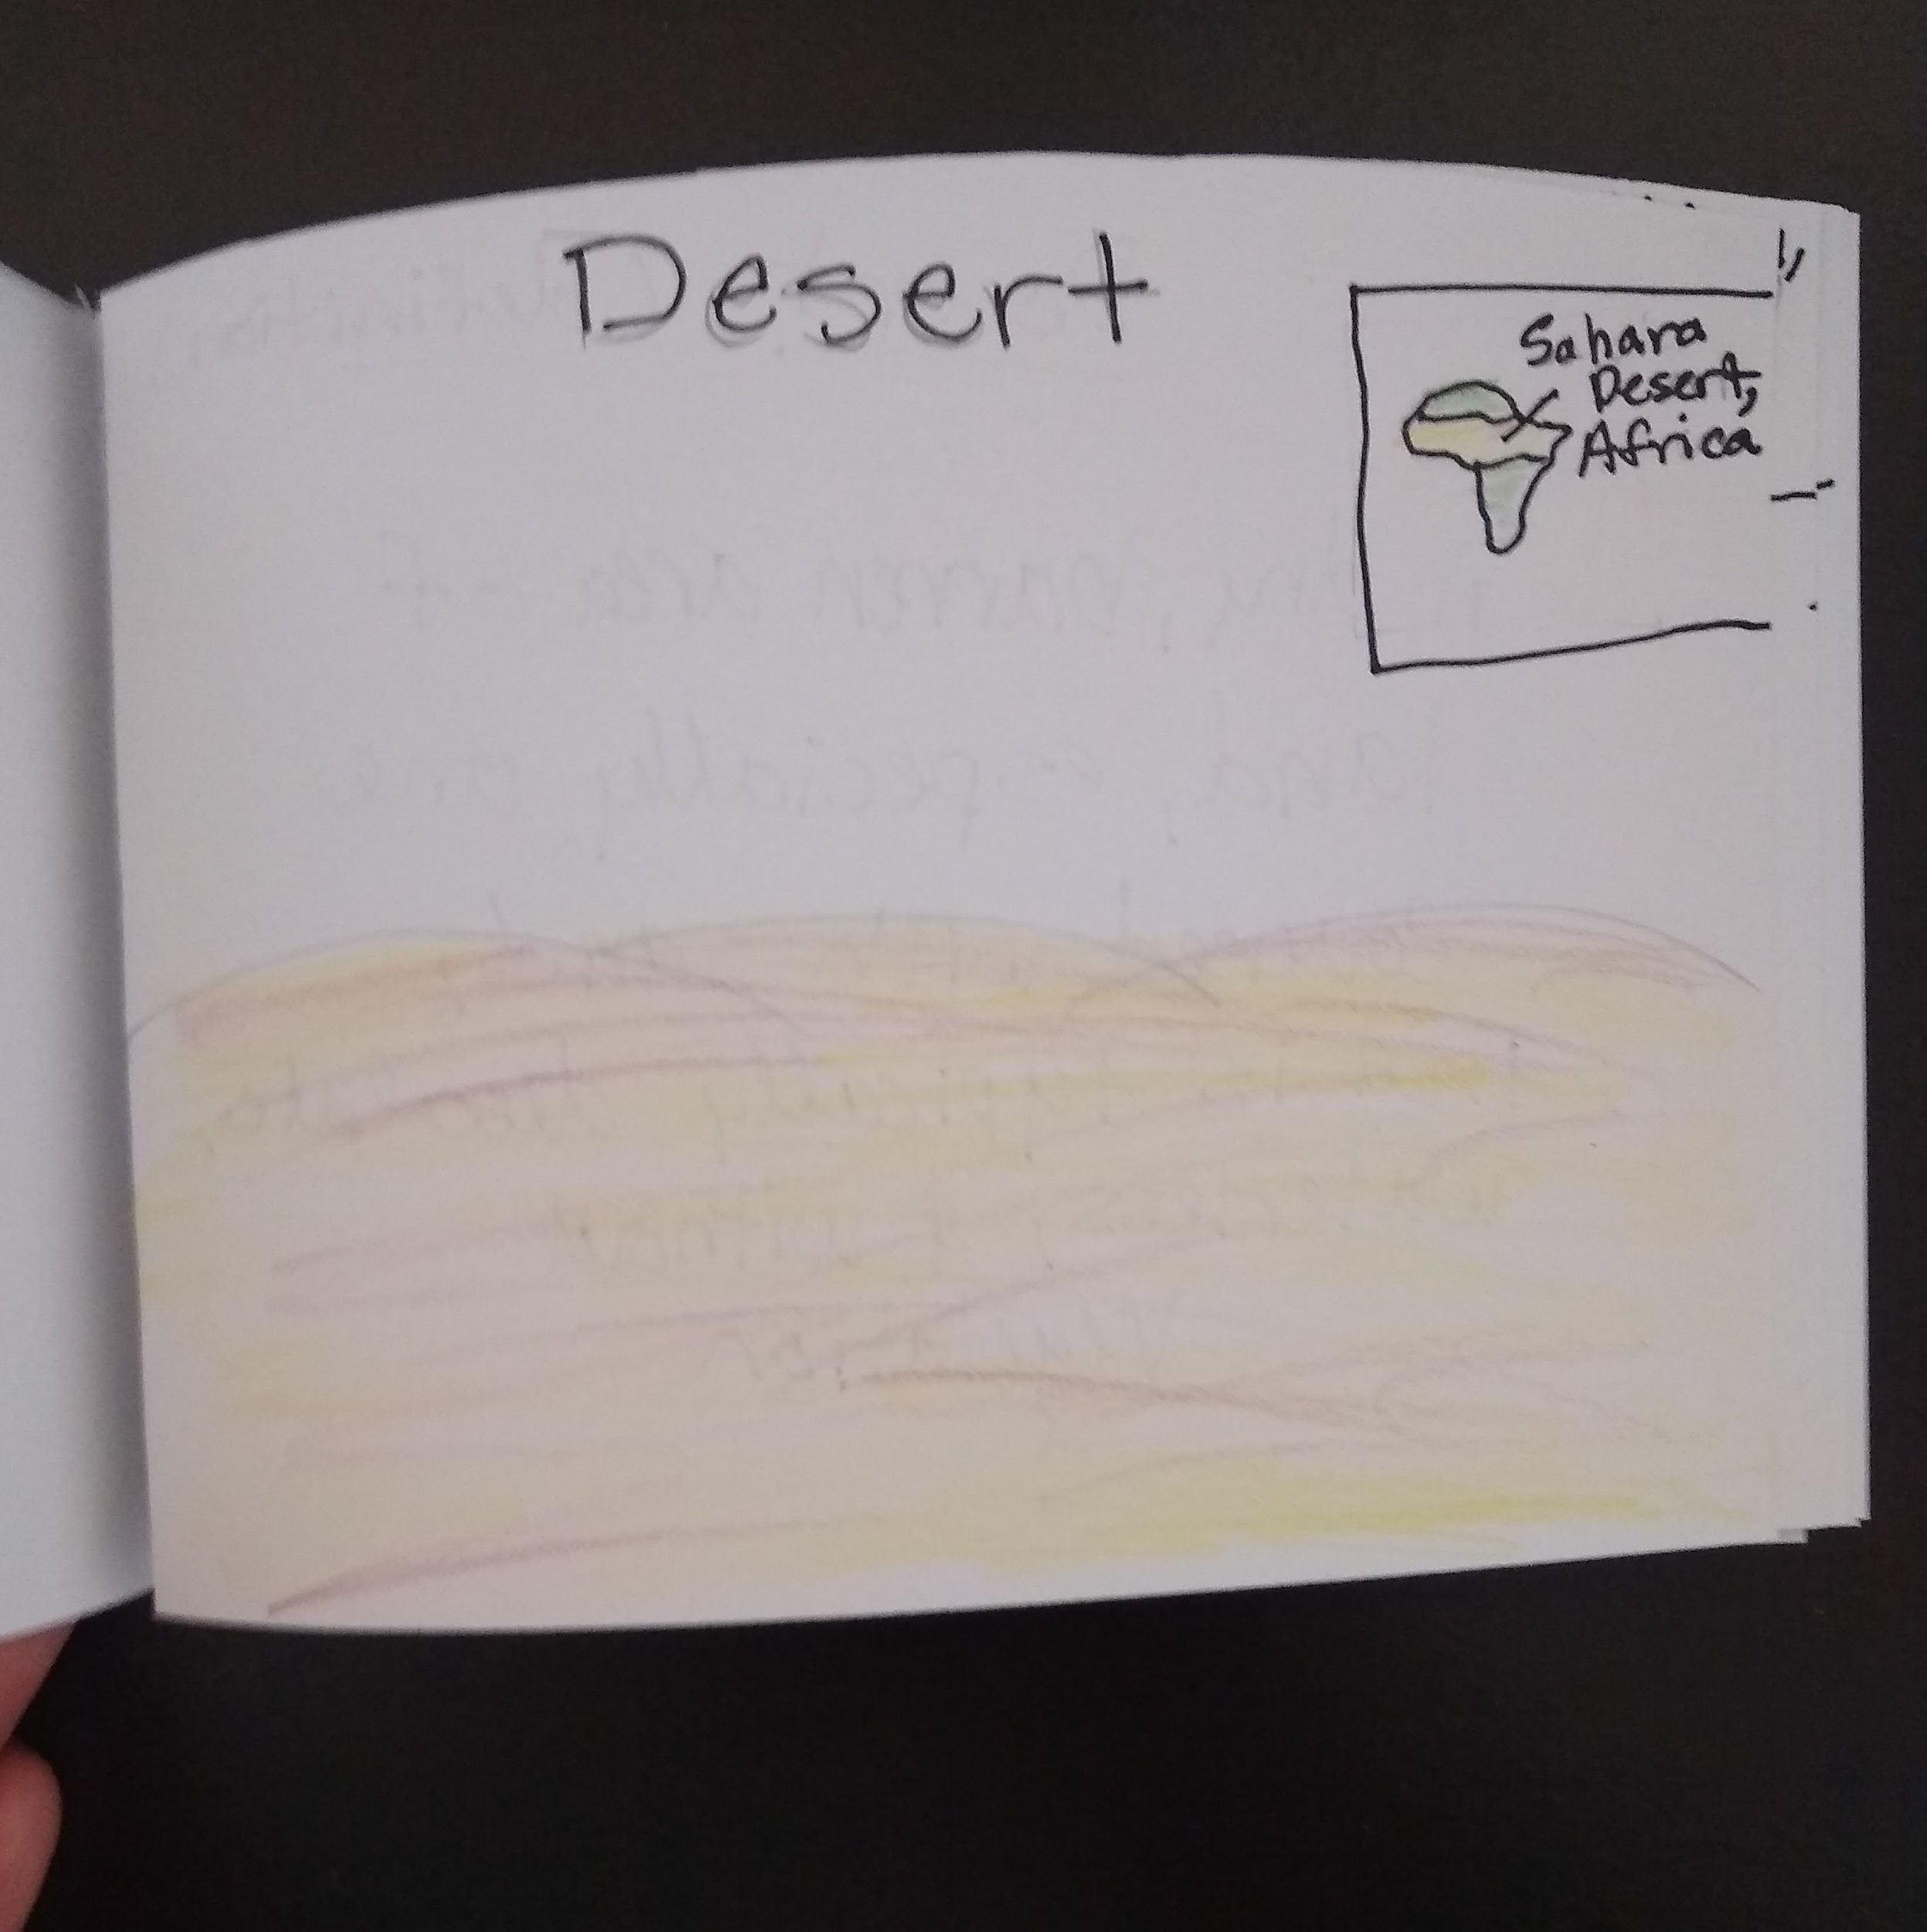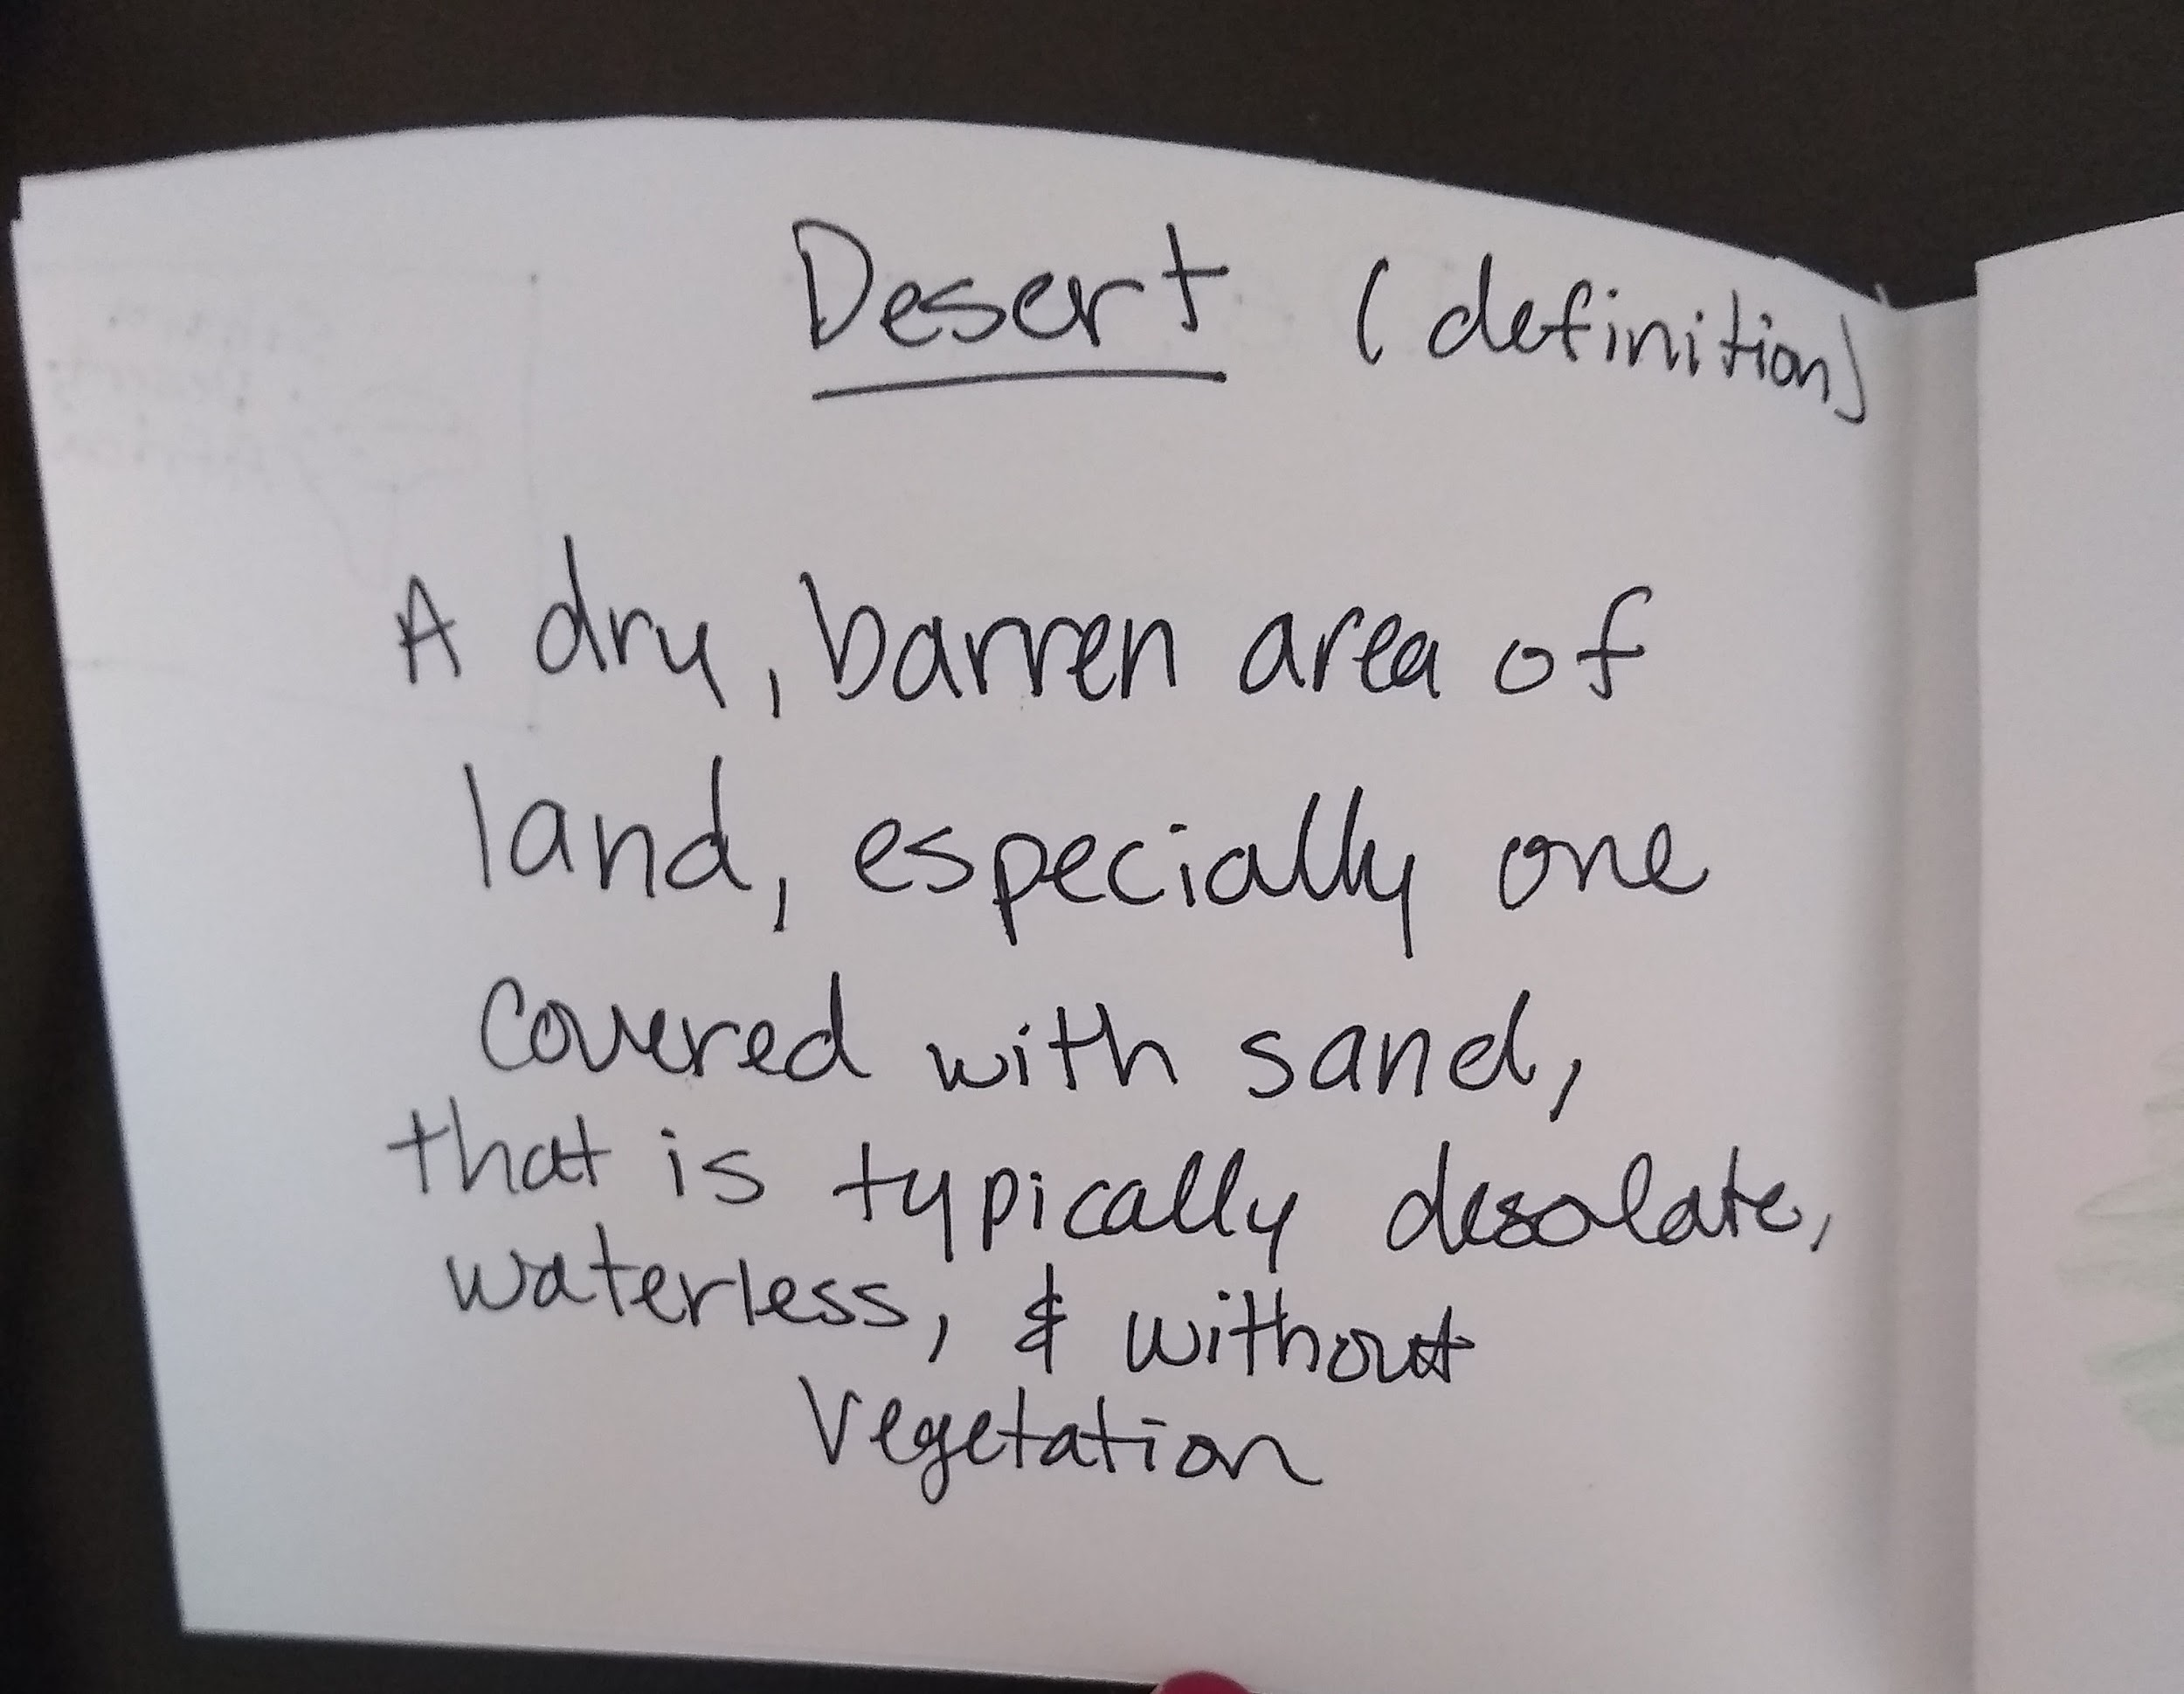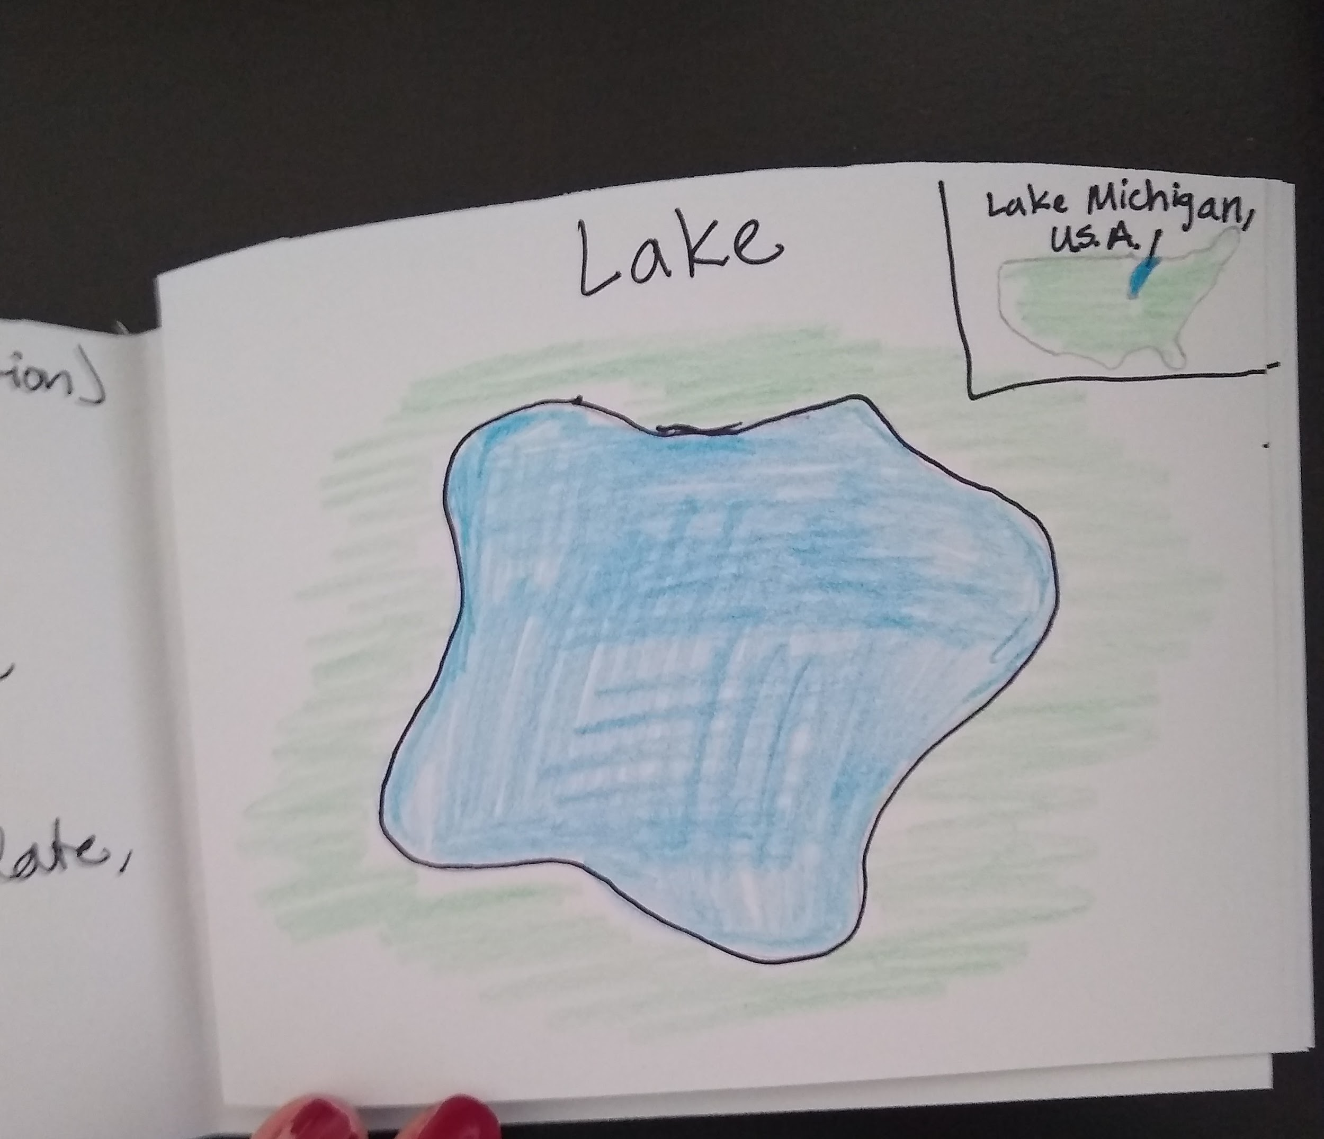

Helpful Hints

Inlet: Small arm of a sea, lake or river 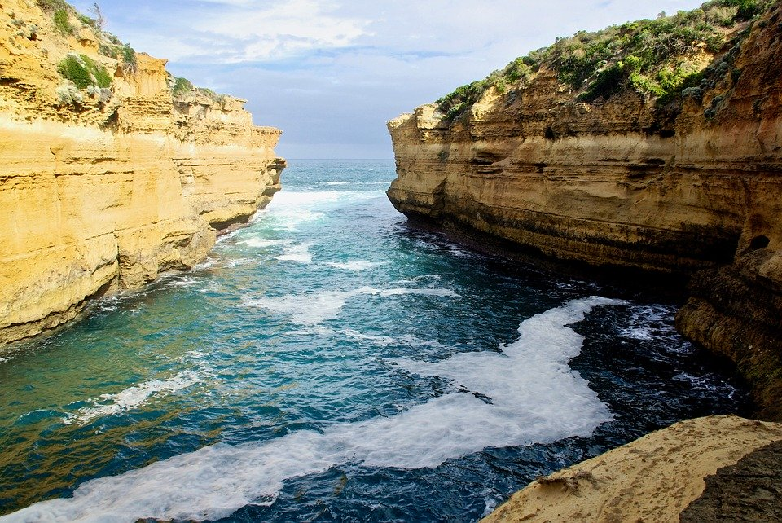
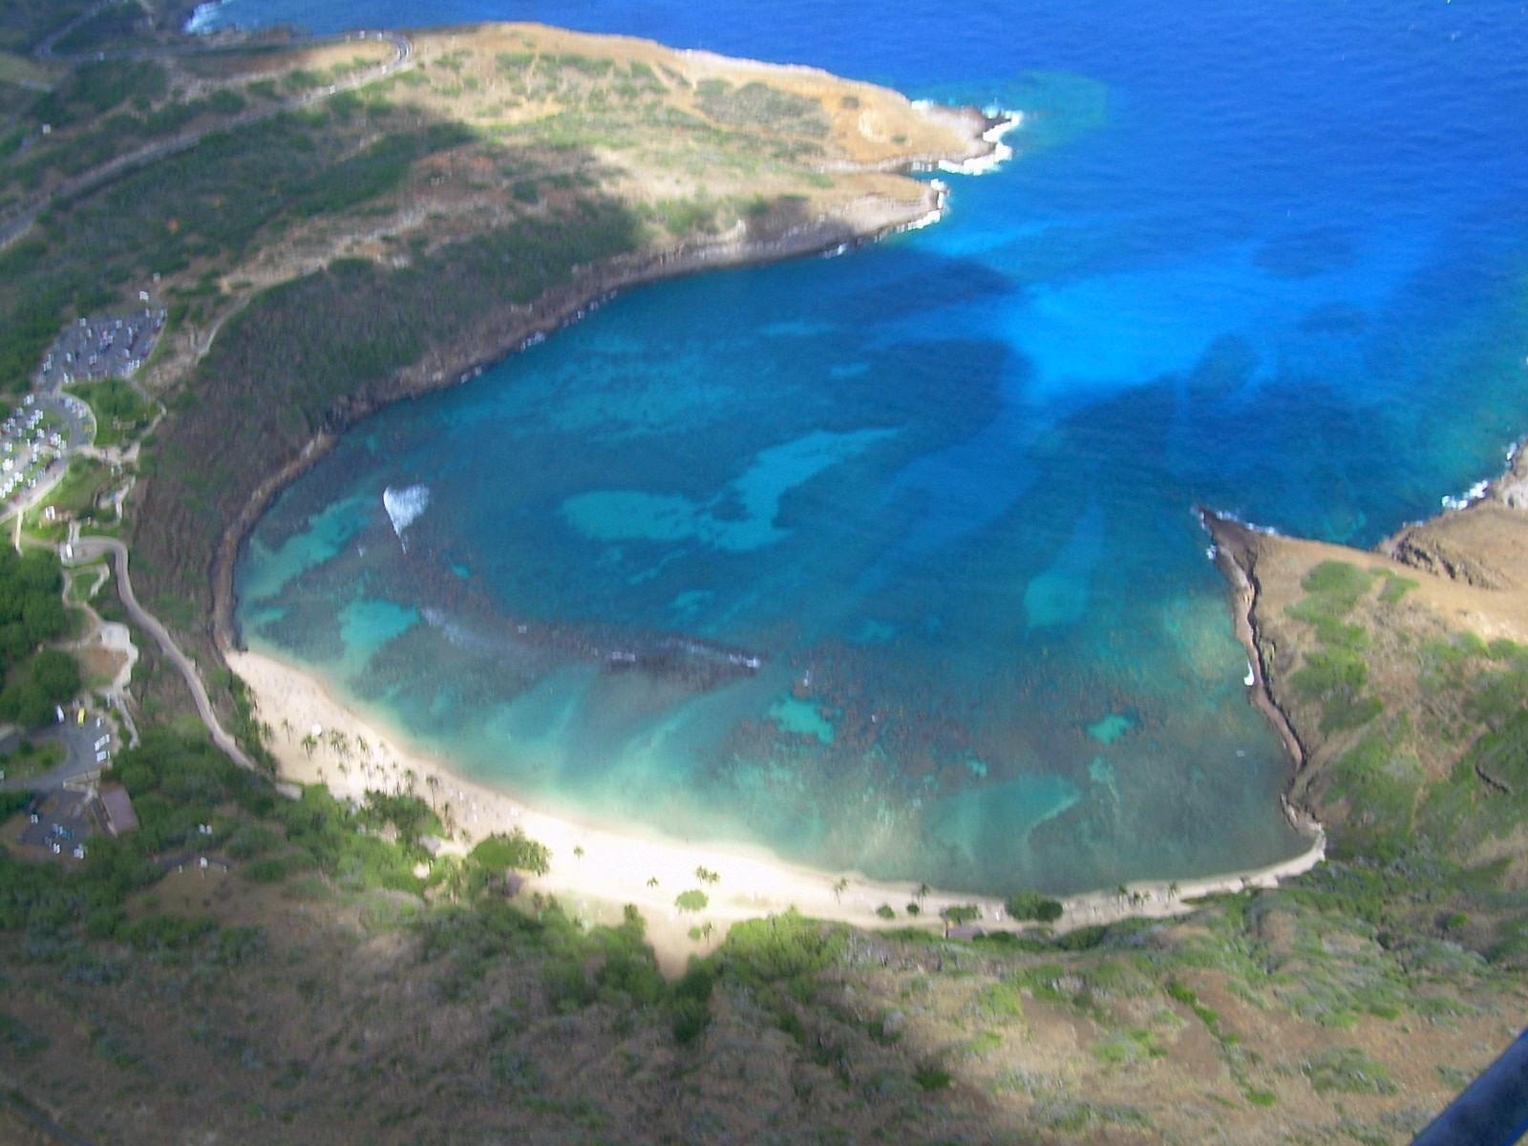

Bay: Wide inlet of the sea where the land curves inward
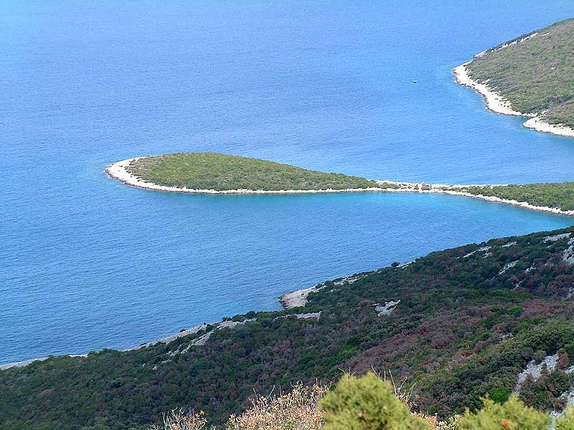

Peninsula: A piece of land almost surrounded by water
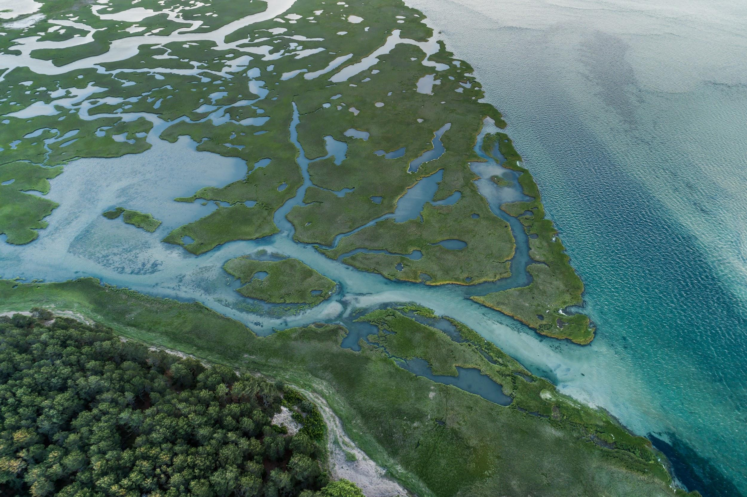

Tributary: A river or stream flowing into a larger river or lake

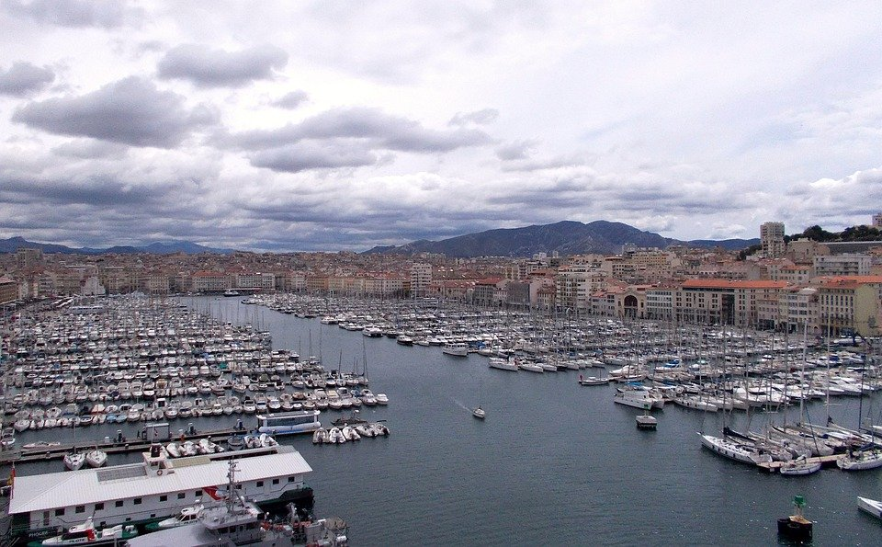
Harbor: A deep body of water that protects boats near land

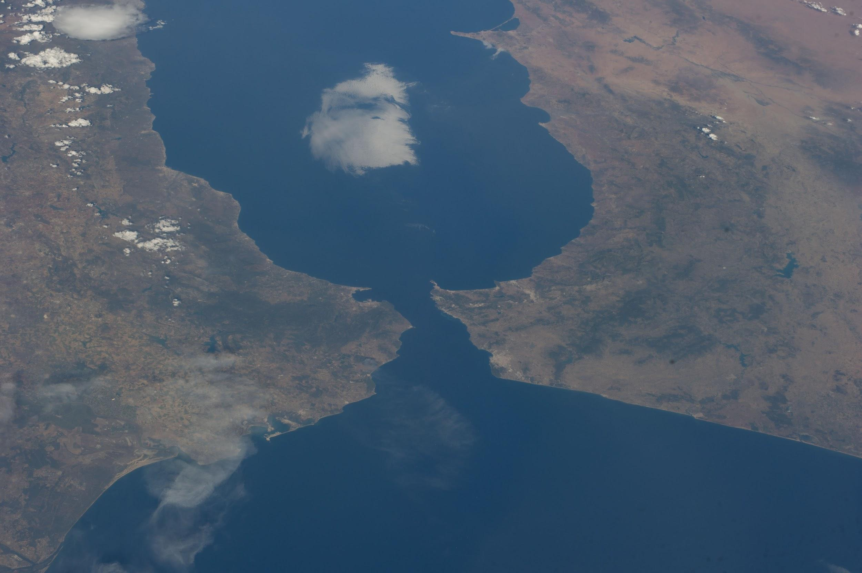

Strait: A narrow body of water that connects to two bodies of water

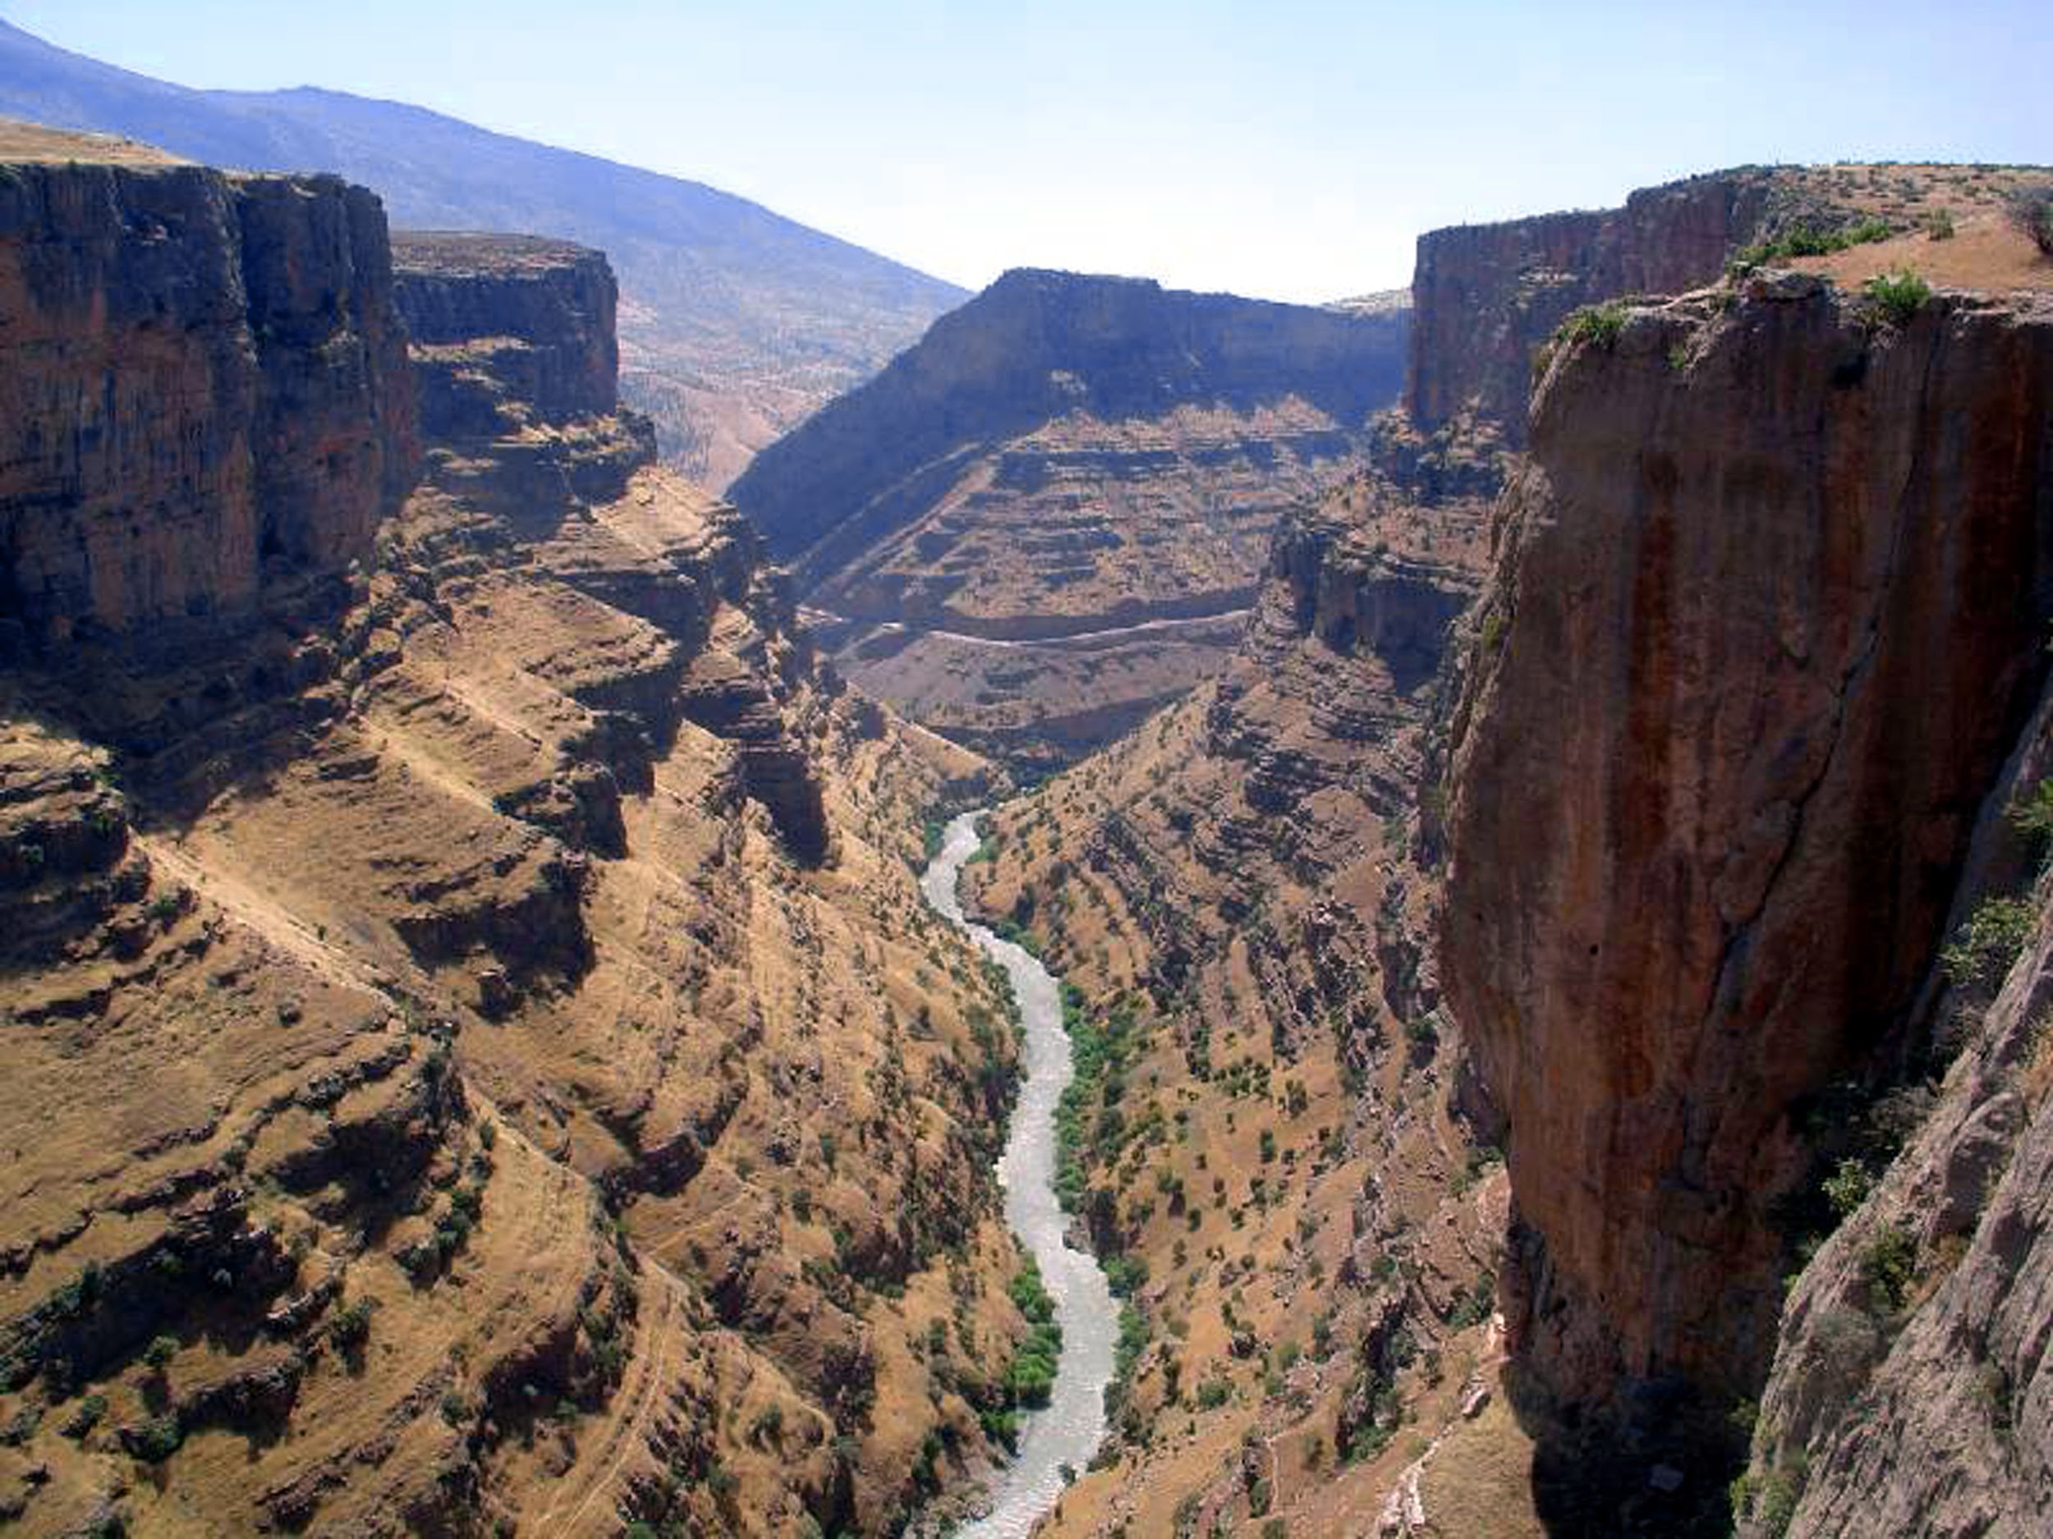
Canyon: Two tall cliffs with a valley running between them, sometimes a river

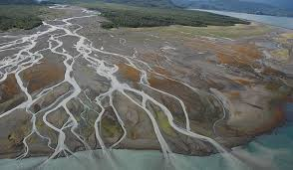
Cape: A raised part of land that goes out into the sea along the coast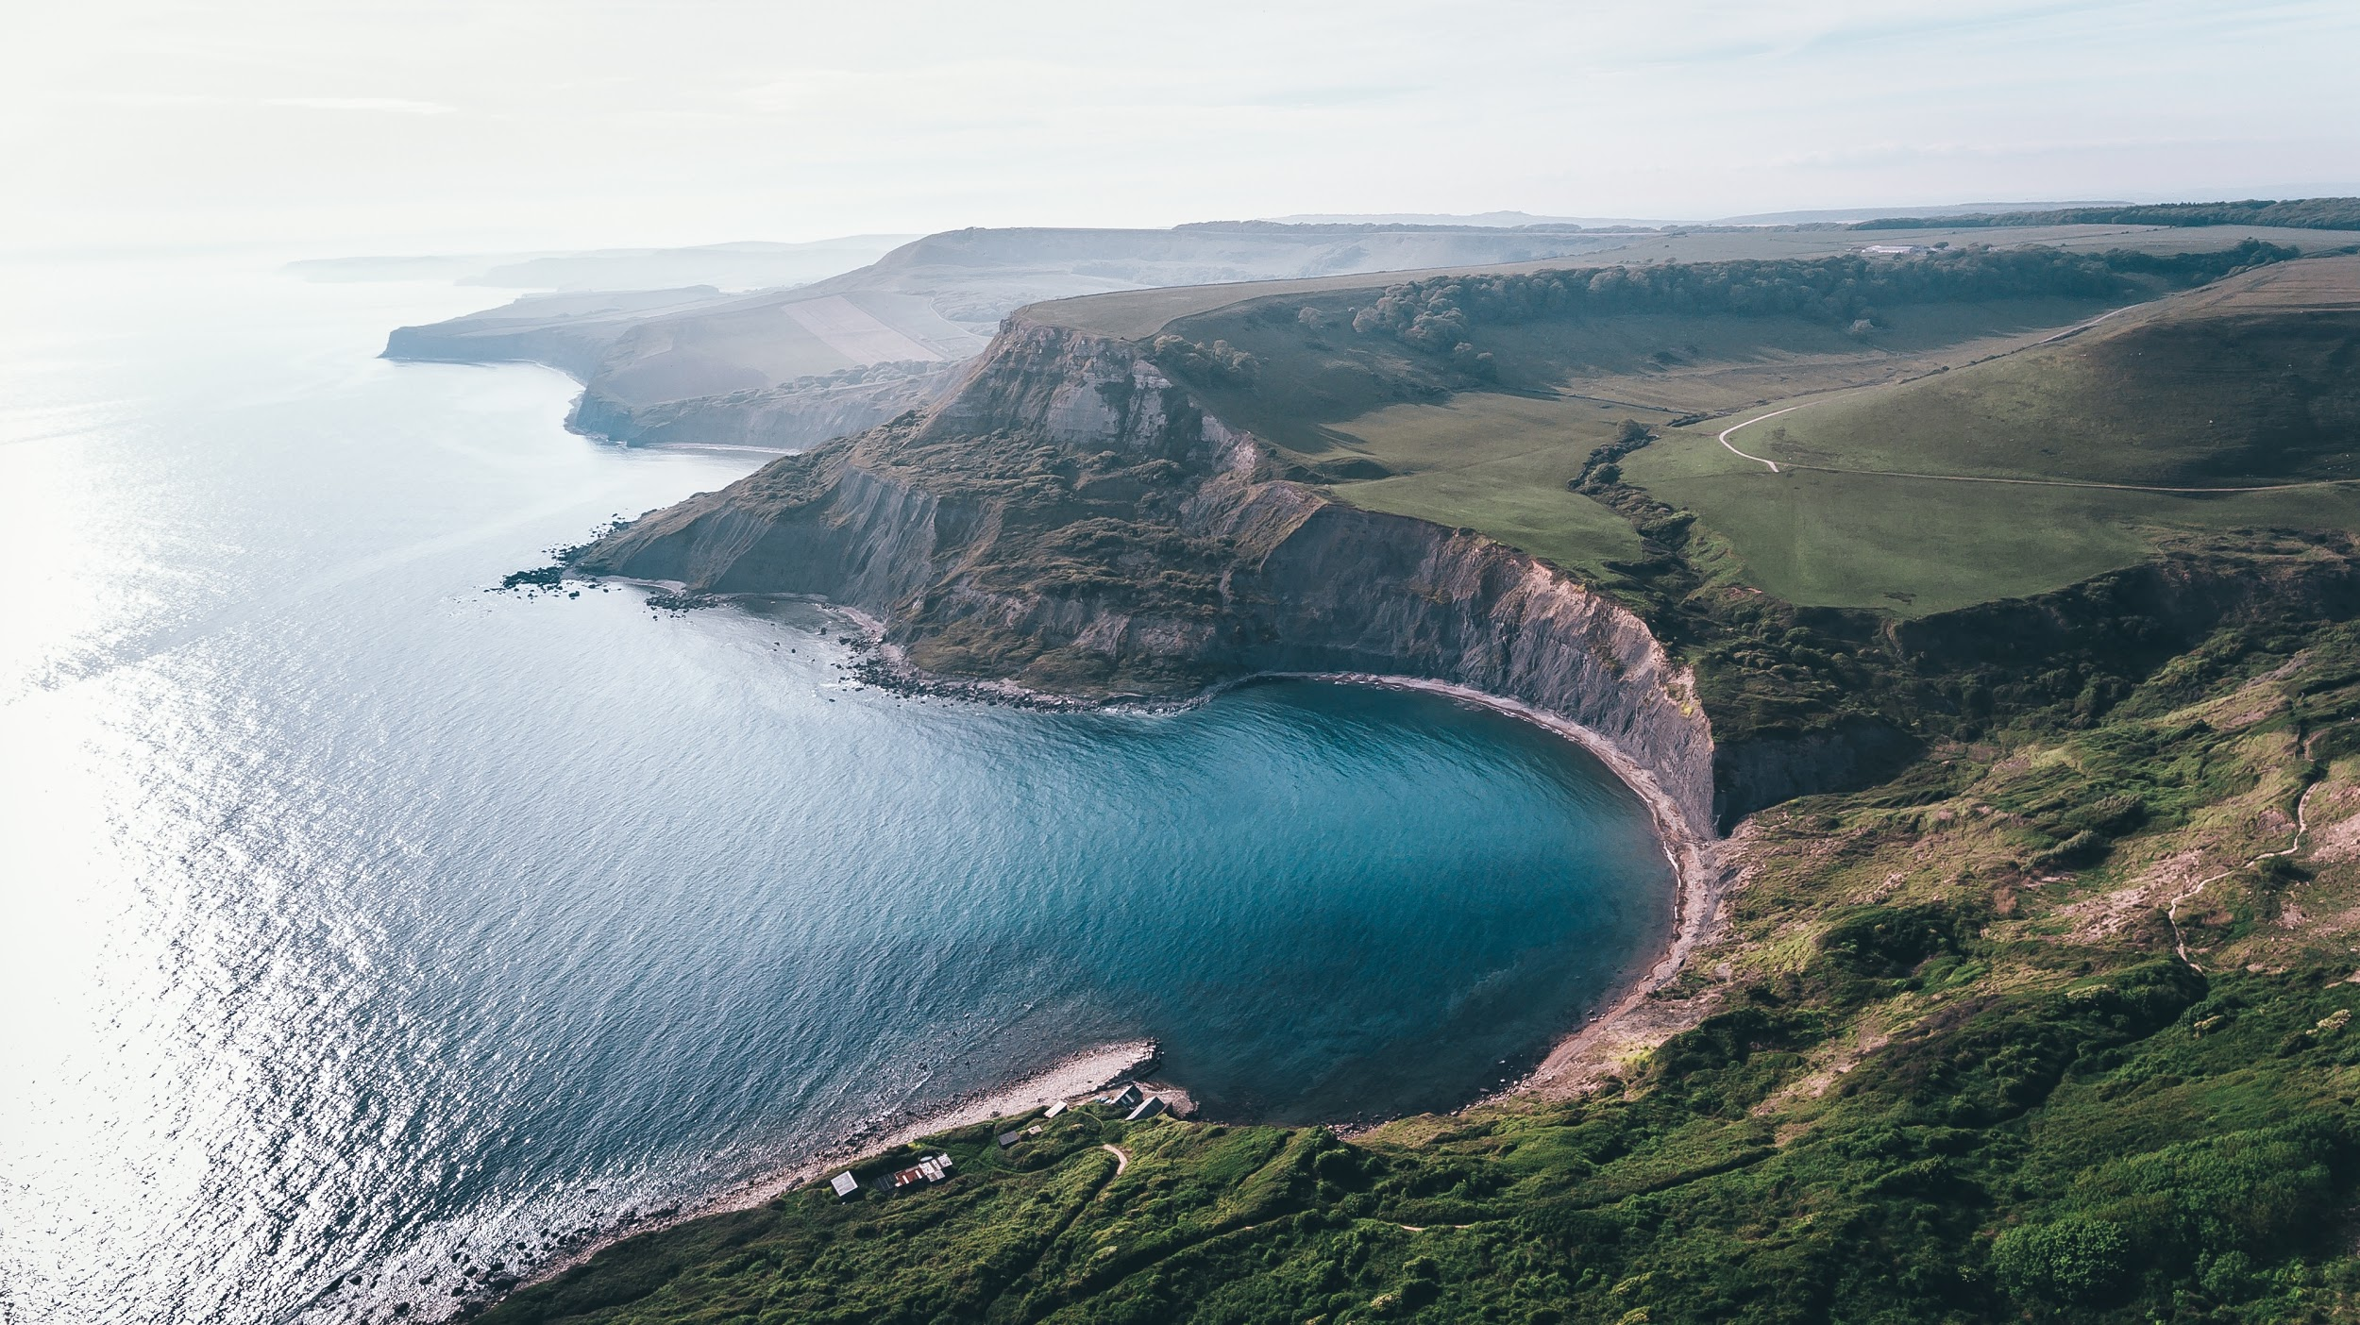

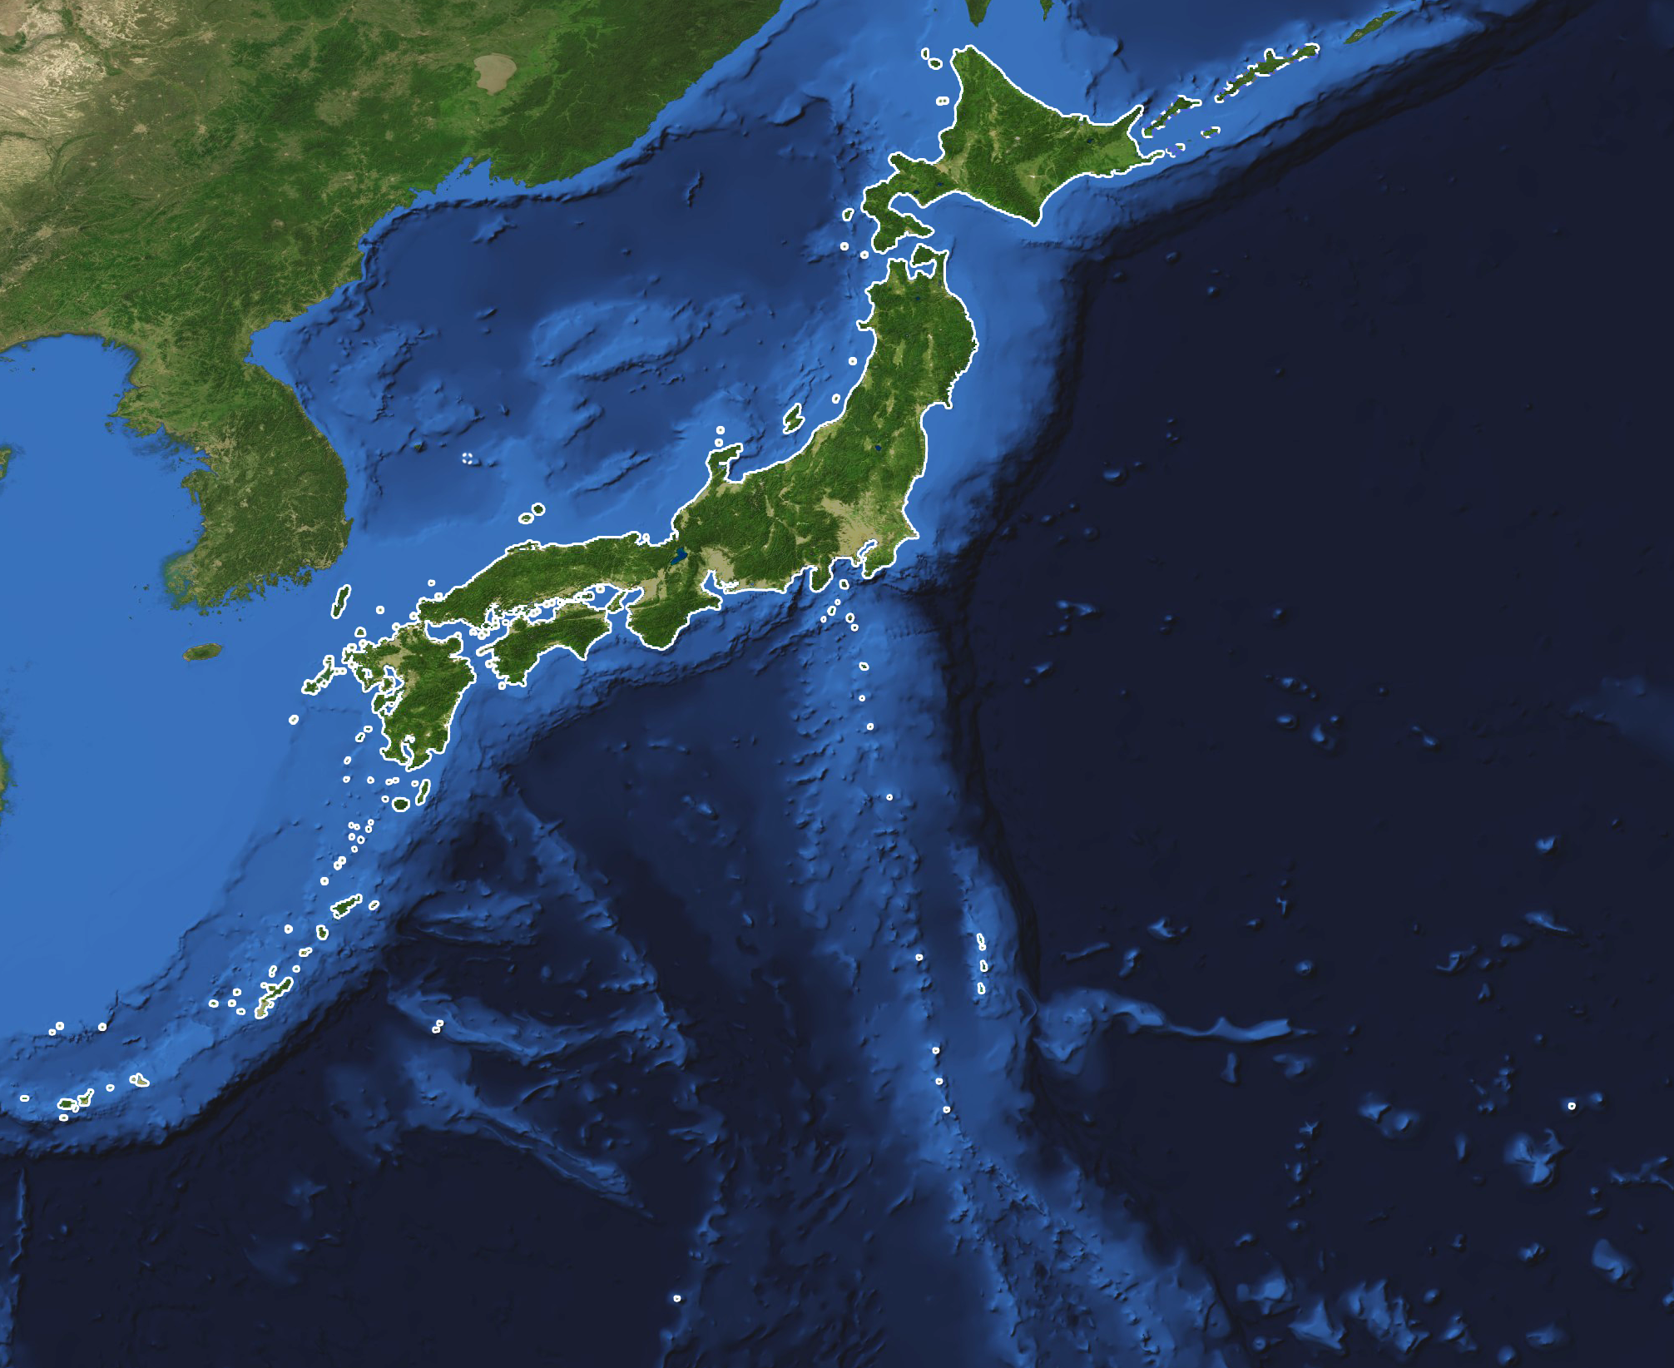
Delta: Land shaped like a triangle, where a river splits and spreads out into several branches before entering the sea.

Archipelago: Group of many islands

Plateau: Tall land with a flat-top and steep slope on at least one side
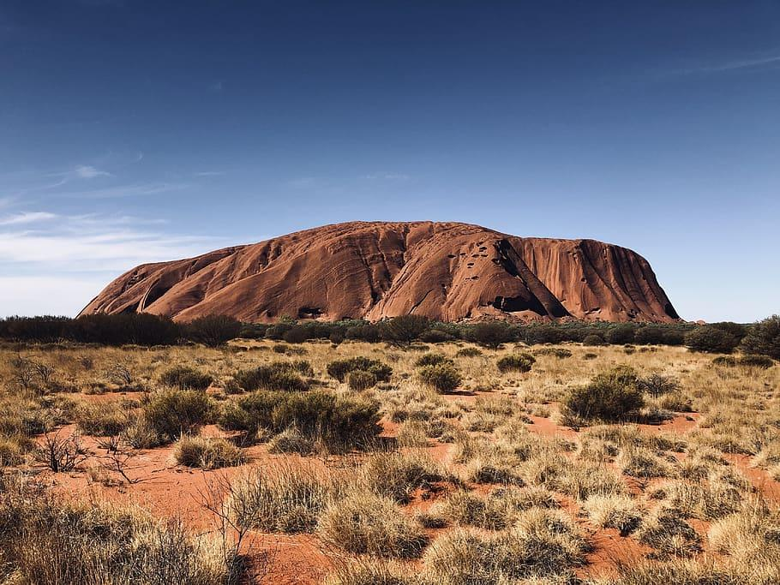
Plain: Area of flat land that doesn’t change much in elevation
