Specialist Challenges
Week 3: April 20th-24th

Art- ONE LINE DRAWING CHALLENGE!

Check out this video: https://www.youtube.com/watch?v=xaiUyI9OB5w

Line is an extremely powerful element of creating art. In the video we witnessed an artist creating various drawings using only ONE line. The word “contour” is French for the word “outline.” Here we will definitely be focusing on the outline while drawing. The rules here are pretty simple. Brainstorm an object, character, or scene that you would like to draw. Now imagine the outline. The goal this week is to create an awesome drawing using only one line!
**Once you put your pencil or pen to the paper you cannot lift the pencil/pen until the drawing is finished!

Feel free to try this as many times as you would like. It is a great exercise for improving our understanding of the art element line in our drawings. It might seem intimidating at first, but once you find a flow it is pretty fun. Things to think about: How much detail should you add? How long can you go without lifting your pencil/pen? 5 minutes? 10 minutes? 30?!

Here are some more examples:
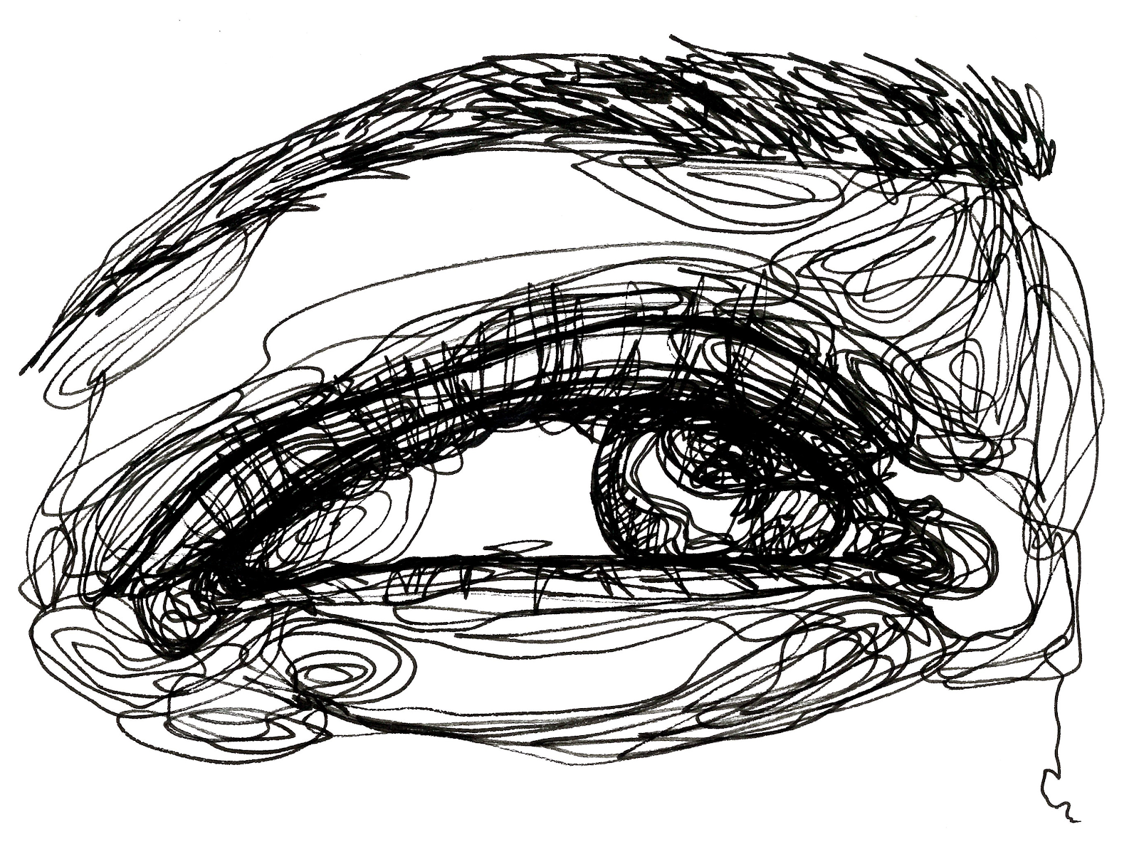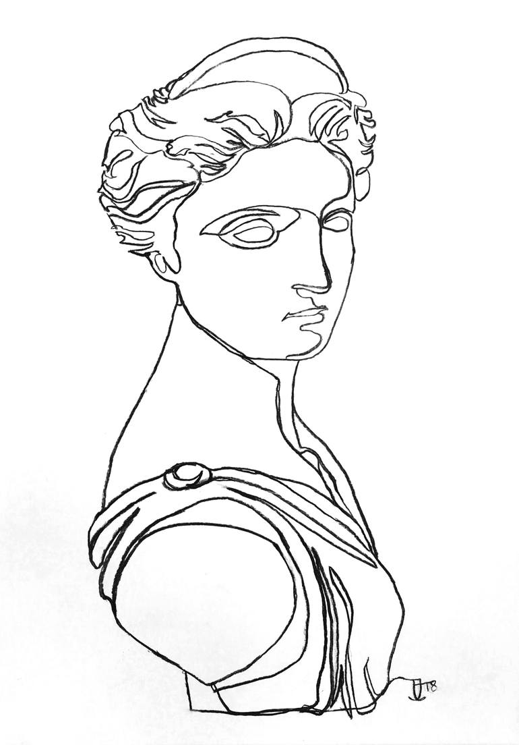

Music-

Turn something you have at home into a musical instrument and play along with your favorite song. Example: a metal or plastic pot, cereal box, coffee can, etc.

PE- Intro to PE class code: jvmbsnr
Rec class code: s27gukj
Extreme class code 5hdxwpe

Point to Point Challenge
Designate 2 points that work for your situation. Example Point A (bottom of the stairs) Point B (top of the stairs) / 2 points in your driveway / 2 points in your hallway / 2 points in your backyard (rock 1 and rock 2).
Once you have established these two points, move from point to point as many times as you can in 10 Minutes. You can move how you want to; Walk, Run, Jog, Sprint, Burpee etc. Keep track of your reps on a paper so you can challenge yourself each day this week.
Example: On Monday, I set 2 cones out in my driveway. In 10 minutes, I jogged between the 2 cones 84 times. My goal for Tuesday is 87. Once I jog Tuesday I make a new goal for Wednesday etc.
Important Reminder - When finished you should exhibit these signs: shortness of breath, sweating, elevated heart rate (120bpm or higher).
Extension- challenge a sibling, parent, pet. Make the points farther apart. Make the work time longer.
Have Fun and be Creative!

Leadership-
Are You A Role Model?
Ask yourselves these two questions: Who is a famous person or celebrity you view as a role model? Who is a person in your life you view as a role model? Remember, a role model is a person looked to by others as an example to be imitated. Now, what would the world be like if EVERYONE acted as if they were a person worthy of being imitated? Think of your words and actions in the following situations:
*In school hallways *In classrooms *Around younger students/family members * When you disagree with parents/guardians *As a fan/athlete at a sporting event *When you hear a rumor *When someone makes a mistake *When you are around special needs students *Out in the community

How will your words and actions affect other people? Are you proud of what you do and say when no one is looking? What positive things could you do, say, or believe in that would help to create a better school, home life, or community?

Legendary baseball player Roberto Clemente said, “Why be bad when you can be good? Improve yourself, your mind, your body, your spirit.”
- What do you think of the philosophy, “Why be bad when you can be good?”
- What are you doing to improve yourself? Your mind? Your body? Your spirit?

Library-
Your challenge is to think about the last book or movie you have seen, and change the ending. Rewatch the end of the movie and or read the last two chapters of the book. On a piece of paper rewrite the ending in two to three paragraphs. Remember to include:
- The character names
- Setting ( when and where the story takes place)
- Conflict (how was the problem solved, new version)
- Wrap up, how the new version of the story ends.
You may also add an epilogue, what happened after the story ended.

If you have any questions about the challenges or need to contact one of the specialists our contact information is below.
Band- Mr. Dietz- dietzr@eastmont206.org

Choir- Mrs. Vandersluis- vandersa@eastmont206.org

Art- Ms. Krause- krausel@eastmont206.org

Leadership- neffb@eastmont206.org

Health-Mr. Monahan- monahanj@eastmont206.org

STEM- Mr. Kane- kanet@eastmont206.org- Class Code- 7w5wrvk

Spanish- Mr. Vivanco- vivancoj@eastmont206.org

Library- Mrs. Heywood- heywoodk@eastmont206.org
Mrs. Kneadler- kneadlerk@eastmont206.org

PE- Mrs. Prazer- prazerkarli@eastmont206.org Class Code-jvmbsnr
Mr. Williamson- williaml@eastmont206.org
Mr. Halle- halleg@eastmont206.org

