Week 4: April 27-May 1
- Character Strong: Forgiveness and Honesty (still being developed)
  - https://curriculum.characterstrong.com/ver_secondary-videos-with-questions-week-4/
- Virtual Assembly, week 4:
  - https://curriculum.characterstrong.com/ver_virtual_assembly_respect/
- Student Character Workouts -
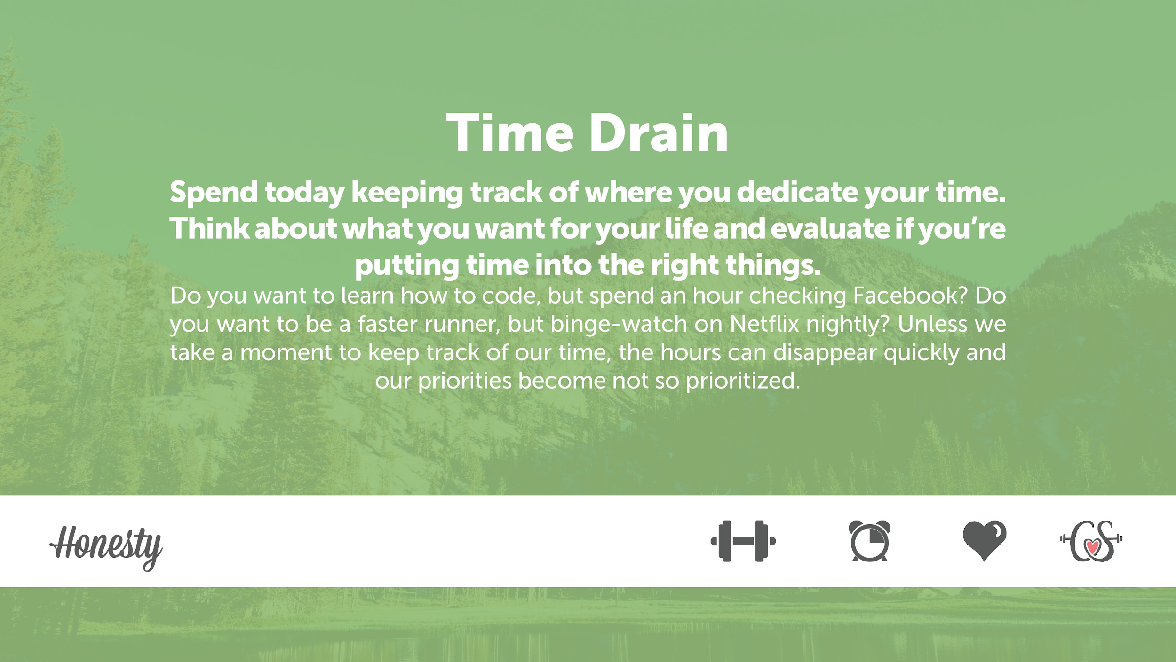
- Were you surprised by where the majority of your time was spent? Why or why not?
- Did where you spend your time align with your life goals? Why or why not?
- Did pausing provide you a new perspective?
- What was the most challenging part of this dare? Why?

- Family Character Workouts -
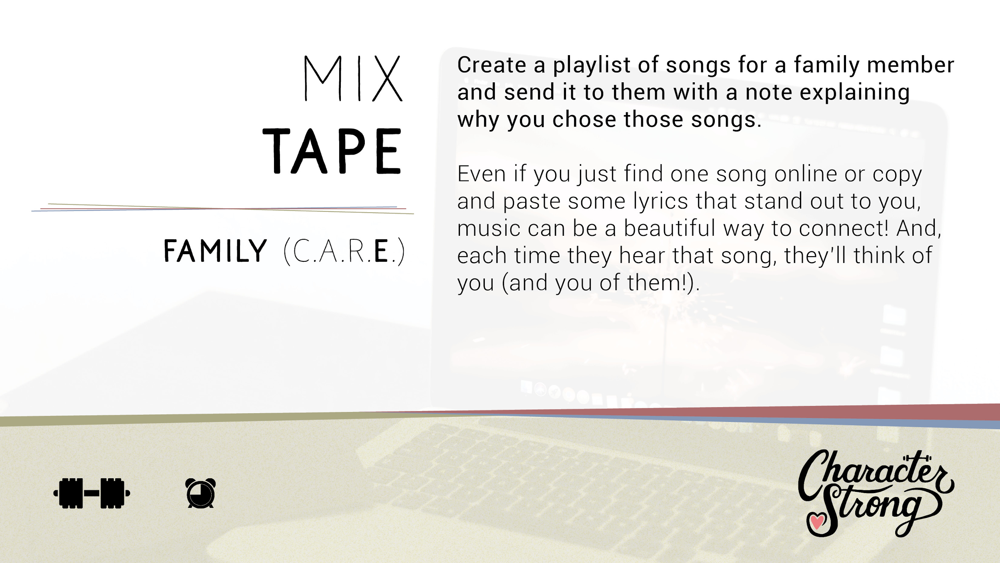

RESOURCES:

Kindness Journal: https://characterstrong.lpages.co/educator-resources-landing-kindness-journal/?inf_contact_key=b501df6d2d573e9e22d46ab5ec4d9db7680f8914173f9191b1c0223e68310bb1

Character Strong YouTube:
- Access to all Character Strong videos
- CharacterStrong

Character Strong FaceBook
- CharacterStrong - Home

Character Strong Instagram
- Follow Character Strong on Instagram: CharacterStrong 💓💪🏽 (@characterstrong)
  - Post your Kindness Journals
  - View how others are using Character Strong to expand their social emotional knowledge and skills

