English Language Arts Challenges
Week 4: April 27th - May 1st
Students, get ready to be challenged! Start by choosing the level that you feel comfortable with and then continue to challenge yourself by going up to another level! When you are finished, feel free to share on your school's Facebook page, with your teacher on Google Classroom, or to family members and friends.
Log into Freckle and check your ELA backpack to complete your assigned work, the icon will appear on the Freckle home page.
My Oh...My Oh….
What have you been
reading? This week we want you to continue to get onto myON and read! Make sure you are trying to read each day and let your teachers know what you find good and interesting.
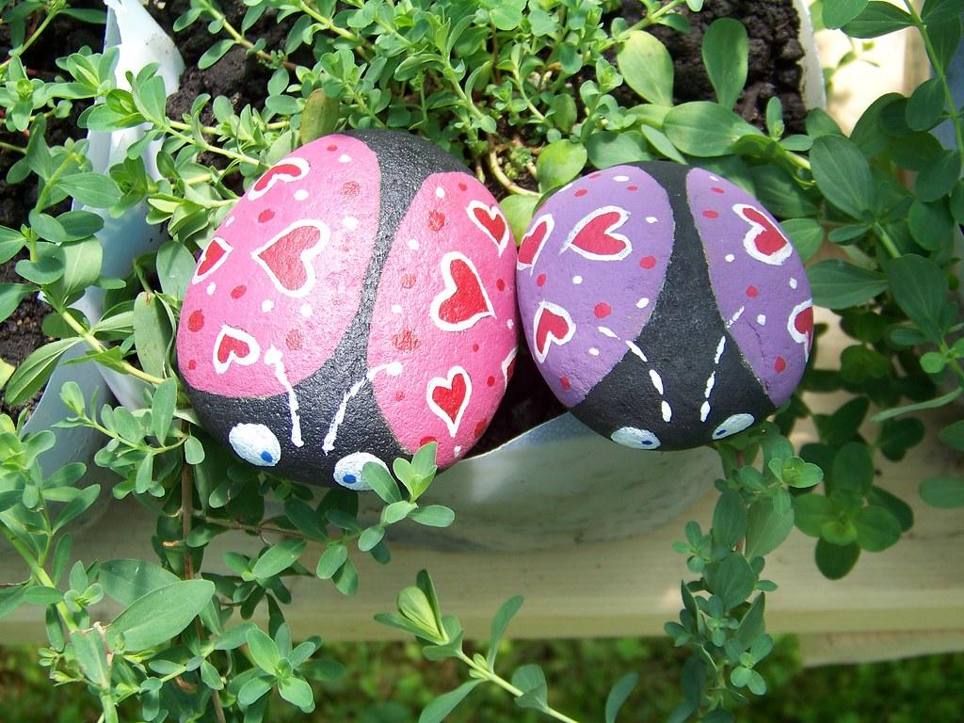
Pet Rock Creation....
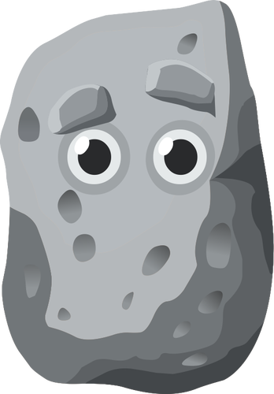
Level 1: Create a pet rock. Paint or color a rock to create a creature. Give your pet rock a name and *personality. Write a brief description about your pet rock.
Level 2: Create a pet rock. *Interview your pet rock by writing 5-10 questions and *responses you believe it would give.
Level 3: Create a pet rock. Write a short story describing the life of your pet rock.

Hints and explanations:
*personality: the way a person is: honest, happy fun
*interview: ask questions
*responses: answers

