Eastmont Math Challenge
Week of 4/27- 5/1

This handout is for all Eastmont Intermediate students. Each week a handout similar to this one
will be available to students. As you work through the problems, work independently but feel free to use online resources if you need help (khan academy or google). This handout is one component of your math activities. The other component is Freckle math. You are encouraged to progress through the Freckle activities as well. Check your google classroom daily for possible updates from your teachers. *Answer keys for handouts will be available the following week.

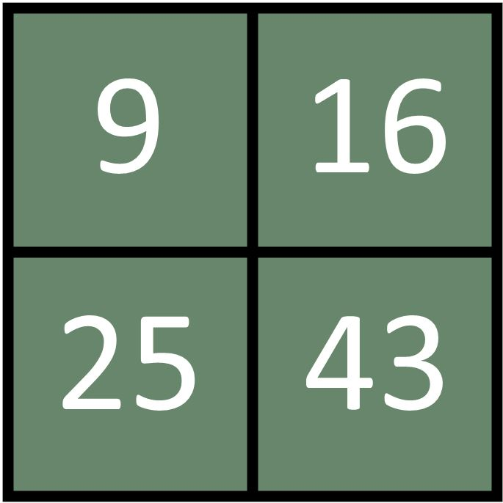
Which One Doesn’t Belong?

Which one doesn’t belong and WHY?
There can be many answers. How many answers and explanations can you find?

The Cougar Clothes store at the mall has four employees (Alexandra, Lauren, Cameron, and Daniel). This week they worked 19, 21, 37, and 34 hours. The employees at Cougar Clothes are paid by the hour. Each employee is paid at a different hourly rate ($14.34, $14.38,$14.33, and $14.83).

Figure out how many hours each employee worked this week and their hourly pay.

1. Lauren had the largest paycheck for the week.
2. This week, Lauren worked the most number of hours.
3. The employee that worked thirty-four hours this week, worked forty-two hours last week. Last week, the employee earned $114.64 more than the amount the employee earned this week.
4. Daniel worked less than thirty-four hours this week and earned the second least amount of money per hour.
5. Cameron earned $311.43 this week.
6. Cameron earns the most amount of money per hour.

Alexandra worked _____ hours and was paid ________ hourly.
Lauren worked _____ hours and was paid ________hourly.
Cameron worked _____ hours and was paid ________hourly.
Daniel worked _____ hours and was paid ________hourly.

Solve each division problem. If you need help, look in the hints section (no calculators).
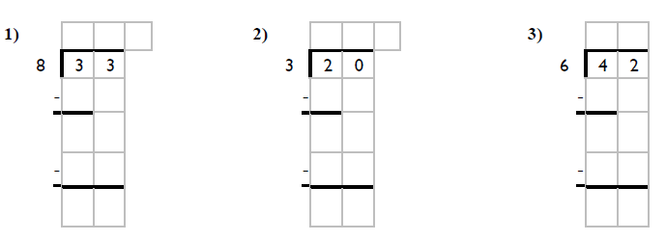
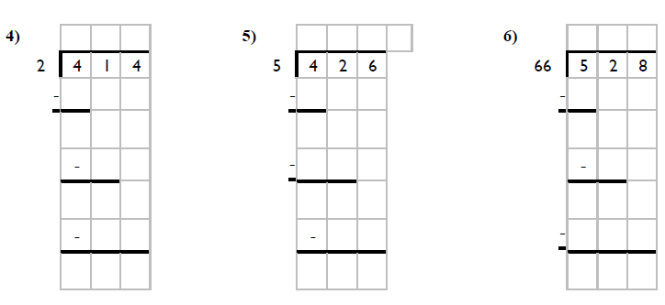
Answers to Division Problems 1. _____ 2. _____ 3. _____ 4. _____ 5. _____ 6. _____

----------------------------------------------------------------------------------------------------------------------------

Complete each pattern. Write what the rule is.
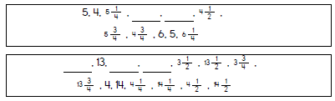

**Helpful Hints:**

Which one doesn’t belong?
This question has a lot of possible answers, just explain why you picked the number you picked!
- What do they have in common? Is there a number that looks different?
- What happens when you add or subtract certain numbers? Do any of them create a number family? Think about skip counting, factors, even and odd numbers!
- Think of a “rule” that all of the numbers (except one) follow.

Cougar Clothes Store
Not sure where to start? You can make a table to help organize the information!
- We know the names: Alexandra, Lauren, Cameron, Daniel
Hint #2 says Lauren worked the most number of hours, so she must have worked 37.
Hint #6 says Cameron earns the most amount of money per hour, so he must make $14.83
Hint #5 says Cameron earned $311.43 this week, since we know he maes $14.83, you can divide to find his hours worked! 311.43 14.83
Carefully read the rest of the hints to sort out the hours and rate, you may need to add, divide, or multiply. You can use the guess and check strategy to see if your answers work!
- We know 4 different amounts of hours: 19, 21, 37, 34
- We know 4 different hourly rates: $14.34, $14.38,$14.33, $14.83

Names | Hours Worked | Hourly Rate
Alexandra
Lauren | 37
Cameron | ___ hours | $14.83
Daniel

**Division** Steps: Divide, Multiply, Subtract, Bring down
