Eastmont science challenge: Week 4 (April 27-May 1)
Invent an Insect
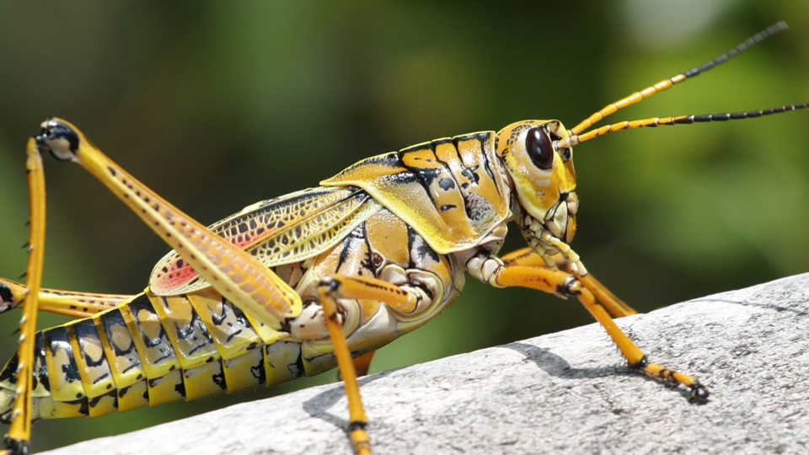
"Grasshopper" by Ryan Wood
There are thousands of species of insects in our world, and each have adapted to survive in their habitat. In this activity, you will learn what an insect is and what some of their adaptations are. Then you will put your knowledge into play by "creating" an insect that is adapted to live in their assigned environment.
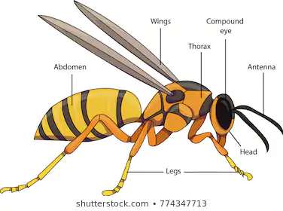
Insects have structures to help them survive.

Level 1: Label the structures on the diagram in the boxes below.

Structures (body parts):

1. | 2. | 3. | 4. | 5. | 6.

Level 2: Living things have structures that help them survive in different habitats. Watch the video to find out more.
Why are there so many insects?

Insects that live in different habitats will have different structures to help them survive. Imagine that you were going to invent an insect.
Think of a structure (body part) that would help an insect survive in this habitat. It can be real or made up. Describe it in the box below.

Think of a structure (body part) that would help an insect survive in this habitat. It can be real or made up. Describe it in the box below.

Think of a structure (body part) that would help an insect survive in this habitat. It can be real or made up. Describe it in the box below.

Level 3: Invent an insect of your own or find an insect living near your home.
Watch this video for inspiration:
Weird insects from around the world

Which weird insect in the video was your favorite?

Why?

Choice #1: Invent a new species of insect that is specially adapted to live in our habitat. Draw a picture of that insect and label at least 10 structures (body parts) and tell how those structures help the insect survive. Take a picture of your insect drawing and paste it in this section of the assignment. Be sure to name it!

Choice #2 Go outside and find an insect. Name 4 structures that are found on this insect that help it survive in its environment. Be sure to tell how they help. If you know that name of the insect, please share. Try to take a picture of the insect and attach it in the box below.

4 structures of this insect and how they are used are:
Structure:  Use: | Structure:  Use: | Structure:  Use: | Structure:  Use:

Name of your insect:

Picture if you can get one: How to take a picture and share it using a Chromebook

HELPFUL HINTS

*Invent = Create or make.

*Species = The same kind of living thing. 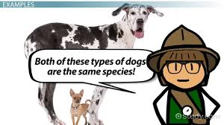
*Adapted/Adaptations = Changing to fit into your environment better. 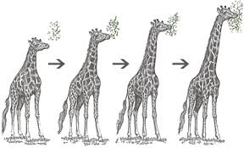

*Survive = To keep living. Not dying. 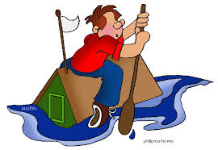

*Habitat = A living thing’s home. 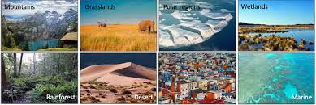

*Structure = Something that is built. 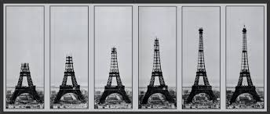

*Diagram = A drawing.
*Describe = Talking about something using details.
*Inspiration = A great idea!

