Specialist Challenges
Week 4: April 27th-May 1st
(The subject areas for Specialist Challenges will rotate weekly)

STEAM- Mr. Kane (kanet@eastmont206.org)We’re on a Roll this Week! Sustainability is important, and this week we challenge you to showcase your Tech & STEM skills to reuse materials at home in a new way. Show us something new that you created with something recycled – specifically, your design must include the cardboard center of a toilet paper roll , or paper towel roll. We know there are a few of these around! Are you ready to give it a try? Can include recycled bottles, cans, etc. as well.
This week’s challenge: build your own cardboard roll design – get creative.
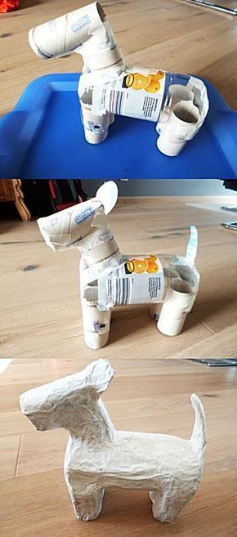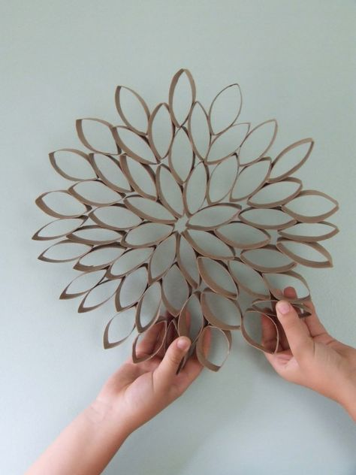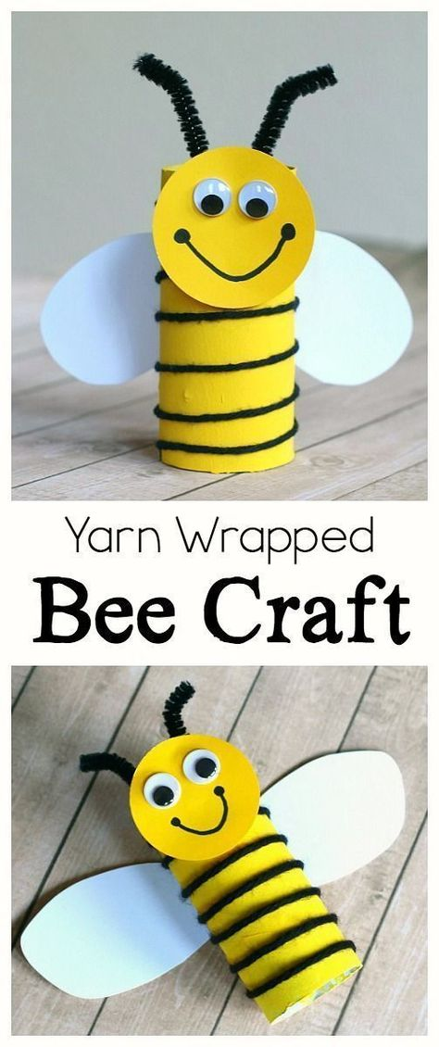

Music

See if you can find 6 different wood sounds from around your house. Use your favorite wood sound to tap a steady beat (or a fun rhythm!) while listening to a song you like.

PE

Directions: There are many options for you to complete a workout each day. Below are a couple of suggested options to keep you active during your time away. If you would rather, please share with us how you are staying active for 30 minutes each day. We would love to hear of other beneficial resources (apps, videos, workouts) you like!

HASFit Videos to get you up and moving. There are two different intensity levels represented in the videos. Feel free to select the one that suits you best. If you have trouble opening these links, you can find them on Youtube.

Daily - 15 minute Basic Cardio Workout
https://hasfit.com/workouts/home/easy-beginner/15-minute-low-impact-cardio-workout-for-beginners/

Monday - 20 minute Arms and Cardio workout (no equipment)
https://hasfit.com/workouts/home/cardio-aerobic/20-min-hiit-cardio-and-arms-workout-without-equipment/

Tuesday – 35 minute Leg workout (no equipment)
https://hasfit.com/workouts/body-weight-training/at-home-butt-and-thigh-workout-no-equipment/

Wednesday - 10 minute Ab workout
https://hasfit.com/workouts/home/ab/10-minute-abdominal-workout/#

Thursday – 30 minute upper body workout (no equipment)
https://hasfit.com/workouts/home/body-weight/no-equipment-upper-body-workout/

Friday – 30 minute (Flexibility workout)
https://hasfit.com/workouts/warm-up-cool-down-stretches-stretching/30-minute-full-body-stretch-routine/

Spanish-Mr. Vivanco(vivancoj@eastmont206.org)

Health-Mr. Monahan-(monahanj@eastmont206.org)

The health challenge is to take weather terms and use them as an analogy for how you are feeling. In example if you were happy you would equate that to being sunny. Use at least the 4 main descriptions of weather (Sky, Temperature, Precipitation, and Wind) to translate your emotions. You may create this assignment any way you want with computer generated emojis or by writing and drawing. Make sure you tell why you feel the way you do.

To see the Google slides and an example go to the Health Google classroom zp5orsw.
or
https://docs.google.com/presentation/d/12ZjgWKGs9S9m8Xp9RhSG3zi0bQRSjp4zwnAEY2_3Pxw/edit#slide=id.g836513d7bb_0_108

If you have any questions about the challenges or need to contact one of the specialists our contact information is below.

Band - Mr. Dietz
dietzr@eastmont206.org

Choir - Mrs. Vandersluis vandersa@eastmont206.org

Art - Ms. Krause
krausel@eastmont206.org

Leadership - Mrs. Neff
neffb@eastmont206.org

Health - Mr. Monahan
monahanj@eastmont206.org

STEM - Mr. Kane
kanet@eastmont206.org

Spanish - Mr. Vivanco
vivancoj@eastmont206.org

Library- Mrs. Heywood & Mrs. Kneadler
heywoodk@eastmont206.org
kneadlerk@eastmont206.org

PE- Mrs. Prazer - prazerkarli@eastmont206.org: Intro to Fitness Class Code: jvmbsnr
Mr. Williamson - williaml@eastmont206.org
Mr. Halle - halleg@eastmont206.org

