English Language Arts
Week 6 : May 13th-May 20th
Students, get ready to be challenged! Start by choosing the level that you feel comfortable with and then continue to challenge yourself by going up to another level! When you are finished, feel free to share on your school's Facebook page, with your teacher on Google Classroom, or to family members and friends.
You Are a Music Producer
You are a music producer who is looking for the
next great songwriter.

Level 1: Go to www.azlyrics.com and read the* lyrics of your favorite song to a family member or friend.

Level 2: After you have found the lyrics to your favorite song, write another verse to the song. Make sure it fits the *theme of the song.
Level 3: Compare and Contrast Songs
You can either listen to these songs, or print out the lyrics to *compare/*contrast in your own Venn Diagram.
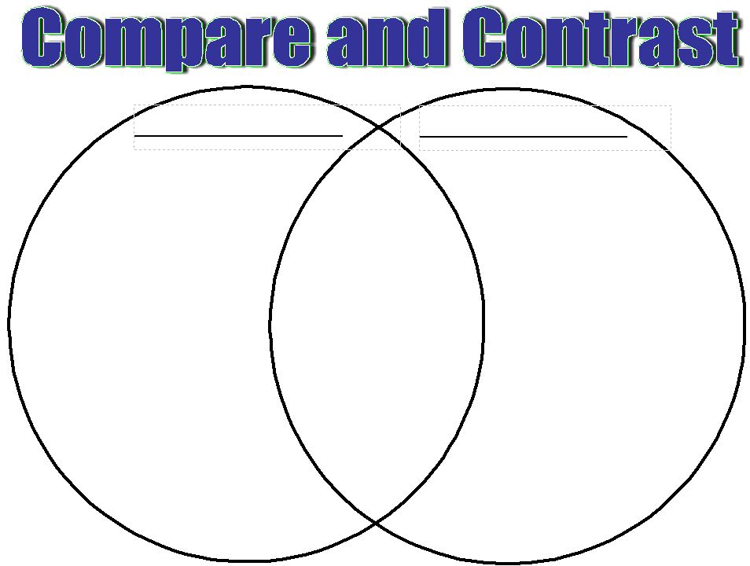
  - "Mean" by Taylor Swift vs. "Roar" by Katy Perry

*Hints and Explanations:
Accessed- where you got it and how they can get it.
Hardcopy: actual book
Lyrics: words to the song
Theme: idea
Compare: things that are the same
Contrast: Things that are different

