Eastmont Math Challenge
Week 6: 5/11-5/15

This handout is for all Eastmont Intermediate students. Each week a handout similar to this one
will be available to students. As you work through the problems, work independently but feel free to use online resources if you need help (khan academy or google). This handout is one component of your math activities. The other component is Freckle math. You are encouraged to progress through the Freckle activities as well. Check your google classroom daily for possible updates from your teachers. *Answer keys for handouts will be available the following week.
-----------------------------------------------------------------------------------------------------------------------
MULTIPLY (show work)

 | 1 | 6 |  |  |  | 5 | 3 |  |  |  | 4 | 6 |  |  |  | 7 | 2 |  |  |  | 6 | 7
x | 1 | 1 |  |  | x | 2 | 3 |  |  | x | 3 | 9 |  |  | x | 4 | 8 |  |  | x | 8 | 5

Salamander Squares Decimal Puzzle
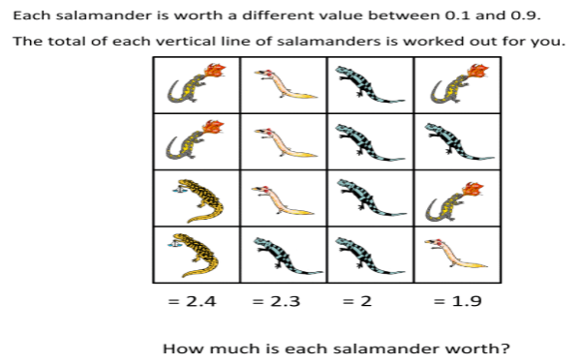

6. 7. 8. 9.
= ____ = ____ = ____ = ____
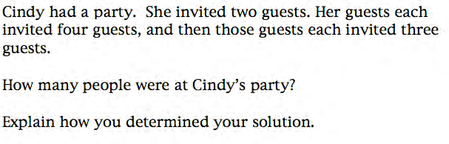
10) ____ people were at Cindy’s party. I found my answer by
___________________________
___________________________.

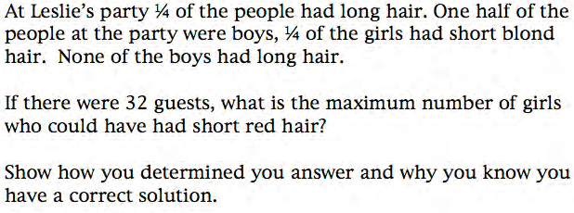

11) The maximum number of girls who could have short red hair is ________________ because ___________________
___________________________
___________________________.

Factors and Multiples
The greatest common factor (GCF) of two or more numbers is the greatest of the common factors of the numbers. The smallest number that is a multiple of two or more whole numbers is the least common multiple (LCM) of the numbers.

Find the GCF of each set of numbers.
12) 6, 12 ____ 13) 28, 42 ____ 14) 44, 55 ____ 15) 35, 20, 15 ____

Find the LCM of each set of numbers.
16) 5, 6_____ 17) 6, 8_____ 18) 4, 10 _____ 19) 15, 12 ____

Simplifying Fractions
A fraction is simplified if the numerator and denominator have no common factors.
Simplify the fractions below by dividing the numerator and denominator by the GCF.
*You can type your answer where the question marks (?) are*

20) $\frac{6}{12}$= $\frac{?}{?}$ 21) $\frac{44}{55}$ = $\frac{?}{?}$ 22) $\frac{28}{42}$ = $\frac{?}{?}$ 23) $\frac{48}{54}$ = $\frac{?}{?}$

24) MARBLES Julio bought 12 new marbles, bringing his total number of marbles
to 72. What fraction, in the simplest form, of Julio’s marbles are new?
Answer _______

**Helpful Hints**
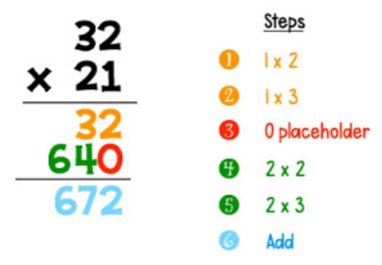
Multiplication
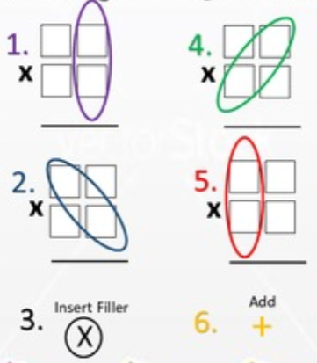

Salamander Squares
Vertical line: top to bottom, a column
Salamander: an animal, they look like slimy lizard
Start with the whole 3rd column is made of this salamander! We know the 3rd row = 2 There are 4 salamanders so we can divide 2$÷$4 = .5
So equals .5
You can plug that in wherever you see a

Next try the column 2 has one salamander worth .5 and three the total for the column is 2.3, start by subtracting the .5 now divide the rest by the 3 remaining salamanders.
Use the same method to find the in column 4.
Party Time
Guest: a person going to your party
Invite: asking someone to come to the party
Maximum: the biggest possible number that will answer the question

Try drawing a picture! Label to help you keep track.

Cindy’s party: Draw her two guests, they each get 4 more, each of those people bring 3 more!

Leslies Party: We want to find: girls with short red hair, draw all 32 of the people (or circles) start crossing off people that don’t fit the criteria, start by crossing off the half that are boys!
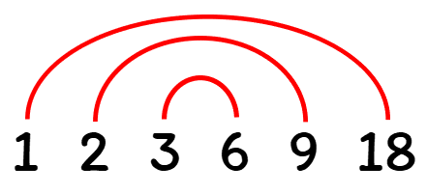
Factors and Multiples

Factor: numbers that can be multiplied to get the larger number. Look at the factor rainbow for 18.

Multiple: think skip counting
The Multiples of 5 are: 5, 10, 15, 20, 25…

Greatest: biggest number

Least: smallest number

Common: the same

Example 1: Find the Greatest Common Factor (GCF) of 12 and 30.
- Make an organized list of the factors for each number.
- Circle the common factors
- Identify the bigglet factory they share
The biggest factor they share is 6. So, the GCF of 12 and 30 is 6.

Example 2: Find the Least Common Multiple (LCM) of 6 and 15.
- List the multiples of each number.
- Identify the common multiples
- Find the smallest multiple they share

Multiples of 6: 6, 12, 18, 24, 30, 36, 42, 48, 54, 60, …
Multiples of 15: 15, 30, 45, 60, …

30 and 60 are common multiples of both numbers.

The smallest multiple they share is 30. So, the LCM of 6 and 15 is 30.

