Eastmont Intermediate Schools Social Studies Challenge
Week 6: May 11th - 15th

Background: In the Week 5 challenge we learned/reviewed that Washington State is one of 50 states in a democratic republic where we elect people to be “us”. In order to join the union (USA) each of the 50 states has to adopt a state constitution that is modeled after the United States Constitution. The framework for how we govern our states must be modeled after that document, thus we have three “branches” of government which is different from “levels” of government. Two of this week’s challenge games deal with this concept.

- Option 1 Create a brochure of a city in Washington. You can choose to use this link: City Brochure or, you can use what is shown at the link to make your own using pencil and paper. Think about where you would like to go, what you like to do or maybe research a city you have never been to.
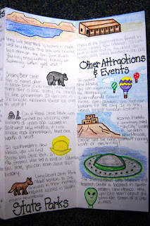

- If you choose Option 2 you play the game “Branches of Power” in iCivics where you have to learn how the three branches of government have to work together.

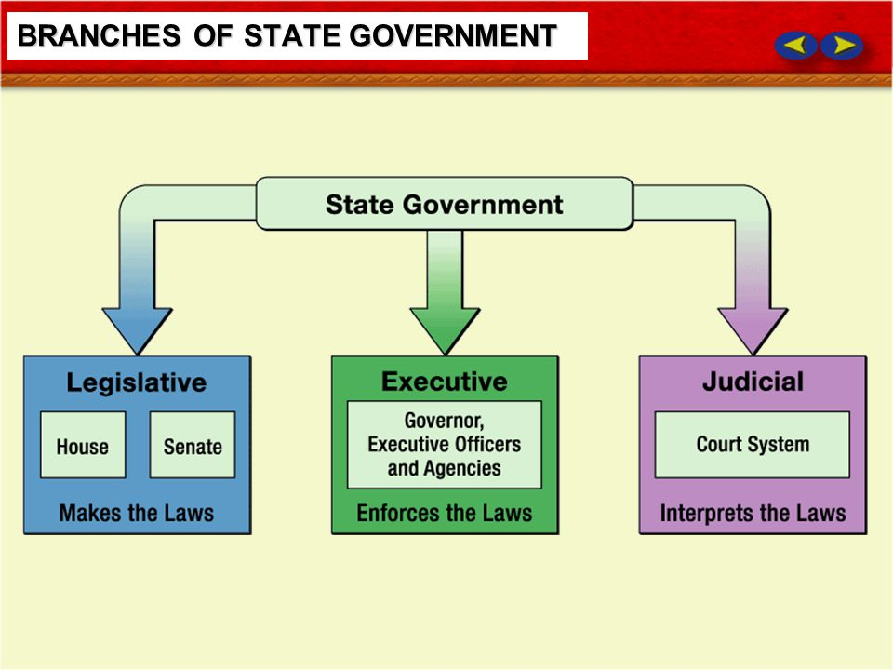
iCivics - Branches of Power
https://www.icivics.org/games/branches-power
Branches of Power help guide: https://drive.google.com/drive/search?q=icivics
- If you choose Option 3, you play the game “Counties at Work” in iCivics. In this game you are a newly elected county official and you need to interact and work with the people of your county to make the county function.
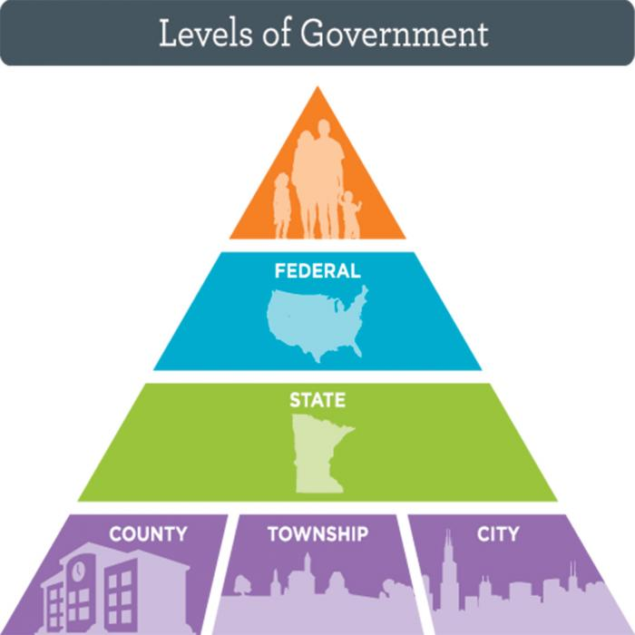

iCivics - Counties at Work https://www.icivics.org/games/counties-work

Counties at Work help guide: https://drive.google.com/drive/search?q=icivics

