Eastmont Science Challenge Week 6: May 11th-15th
Computer *Modeling of Energy *Transfers

Level 1: Use a computer model to explore energy transfers.

Step 1: Click here to go to the skate park.

Step 2: Click on “intro.”

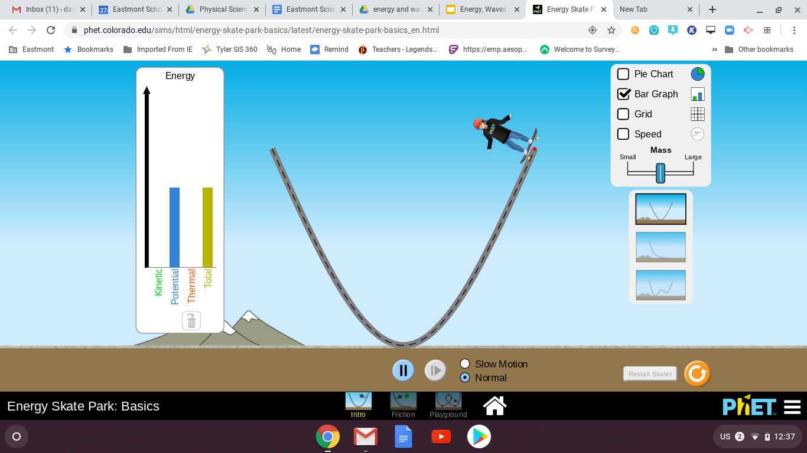

Step 3: Click “bar graph” and put the skater on the ramp.
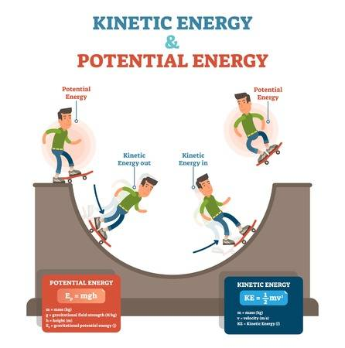

The skater on the ramp is *considered a “system.” The amount of energy in a system will stay the same, however the types of energy in a system might change.

*Potential energy is the energy of position and kinetic energy is energy of motion.

Step 4: Answer these questions.
What do you notice about the energy? When the kinetic energy is high where is the skater on the ramp?

When the potential energy is high where is the skate on the ramp?

What do you notice about the total amount of energy in the system?

Try all 3 ramps. You should notice the same relationship in the potential and kinetic energy in all three ramps.

Level 2: Add friction to your system.
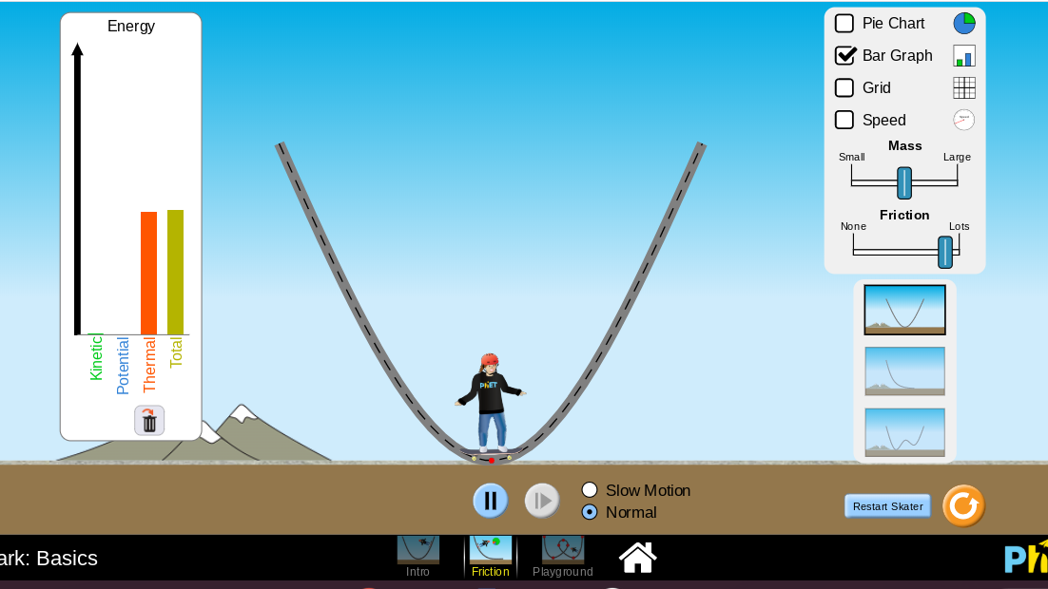

On the bottom of the screen, choose the ramp marked “friction.” Be sure to turn on your bar graph and increase the amount of friction like shown in the picture.

You should notice another type of energy. Friction creates heat, known as thermal energy. That is why your hands get hot when you rub them together.

When the skater is first put on the ramp, what type of energy is the highest?

At the end of the ride, which type of energy is the highest?

Change the mass of the skater to low. Watch the amount of thermal energy. Change the skater’s mass to high. Watch the amount of thermal energy. How does the amount of thermal energy change as the mass of the skater increases?

The amount of thermal energy _______________________ (increases, decreases or stays the same) when the mass of the skater increased.

Try the skater in all 3 ramps. How does adding friction affect the speed of the skater?

Level 3: Make your own skate park.
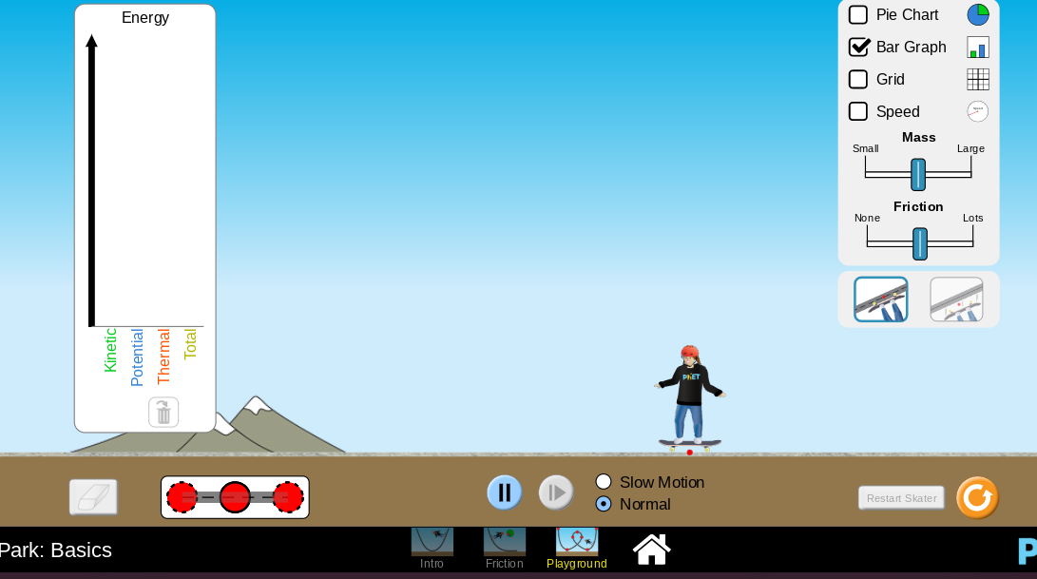
Choose “playground” at the bottom of the screen and select the bar graph.

Start putting sections together to make a ramp or ramps for your skater.

Can you create a skate ramp (a system) that keeps the skater going from kinetic to potential energy and back again?

In other words, can you get the skater to end the ramp and start again automatically.

After you made your own skatepark you can describe it in the box below. Tell how many sections of ramp you used, how many jumps or inclines you have, etc.

Describe:

Or

You can screenshot your screen to show the finished skate park. (To screenshot with a chromebook press control + button above 6 and with other computers it is by pressing the “print screen” button) Paste the screenshot in the box below.

Screenshot:

*Helpful Hints:

*Modeling: a drawing to show a 3D object | 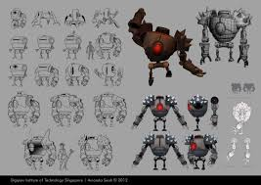
Transfers: move from one thing to another | 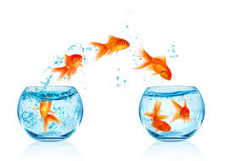
*Considered: to believe that
*Potential: maybe turn into | 