STERLING SCHOOLWIDE PLAN
Title 1 Part A - Schoolwide Plan
Chris Hall, Principal 2019-20

Planning Team
Name of Team Member | Position/ Representation
Erica Alexander | HomeField / RTI
Chris Hall | Principal
Debbie Ramos | 600 Wing Team
Rachel Browning | 500 Wing Team
Anna Rankin | 100 Wing Team
Nancy Hazenbihler | Facilitator 5-7 RTI
Amy Schall | K-4 Team
Christy Rolfs | Secretary
Kim Sebastian | Paraeducator
Dave Dewitt | Math Chair
Vicki Robins | Read Chair
Travis Kane | Science Chair
Mark Koley | SS Chair
Gerald Halle | Specialist Chair
Joel Barnes | Writing Chair
Kevin Newell | Behavior RTI
COMPREHENSIVE NEEDS ASSESSMENT
The school-wide team met weekly throughout the school year to conduct a needs assessment. Data was taken from State Report Card, District Assessments, Surveys, and Tyler Student Records. The team presented the needs assessment to the School Board in a public meeting in April.

Demographics
Enrollment (All Students) Enrollment (By Program)
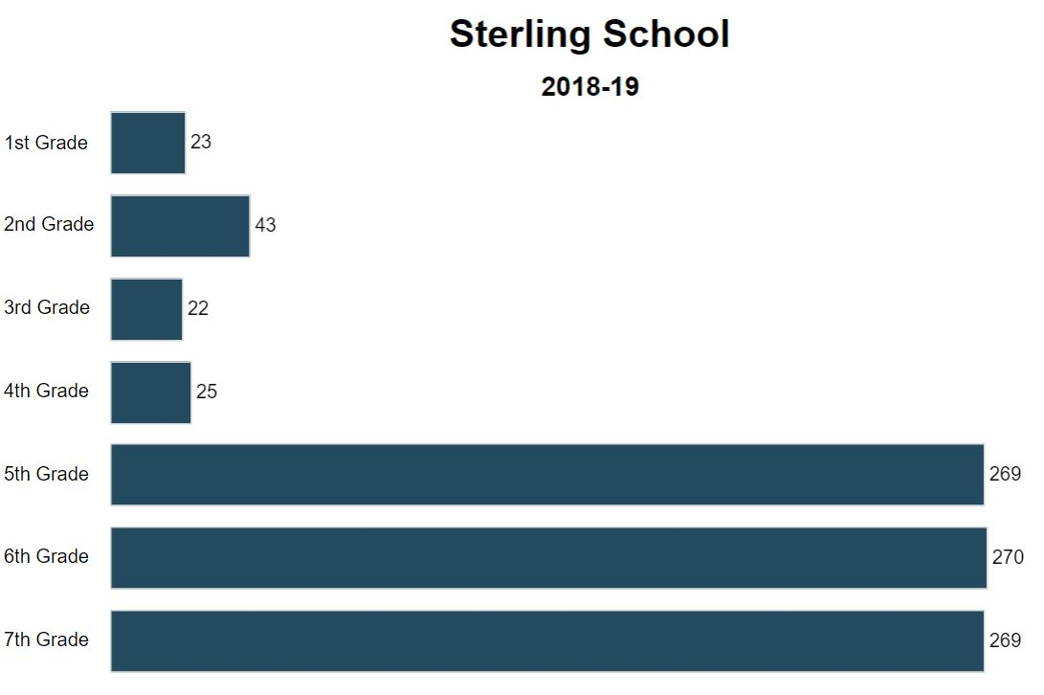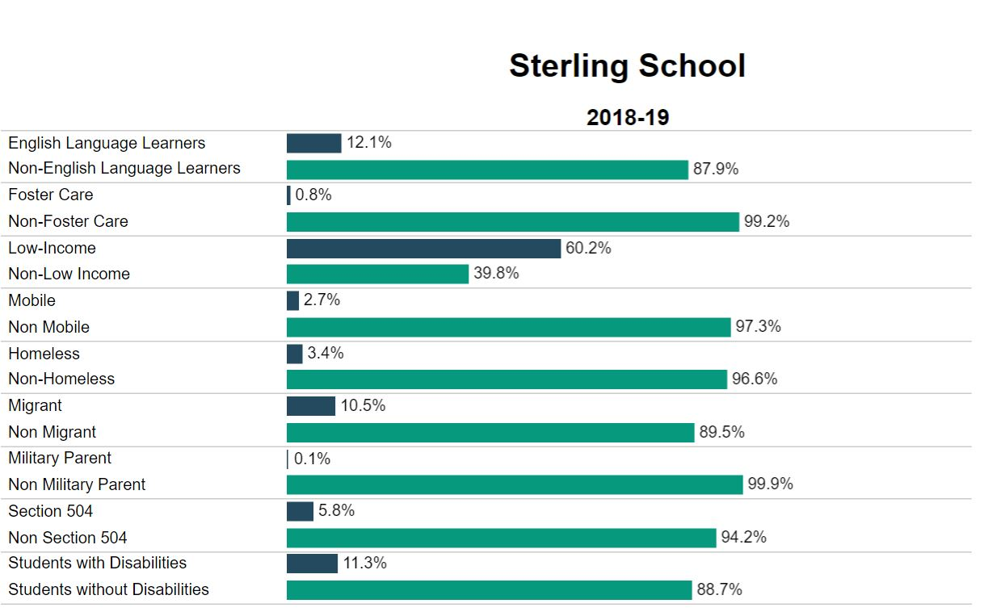

Review | Sterling numbers were relatively stable this year. We were able to start without a major rescheduling conflict that affected the prior year. We changed the program to minimize or eliminate overload issues. Added WEE Cougar program that included PreK students.
Evaluate  Strengths  Challenges | Program changes allowed 10 person teams in 5-7 and eliminated overload. Pullout classes reduced student numbers by 50% in level 9 and 10. Changed opportunities (free choice) to a rewards program that allowed students to purchase activities with PBIS points.
Change  Solutions | - Eliminated multiple transitions with the 9/10 teams.  - Created 6/7 blended classes to reduce overload.  - Changed to a 5 period day with mixed results to match the high school.  - Change “opportunities” period to “rewards” period.  - Implemented Trimesters.  - Implemented 6th and 7th grade hallways.
Goal #1 | Eliminate student overload.. Reference District Goal(4000 B Community Relations) Eastmont educational programs are consistent with leading public, charter, and private school systems.

Assessment Results
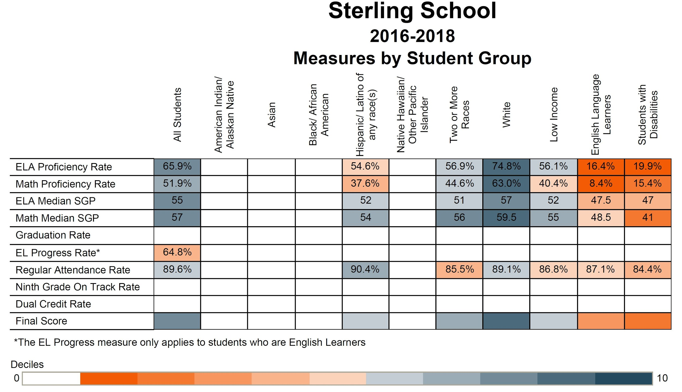

Review | 5th grade math scores were considerably lower than in years past.  4th grade reading and math scores were considerably higher than years past.
Evaluate  Strengths | 5th grade math piloted multiple programs.  4th grade is difficult to measure with just one class at Sterling. 2-3 students can create extreme gains or losses with few students being tested.
Change  Challenges  Solutions | - Mixed results with our computer based instruction.  - Purchased and implemented Freckle (computer Math/ELA program)  - Struggled at the beginning of the year purchasing licenses for the computer individual instruction courses. It helps tremendously to purchase programs in the spring for the following year.  - Implemented Interim testing at Trimester.  - Hired .5 RTI Cert. to push in with the lowest CORE classes.
Goal #2 | Increase average student performance on a majority of State required tests by 2% until 80% of students are scoring 75%. Reference District Goal(2000 Instruction) Students will perform academically at or above the state average for districts of similar size and demographics.

Athletic Participation
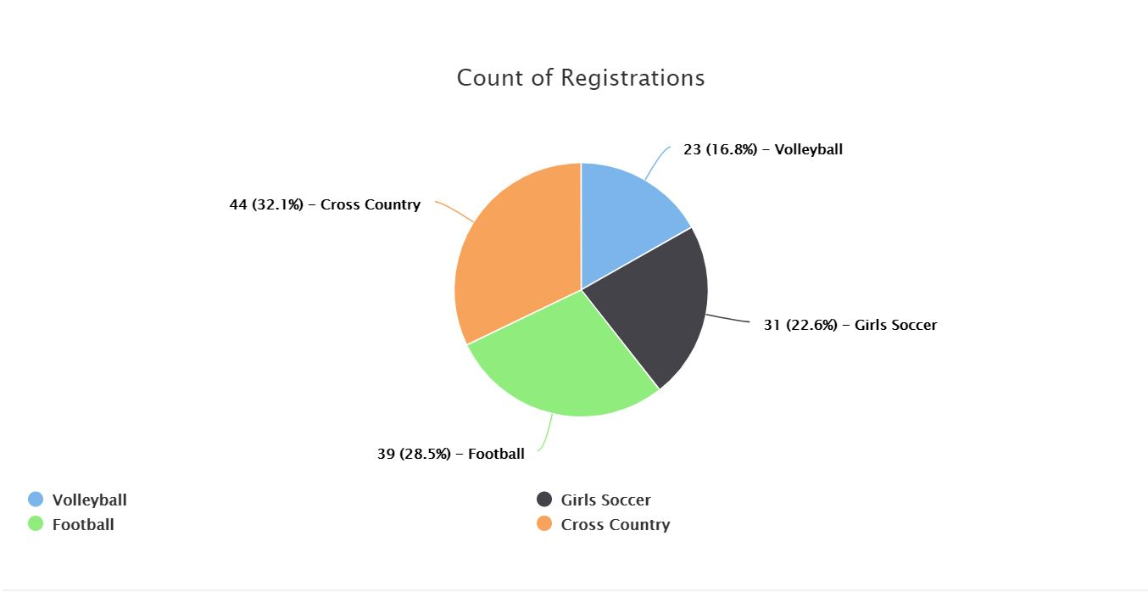
Review | FB32/49, BBB 29/45, BXC 15/17, Wrest 9/17 GVB 31/31, GS 20/24, GXC 20/17, GBB 36/51
Evaluate  Strengths  Challenges | Decline in participation across the board. Possible reasons might include focus on eligibility and a decrease in Community AAU programs.
Change  Solutions | - Emphasize sportsmanship.  - Hire C team coaches early.  - Schedule evening clearance nights for parents and students.  - Create a process for blue slips and student eligibility dependent on grades and behavior.
Goal #3 | Increase student participation in extracurricular athletic activities by 2% over the prior year. Reference District Goal(2000 D Instruction) Strategy #5: Remove, or minimize fiscal, transportation, and other barriers for participation in athletics.

Student Safety
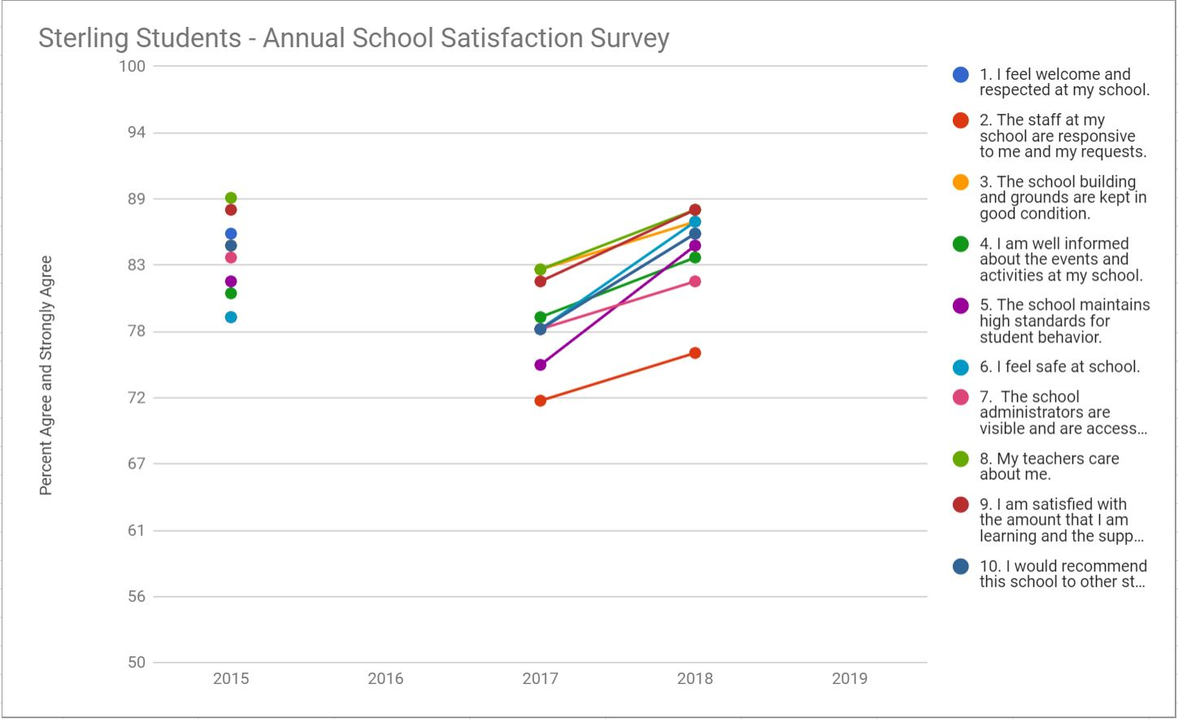
Review | Satisfaction Survey Results: Parents 96%, Staff 95%, Students 78% feel safe at school.
Evaluate  Strengths  Challenges | - ASB focused on “Dude be Nice”.  - Improved visibility and reporting of bully behavior.  - Anti-bullying assembly and Character Strong curriculum.  - Shout outs over the intercom.  - Need additional cameras and radios.  - Conducted monthly drills.
Change  Solutions | - Improve para training and supervision on the outside playground.  - Increase student mentor supervision and training.  - Increase ASB focus on anti-Bullying  - Expand PBIS systems and training for staff and students.  - Add additional cameras and radios  - Supervise front and rear entrance at all times.
Goal #4 | Parent, staff, and student surveys will indicate a satisfaction rate of 80%+. District Goal C (6000 Mangagement Support) Ensure student and staff safety with emphasis on security and health issues.

Attendance
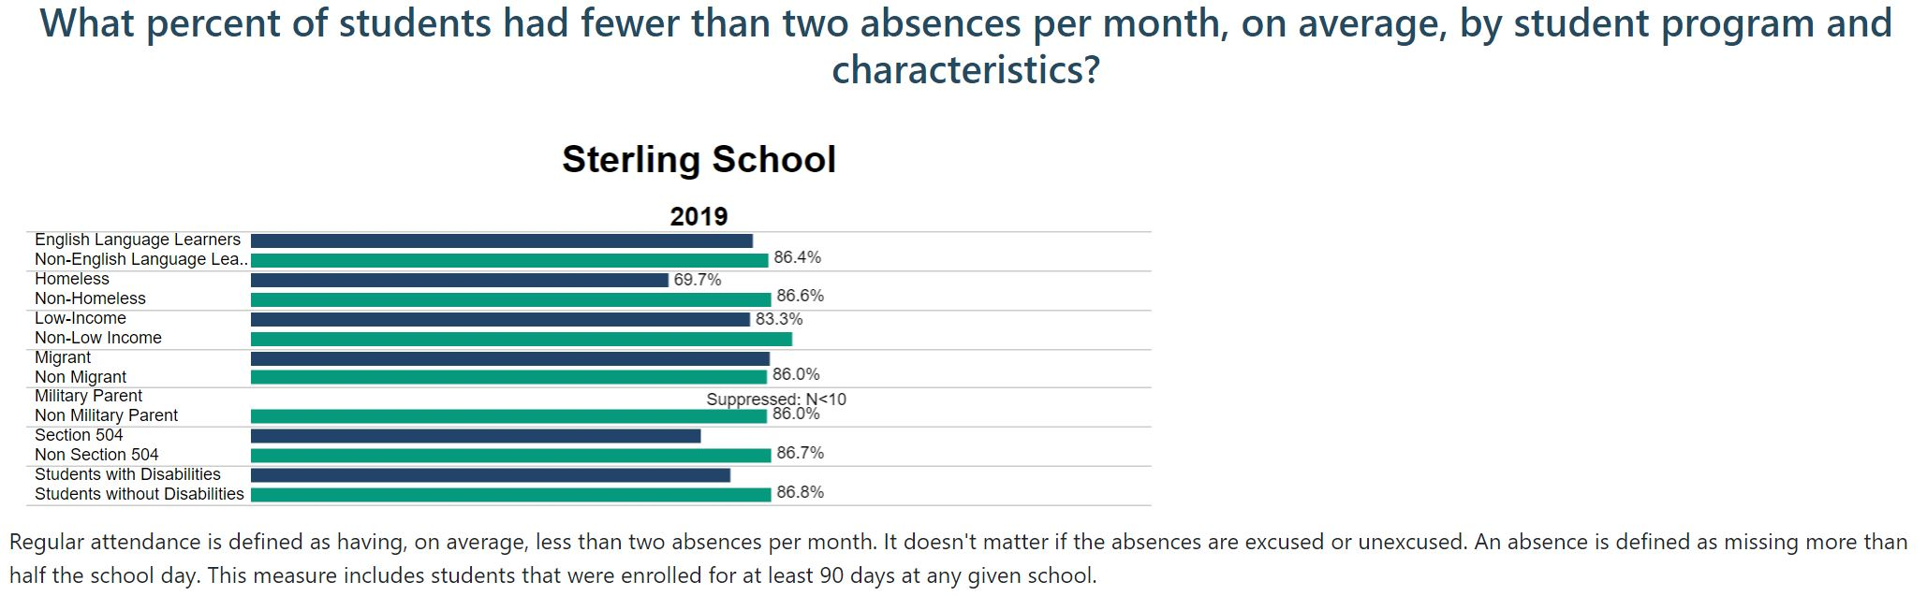
Review | Average Days Absent during the school year 17-18 to 18-19  - 7th Grade Decreased from 9.46 days absent per year to 7.17 days absent per year. 2.29  - 6th Grade Decreased from 8.55 days absent per year to 6.73 days absent per year. 1.82  - 5th Grade Increased from 1.17 days absent per year to 5.05 days absent per year. 3.88  - 1-4th Grade Decreased from 11.12 days absent per year to 7.47 days absent per year. 3.65  *Homeroom data
Evaluate  Strengths  Challenges | Improved attendance in 3 of 4 areas. . Opportunities continue to be the best intervention for students who need to make up for missing work. Students who are habitually absent are put on an attendance contract.
Change  Solutions | - Review all choice students and possibly revoke choice for those who are high risk.  - PBIS and reward student attendance.  - Review and track student attendance rates for each teacher class.  - Improve attendance tracking to match state data (Per month)
Goal#5 | Sterling will be below the district 14.7% chronic absent rate. District Goal E(2000 Instruction) Strategy: Meet, or exceed the State average for chronic absenteeism.

Grading
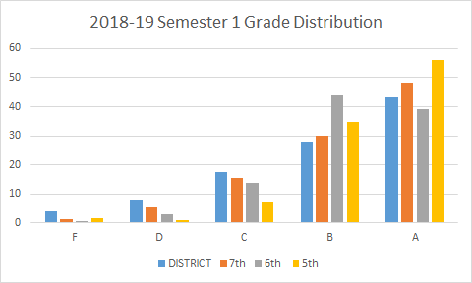
Review | High Risk: Received at least one D/F at Semester  High Risk: 7th Grade : 15% 6th Grade: 14% 5th Grade: 13%
Evaluate  Strengths  Challenges | Principal reviews teacher gradebooks quarterly. Students who receive an F for 2nd qtr., attended a pullout class for 3rd qtr. Student athletes who had a D/F during prior quarter were required to carry a blue slip to compete. No-Zero parties were inconsistent throughout the year. RTI oversight on grading. PTO supporting 4th Qtr. success.
Change  Solutions | - Students complete a learning plan if they receive a D/F.  - Teachers refer students and participate in the student learning plans.  - Students receive an intervention study hall.  - More consistent No-Zero parties.  - Require Parent conference on F grades.  - Continued professional development in Grade level meetings.
Goal #6 | No more than 10% of the students in each grade level receive a D/F. District Goal(2000 B Instruction) Strategy #2: Use formative assessment to identify appropropriate core and supplemental instructional interventions.

Discipline
How long are students being excluded for in response to a behavioral violation, over time?
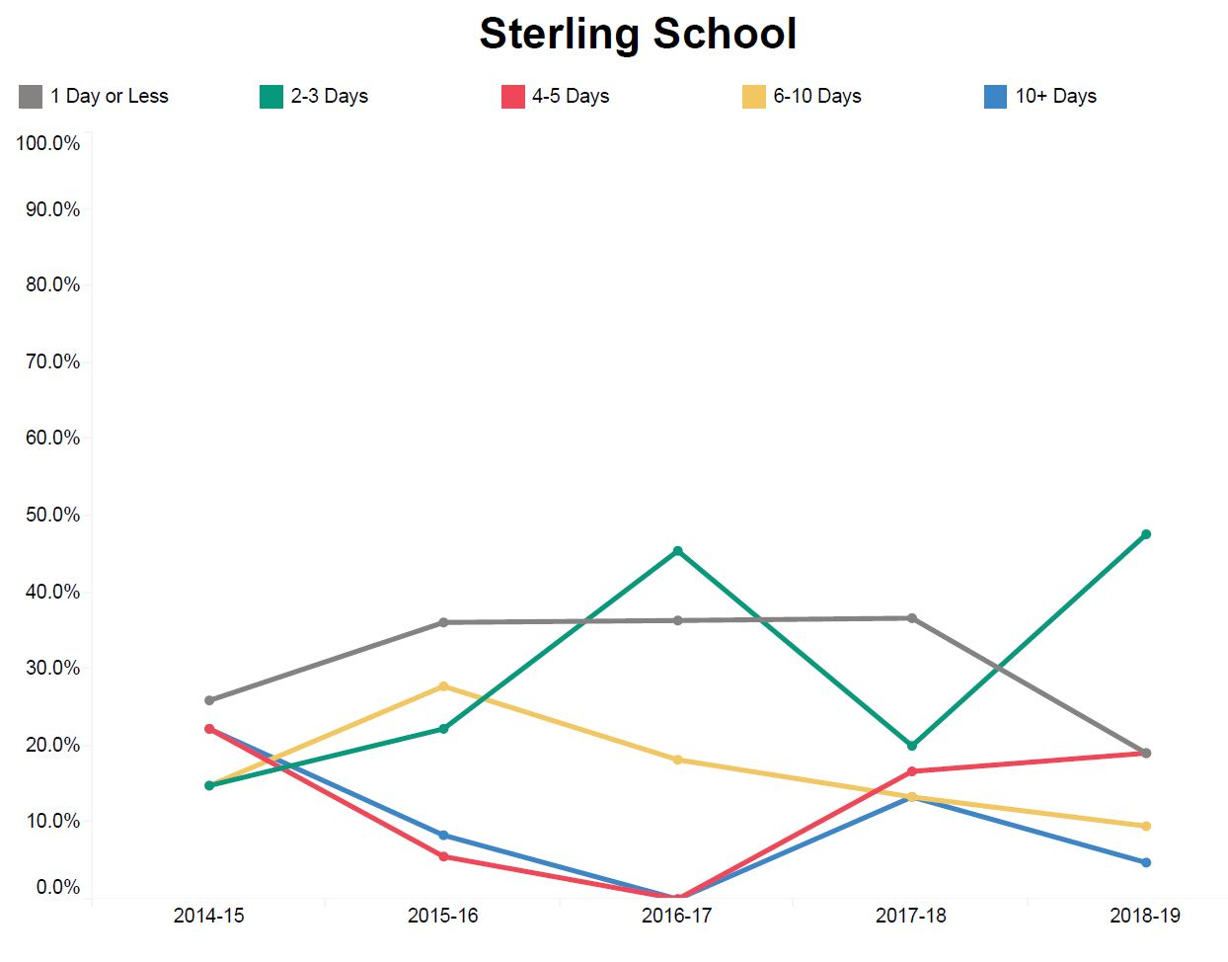
Review | 47 Safe School Incidents: 30% In house suspension 70% Home suspension  7th Grade 47% 6th Grade 38% 5th Grade 15%
Evaluate  Strengths  Challenges | 5th Grade had 18 incidents, 6th Grade had 16 incidents, and 7th Grade had 28 incidents for a total of 62. Half of the suspensions were 7th grade students. Implemented the PBIS system in the 7th grade in March. Met with Grade levels bi-weekly to discuss problem areas and improve communication. Conducted reentry conferences on all student suspensions.
Change  Solutions | - Expand PBIS  - Professional development for staff in ACEs  - RTI interventions and increase parent communication with students who are at risk.  - Conduct quarterly behavior assemblies.  - Recognize positive behavior on a trimester basis.
Goal #7 | Decrease out of school suspensions by 10% from the previous year. District Goal(3000 A Students) Strategy #2: Decrease out of school suspensions and expulsions.

Extended Day/Intervention Participation
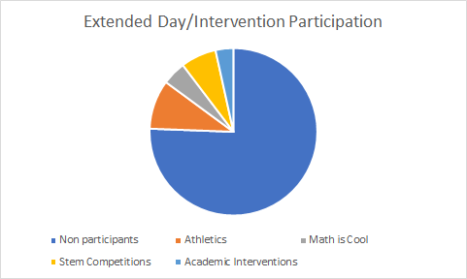

Review | Extended Day: Bilingual: 16 Elem. and 23 5-7th grade students.
Evaluate  Strengths  Challenges | High participation due to the snack program provided by Sodexo. Students loved attending the after-school programs. Highly effective results from the ELA programs but only marginal results from Math. D/F intervention focused on creating buy-in with limited results.
Change  Solutions | - Start the program in 2nd QTR.  - Supplement the Math intervention program.  - Run blue slips/ progress reports for the D/F students.  - Communicate with CORE teachers and require work from them.  - Track all extended day participants with student Mgmt. system.
Goal #8 | Increase the participation in extended day intervention programs by 10% over the previous year. District Goal(2000 D Instruction) Strategy #4: Increase student participation in extracurricular activities.

STERLING SCHOOLWIDE REFORM STRATEGIES

Strengthening the core academic program in the school

Sterling implements a fluid instructional program that is responsive to student academic needs: Students are placed and moved when they exceed/underachieve at grade level in mathematics, reading. Teachers will meet to review student scores and progress each trimester.. Parents can request a placement conference at any time during the year. Teachers, Students, Parents and Administration will agree on placement prior to changing

Rewards: A common time during the school day for students to receive additional assistance for academic success. Students choose, by spending points, the class they will attend.

Peer Tutors: Students will have the opportunity to tutor other struggling math students during their specialist time. This program is available during the last 6 weeks of the tri-mester.

Re-Teach: Pull students from specialists as needed to re-teach key concepts.

Extended Day: Focus Math and Reading skills on students at most risk for the SBA.

PLCs meet at all grade levels to discuss needs of their students both academic and behavioral.

Staff meetings held monthly to discuss the needs of the Sterling community

School-wide, Safety, and Behavior team meets bi-monthly to discuss the building plan and needs to meet goals

School Improvement Team (SIT) meets bi-monthly to discuss the needs of teachers and student learning.

Grade Level Teams meet bi monthly with the principal to discuss student learning and impacts on the teaching schedule.

Curriculum: Additional curriculum materials are purchased to address the needs of low-performing students.

Staff Development: Staff development is supported with registration fees, travel expenses, materials, and substitute coverage.

Maker Space: Advanced students will have an opportunity to create STEM projects in a Maker Space in place of their specialist rotation. Preference will be given to Highly Capable designated students.

Attract highly qualified staff to work with the most at-risk students: Building staff have the opportunity to participate in the Spanish for Educators courses taught locally. These will increase the ability of existing staff to provide native language instruction as needed. There is also a full slate of ESL offerings through the ESD, leading to an ESL endorsement. The goal of this strand of professional development is to provide both bilingual and ESL-trained staff that reflects the make-up of the student body and is prepared to manage migrant and bilingual issues effectively at the building level.

Finally, staff will continue to be trained on uses of technology, especially as they relate to the education of migrant and bilingual students. We will continue to inform site-based decision makers of migrant/bilingual issues by interfacing with information on building file servers and by utilizing Tyler to provide up-to-date information on migrant and bilingual students, their educational needs, progress toward stated learning goals, and achievement levels. Training may be provided on demand by the Special Programs Office in any of these areas.
Actively participate in Job fairs and recruitment.
- Staff retreat
- Teacher salary funding to reduce class size
- PTL and PLCs
- Professional development days

Transitions between grades and/or schools
Sterling will assist students and families transitioning to the school in the following ways:
- Administration will meet and welcome all students new to their Intermediate building
- Administration provides a night for parents to get information and ask questions
- Building counselors are available to parents and students by appointment.
- Site visits by counselors
- Summer transition classes for students entering Sterling for the first time.
- Transition meetings for at-risk students
- Transition meetings for SPED students.
- Test information is shared between buildings
- Students have an opportunity to participate in the 4th Grade assembly to select specialist classes.
- Open House for Spanish-speaking parents in the Fall.
- Orientation Days prior to the start of school.

Sterling will assist students and families transitioning from the school in the following ways:
- Site visits by counselors
- Transition meetings for at-risk students
- Transition meetings for SPED students.
- Test information is shared between buildings
- Students have the option to complete Algebra readiness test and/or Honors English essay in the Spring.
- 7th graders attend ½ day at the Jr. High meeting teachers and touring buildings.
- Eastmont Junior High School counselors meet with our seventh grade students to design junior high schedules.

Enrich and Accelerated Curriculum
Within Advanced classes, all students receive high-quality, scientifically based instruction provided by qualified personnel to ensure that their difficulties are not due to inadequate instruction. All students are screened on a periodic basis to establish an academic and behavioral baseline and to identify struggling learners who need additional support. Students identified as being “at risk” through universal screenings and/or results on state- or districtwide tests receive supplemental instruction during the school day in the regular classroom. Students can attend opportunities for 30 minutes a day. During that time, student progress is closely monitored using a validated screening system. Students showing significant progress are generally returned to the regular classroom program and have a choice to attend opportunities. Students not showing adequate progress are moved to Tier 2.

Students qualifying as gifted and talented are clustered within the advanced team. Generally, these classes have a high ratio of no more than 32:1 Students scoring above standard on the SBA assessment will receive enriched or accelerated grade level instruction in any or all of the following areas:
- 65 minutes of Reading
- 65 minutes of Math

Opportunities for students both ahead of and behind grade level
Academic Probation: Any student failing more than one class in a quarter may be assigned to a 30 minute after-school instruction. Students failing 2 or more classes in a quarter will receive additional instruction before school, during lunch and during the school day.

Summer School: Any student below the standard in reading or mathematics, or students determined to be “at-risk” as determined by teacher recommendation will receive summer instruction.

Migrant coordinator will meet with students to discuss progress, issues, and provide support.

Program Participation: Parents will receive a letter advising them of their son/daughter’s conferences, a “Student/Parent/Staff Learning Plan” to be signed, returned, and kept on file, and a copy of the district Parent Involvement Policy. Further, Title I/LAP parents are informed about the opportunities for planning and involvement through the “Shared Decision Making” process.”

Title 1/LAP planning: Program planning is incorporated into the existing school plan. The School-wide committee will meet monthly to evaluate student progress and program effectiveness. The committee will report discussion items and meeting minutes to the School Improvement Team.

Special Education (State Funded): Any student qualifying for Special Education services receives individualized instruction to accommodate their disability.

Migrant Students (State Funded): Any student qualifying as migrant will attend classes (non-Special Ed.) based on assessment results. All migrant students are automatically invited to summer-school.

English Language Learners ELL (State Bilingual): Any student qualifying in transitional bilingual program or recently exited students will attend specific classes to accommodate their language and remediate English language deficiencies based on assessment results.

Staff Retreat/Pro. Development: staff collaborates to identify individual needs for "at-risk" students in order to fine-tune instructional strategies and plan wrap-around support services for these students.

Paraprofessional Support: Intensive classes receive paraprofessional support in order to provide more frequent monitoring and redirecting of student learning.

Technology Training for Staff: Staff members receive technology training in order to integrate technology as an intervention tool for students.

Professional Learning Communities (PLC): Teachers are given time and resources to support teacher collaboration within PLCs in order to fine-tune curriculum and instructional strategies. The instructional coach will provide professional development and facilitate PLCs as they work to improve student learning.

SBA Preparation: SBA preparation materials are provided in order to better prepare our students for success on the SBA. Substitutes are provided in the months leading up to the SBA to release teachers to team-teach, provide small group instruction based on student need, or allow substitute teachers to provide small group instruction.

SCHOOL ACTIVITIES TO ENSURE MASTERY

How does the school screen all students to identify those that are at-risk of falling behind on mastery of key skills?
The main assessment focus is the SBA. Goals are established to ensure student learning and improvement of SBA scores and AYP compliance. Teachers meet quarterly to determine student progress towards goals, and make indicated instruction and/or curriculum changes.

Each student/parent/teacher participates in student learning plans established in the Fall. Grade standards score progress is monitored and communicated through report cards and parent teacher conferences in the Fall, Winter and Spring. Measuring and reporting student progress may also include:

- Quarterly Report Cards sent home reflecting progress in each class.
- Growth report sent home in the Spring of each school year.
- SBA individual report sent home.
- Trimester progress toward IEP goals for SPED students.
- Students exit specific programs when they exceed placement level. Parents are notified by letter.
- Parents can choose to exit their students and not receive specific placement level help by meeting with building administration.

Reading: All students are assessed in the fall, winter and spring of the school year with the SBA test. Scores include each strand and comparison data. Indicated additional reading skill diagnostic tests are used to place students in strategic and intensive level classes. Scores for all assessments are rank ordered to determine student placement, curriculum and instructional needs.

Mathematics: All students are assessed in the fall, winter and spring of the school year with the SBA interim test. Scores include each strand and comparison data. Indicated additional classroom assessments are used to determine student placement, curriculum and instructional needs.

New students: Students who transfer into our district, are assessed with the SBA Comprehensive test that is a dipstick measure in Reading and Math.

Program students: Students in a specific program are assessed each trimester for growth in both Reading and Mathematics. Teachers modify and adjust curriculum and instructional strategies to ensure individual student progress and achievement of grade level standards.

Extended Day Opportunities include a broad range of programs that provide children with academic interventions beyond the traditional school day, and in some cases, beyond the traditional school year. Extended learning programs are a strategy for improving or enhancing student achievement, and for students who need extra support to be successful academically. What happens before and after school can be as important as what happens during the school day.

How does the school monitor progress of at-risk students in their mastery key grade level skills?
Increased Instructional Time: Students receive more instructional time in reading, math, or writing by integrating Social Studies and Science instruction.

Direct Instruction: Intensive level students receive focused instruction using research-based materials.

Small class size/ Paraeducators: Lower teacher to student ratio enables more frequent one-on-one remediation and individualized instruction.

Computer Instruction: Enables students to progress at individual rates of learning.

Flexibility in Program: Students change curriculum and/or placement when scores warrant a change.

Parent Involvement: We will continue our efforts to communicate with parents in their home language. This includes the hiring of additional bilingual staff, classified and certificated, providing interpreters during all parent activities, and providing important home/school communications in both languages. In addition, we make every effort to inform parents of academically at-risk students as to what they can do to support the education of their son/daughter. This may include working to ensure good attendance, support for school policies and rules (especially as it relates to student behavior), and providing both a time and place for homework to be completed.
- Open House allows parents to meet teachers and learn classroom expectations.
- Fall parent conferences, arena style: share student learning plans, progress, improvement, and achievement. We use Parent-Teacher-Student learning plans with all students, providing translation for learning plans as needed, in order to better communicate with language minority families. All parents receive a copy of the plan.
- Parent/Student/Staff are included in future design, modification and approval of the Learning Plan.
- A Parent/Staff Steering Committee based on area representation; one parent from each of the elementary school service areas meets monthly. The committee is involved in school governance.
Formative assessments:
  - SBA assessment
  - Common Assessments within subject areas
  - STAR
  - Washington Language Proficiency (WLP)
  - Classroom Assessments either designed by teacher or provided in the curriculum.
  - Teacher observation (formal and informal)
  - Progress Reports
  - Trimester Grades
  - PRE/MID/POST SBA interim assessment blocks in Reading and Mathematics. Scores include each strand and comparison data. Results are posted on Schoolmaster and a growth report will be available to the parents in the Fall, Winter, and Spring.
  - SBA Comprehensive Assessment: Dipstick measure in Reading and Mathematics that only includes a score for students new to the district or students who have undergone extensive intervention.

How does the school make data-based decisions on the appropriate interventions for at-risk students and the effectiveness of interventions?
Site-based decision making: Program decisions and goals are reviewed by the school improvement team and approved by the site decision making team (staff as a whole).

Committee: All committees meet monthly and are formed around middle school philosophy and student needs.

Curriculum Meetings: Teachers meet monthly in their individual curriculum areas. Purchase curriculum materials to support student learning

Common planning time: Team concept allows common planning time and shared students. Through PTL and PLCs, teachers collaborate to improve student learning scores. Release time with sub support to go to MSP, SBA and other assessment training that support student learning.

Migrant: We specifically monitor and evaluate our migrant population assessment scores and progress, through on-going evaluations.

Computers: purchased and upgraded to support student success, which includes but is not limited to SBA and MSP assessments.

Describe the school’s three tiers of intervention to support at-risk students.

Tier 3:
At this level, students receive individualized, intensive interventions that target the students’ skill deficits. Students who do not achieve the desired level of progress in response to these targeted interventions are then referred for a comprehensive evaluation and considered for eligibility for special education services under the Individuals with Disabilities Education Improvement Act of 2004 (IDEA 2004)

For students well below grade level in math, reading or writing. Research-based Direct Instruction Curriculum focus with an emphasis on essential skill attainment. Students scoring below standard in the SBA assessment will receive intensive instruction in reading and math in any or all of the following areas:
- Up to 45 minutes Common Core instruction Reading at Grade level with the CORE teacher at a ratio of no more than 15:1.
  - Up to 35 minutes of skill remediation provided by the RTI teacher (Decoding, Comprehension, Fluency with an increased emphasis on vocabulary development at individual level of need by computer based remediation.
- Up to 45 minutes Common Core instruction at Math Grade level with the CORE teacher at a ratio of no more than 15:1.
    - Up to 35 minutes of skill remediation provided by the RTI teacher (Math fact fluency with an increased emphasis on vocabulary and skill development at individual level of need by computer based remediation)

Tier 2:
Students not making adequate progress in the regular classroom in Tier 1 are provided with increasingly intensive instruction matched to their needs on the basis of levels of performance and rates of progress. Intensity varies across group size, frequency and duration of intervention, and level of training of the professionals providing instruction or intervention. These services and interventions are provided in addition to instruction in the general curriculum. Students who continue to show too little progress at this level of intervention are then considered for more intensive interventions as part of Tier 3.

For students one year below grade level in math, reading or writing with a ratio when possible of ideally no more than 25:1 with shared Para-educator time. Students scoring below standard with the SBA may receive strategic instruction in any or all of the following areas:
- Up to 45 minutes of additional Reading (Elements of Literature, class novels with instruction targeting deficit areas, increased emphasis on vocabulary development, computer based remediation)
- Up to 45 minutes of additional Math (Holt Mathematics, Courses 1 and 2, Accelerated Mathematics computer based remediation)

Tier 1:
Within Tier 1, all students receive high-quality, scientifically based instruction provided by qualified personnel to ensure that their difficulties are not due to inadequate instruction. All students are screened on a periodic basis to establish an academic and behavioral baseline and to identify struggling learners who need additional support. Students identified as being “at risk” through universal screenings and/or results on state- or districtwide tests receive supplemental instruction during the school day in the regular classroom. Students can attend opportunities for 30 minutes a day. During that time, student progress is closely monitored using a validated screening system. Students showing significant progress are generally returned to the regular classroom program and have a choice to attend opportunities. Students not showing adequate progress are moved to Tier 2.

COORDINATION AND INTEGRATION OF FEDERAL, STATE AND LOCAL SERVICES
Funds will be used to support salaries and related staffing and operational costs as they relate to the School-Wide Program Goals
Sterling2-4
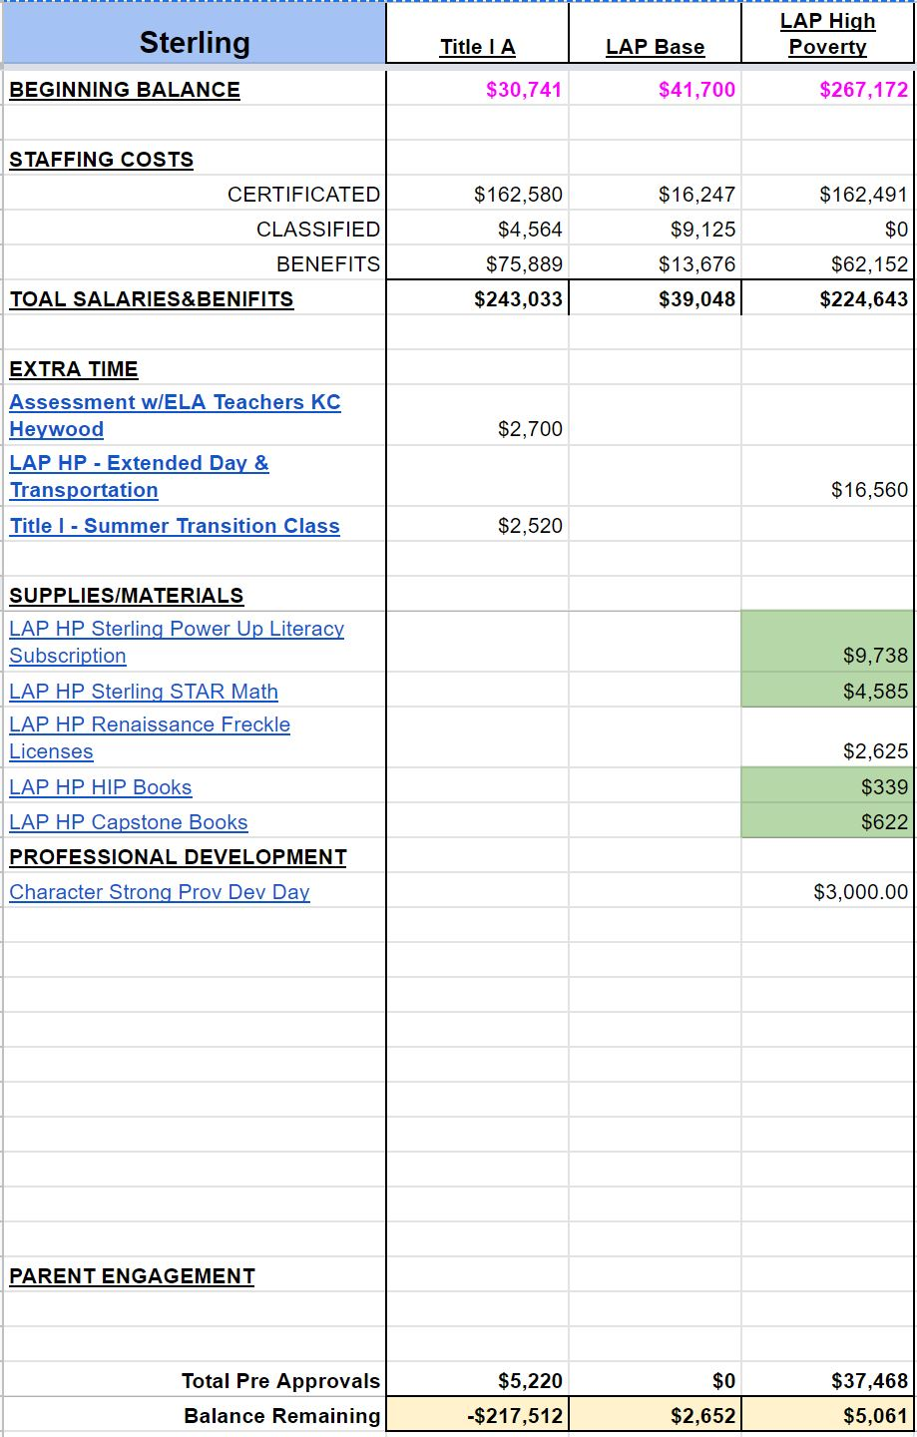
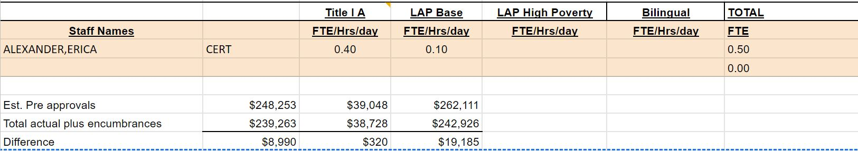

Funds will be used to support salaries and related staffing and operational costs as they relate to the School-Wide Program Goals
Sterling 5-7
