STERLING SCHOOLWIDE PLAN Review
Title 1 Part A - Schoolwide Plan Review
Chris Hall, Principal 2019-20

Planning Team
Name of Team Member | Position/ Representation
Erica Alexander | HomeField / RTI
Chris Hall | Principal
Debbie Ramos | 600 Wing Team
Rachel Browning | 500 Wing Team
Anna Rankin | 100 Wing Team
Nancy Hazenbihler | Facilitator 5-7 RTI
Amy Schall | K-4 Team
Christy Rolfs | Secretary
Kim Sebastian | Para-Educator
Dave Dewitt | Math Chair
Vicki Robins | Read Chair
Travis Kane | Science Chair
Mark Koley | SS Chair
Gerald Halle | Specialist Chair
Joel Barnes | Writing Chair
Kevin Newell | Behavior RTI
COMPREHENSIVE NEEDS ASSESSMENT
The school-wide team met weekly throughout the school year to conduct a needs assessment. Data was taken from State Report Card, District Assessments, Surveys, and Tyler Student Records. The team presented the needs assessment to the School Board in a public meeting in April.

Demographics
Enrollment (All Students) Enrollment (By Program)
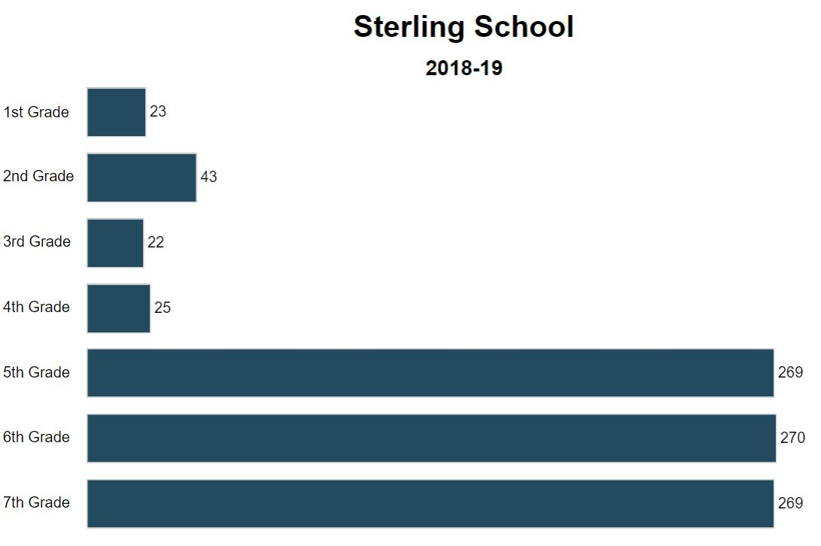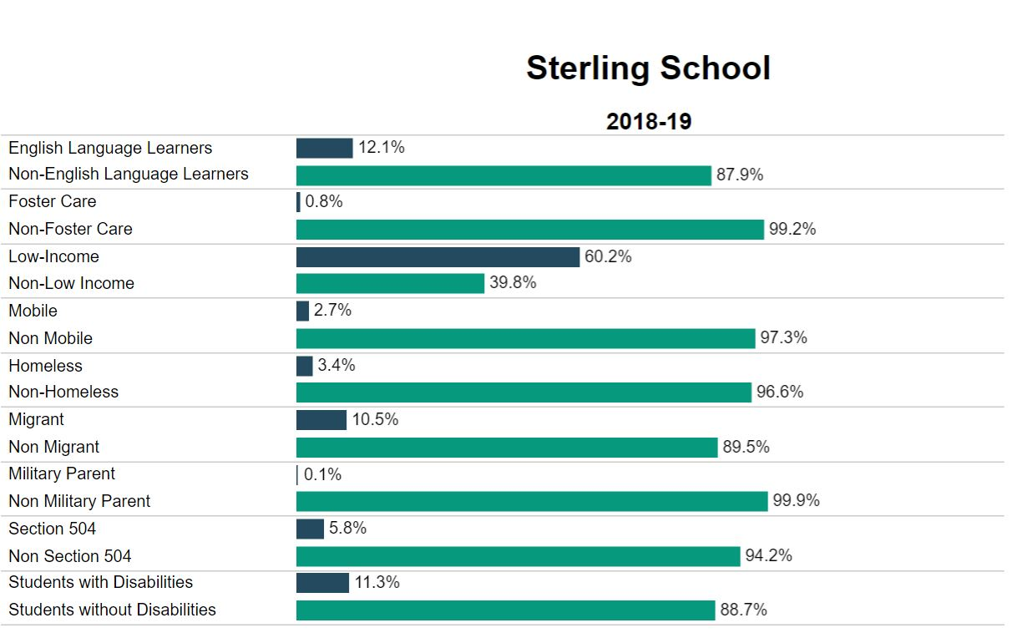

Review | Sterling numbers were relatively stable this year. We were able to start without a major rescheduling conflict that affected the prior year. We did change program to minimize or eliminate overload issues. Added WEE Cougar program that included PreK students.
Evaluate  Strengths  Challenges | Program changes allowed 10 person teams in 5-7 and eliminated overload. Pullout classes reduced student numbers by 50% in level 9 and 10. Opportunities/Advisory continued with mixed results.
Change  Solutions | - We do have some concerns over the amount of transitions created by level 9 and 10. Explore program options for reducing transitions for the following year.  - We are evaluating program changes to the schedule to match up with the new 5 period day like the high school schedule next year.  - Change Advisory to intervention time and/or add structure to eliminate student time that was misused.  - Explore Trimesters.

Assessment Results
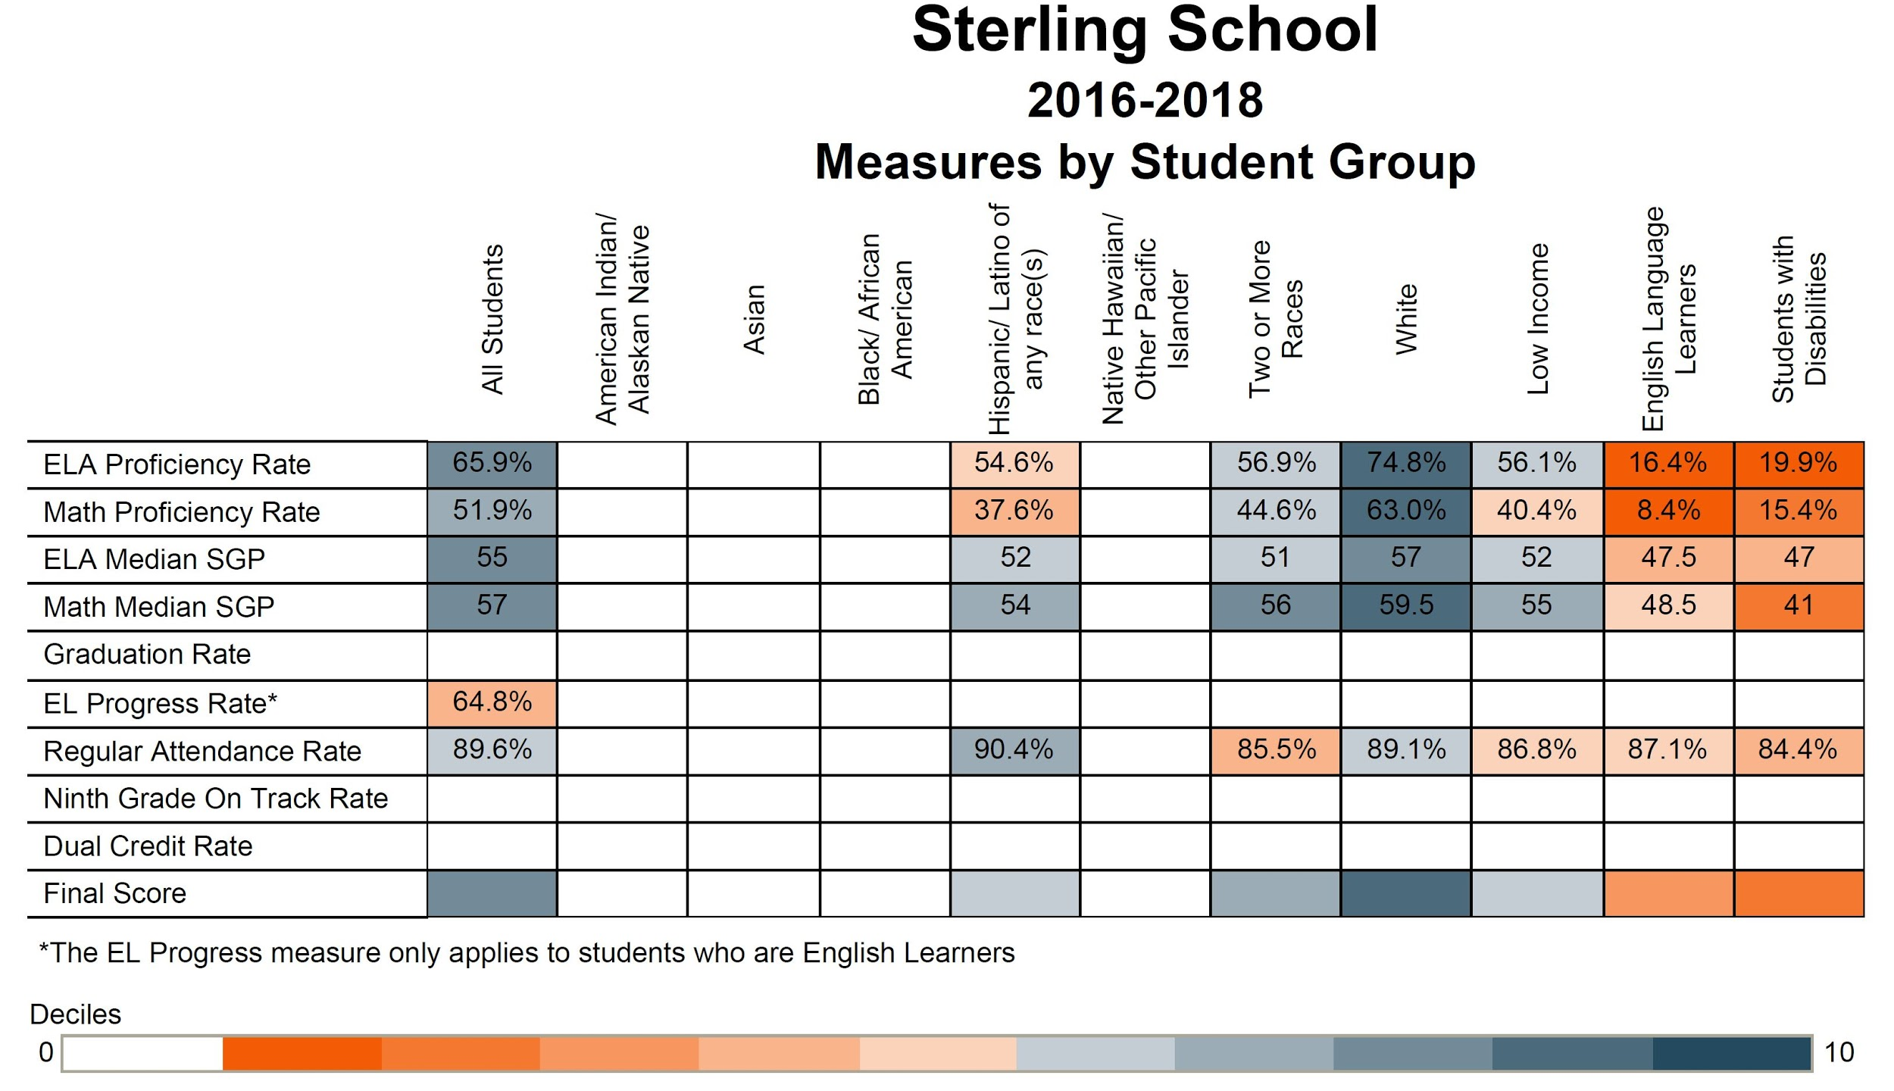

Review | 5th grade math scores were considerable lower than in years past.  4th grade reading and math scores were considerably higher than years past.
Evaluate  Strengths | 5th grade math piloted multiple programs.  4th grade is difficult to measure with just one class at Sterling. 2-3 students can create extreme gains or losses with few students being tested.
Change  Challenges  Solutions | - Mixed results with our computer based instruction. Students had growth and teachers support Achieve 3000, Lexia, and Reflex math. Concerns arose from Successmaker. We piloted dreambox to possibly replace Successmaker next year.  - Struggled at the beginning of the year purchasing licenses for the computer individual instruction courses. It help tremendously to purchase programs in the spring for the following year.  - State mid-year assessments need to be done prior to the end of the semester and done consistently to remediate and put intervention programs into place.

Athletic Participation
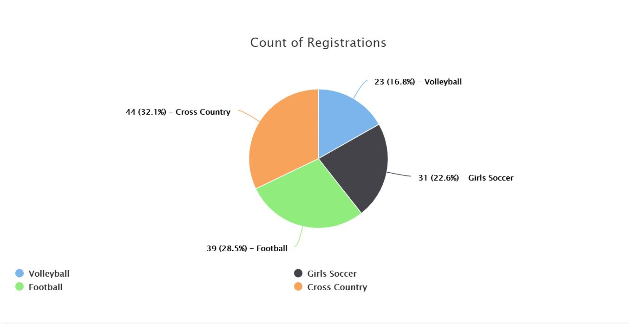
Review | FB32/49, BBB 29/45, BXC 15/17, Wrest 9/17 GVB 31/31, GS 20/24, GXC 20/17, GBB 36/51
Evaluate  Strengths  Challenges | Decline in participation across the board. Possible reasons might include focus on eligibility and a decrease in Community AAU programs.
Change  Solutions | - Hand out sportsmanship medals after each game. Focus on Sportsmanship  - Schedule evening clearance nights for parents and students.  - Create a process for blue slips and student eligibility dependent on grades and behavior.

Student Safety
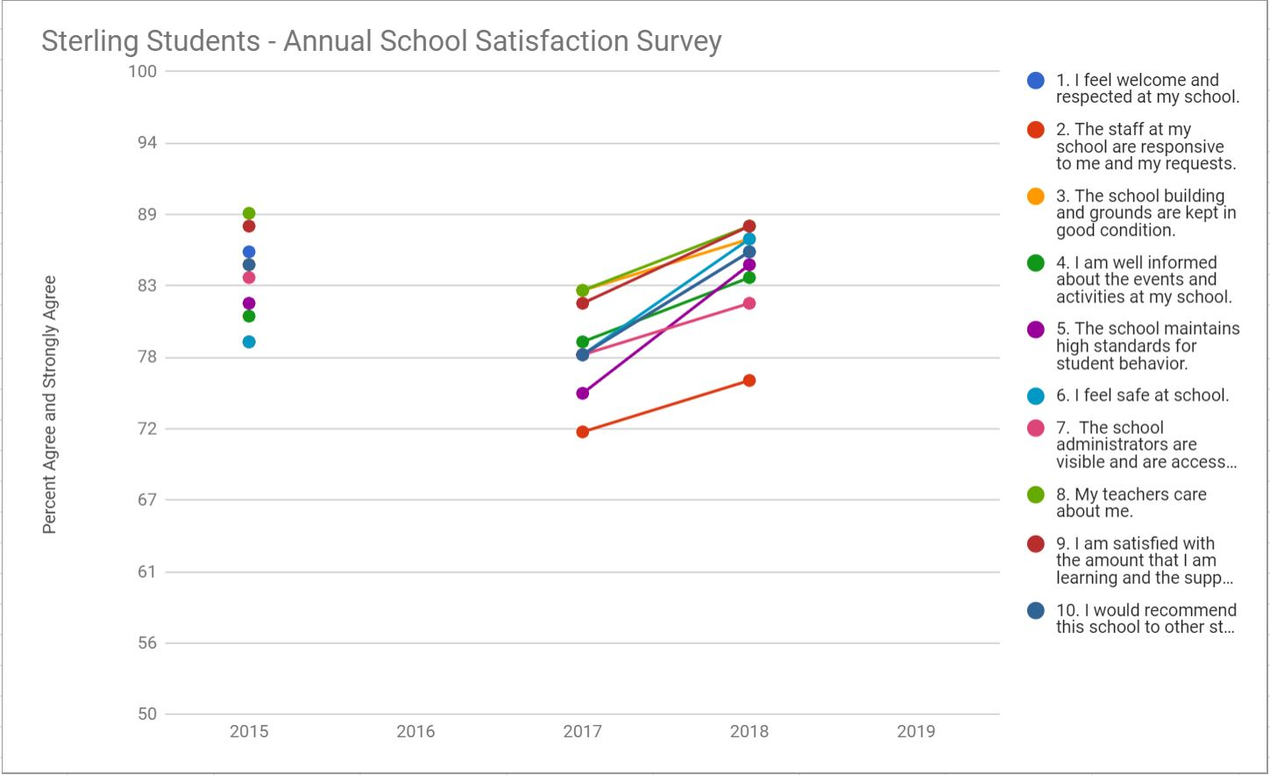
Review | Satisfaction Survey Results: Parents 96%, Staff 95%, Students 78% feel safe at school.
Evaluate  Strengths  Challenges | ASB focused on Kindness Counts. Improved visibility and reporting of bully behavior. Anti-bullying assembly was well recieved. Shout outs over the intercom. Need addtional cameras and radios. Conducted monthly drills.
Change  Solutions | - Improve para training and supervison on outside playground.  - Increase student mentor supervison and training.  - Increase ASB focus on anti-Bullying  - Expand PBIS systems and training for staff and students.  - Add additional cameras and radios  - Supervise front and rear entrance at all times.  - Increase student support services.

Attendance
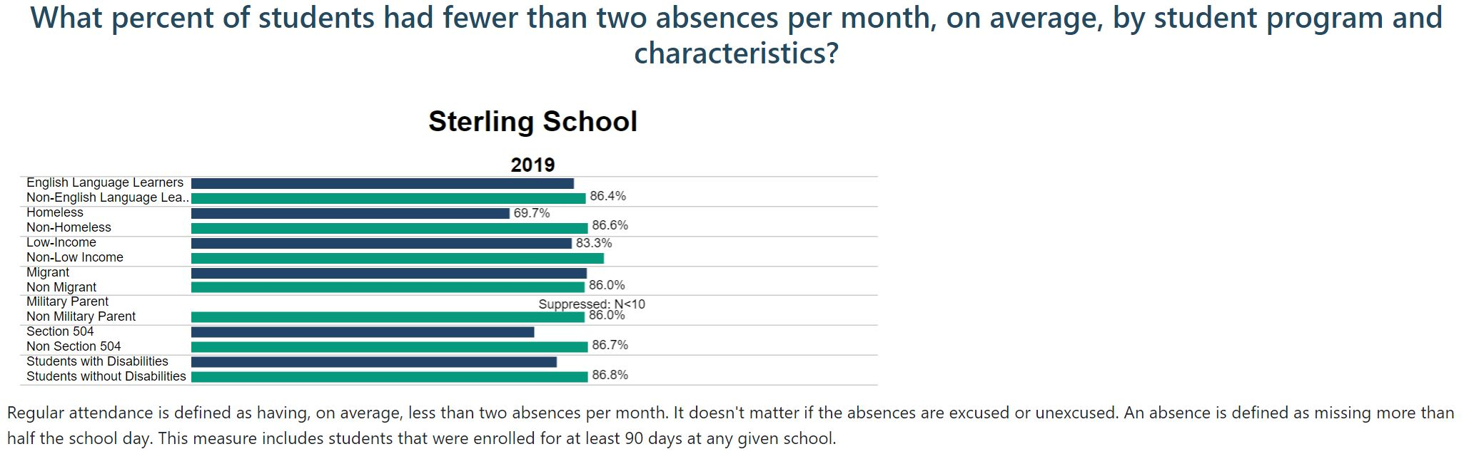
Review | Average Days Absent during the school year 17-18 to 18-19  - 7th Grade Decreased from 9.46 days absent per year to 7.17 days absent per year. 2.29  - 6th Grade Decreased from 8.55 days absent per year to 6.73 days absent per year. 1.82  - 5th Grade Increased from 1.17 days absent per year to 5.05 days absent per year. 3.88  - 1-4th Grade Decreased from 11.12 days absent per year to 7.47 days absent per year. 3.65  *Homeroom data
Evaluate  Strengths  Challenges | Improved attendance in 3 of 4 areas. The increase in 5th grade may be data issues, as the average is more in line with what is occuring in the other grades. Opportunities continues to be the best intervention for students who need to make up missing work. Students who are habitually absent are put on an attendance contract.
Change  Solutions | - Review all choice students and possibly revoke choice for those who are high risk.  - PBIS and reward student attendance.  - Review and track student attendance rates for each teacher class.

Grading
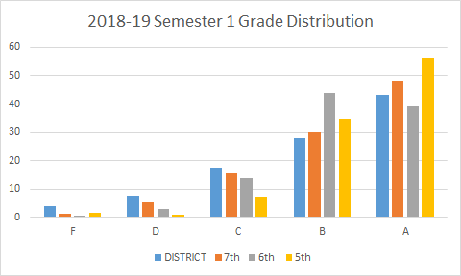
Review | High Risk: Received at least one D/F at Semester  High Risk: 7th Grade : 15% 6th Grade: 14% 5th Grade: 13%
Evaluate  Strengths  Challenges | Principal reviews teacher gradebooks quarterly. Students who recieve an F for 2nd qtr., attended a pullout class for 3rd qtr. Student athletes who had a D/F during prior quarter were required to carry a blue slip to compete. No-Zero parties were inconsistent throughout the year. RTI oversight on grading. PTO supporting 4th Qtr. success.
Change  Solutions | - Students complete a learning plan if they recieve a D/F.  - Teachers refer students and participate in the student learning plans.  - Students recieve intervention study hall.  - More consistent No-Zero parties.  - Require Parent conference on F grades.  - Continued professional development in Grade level meetings.

Discipline
How long are students being excluded for in response to a behavioral violation, over time?
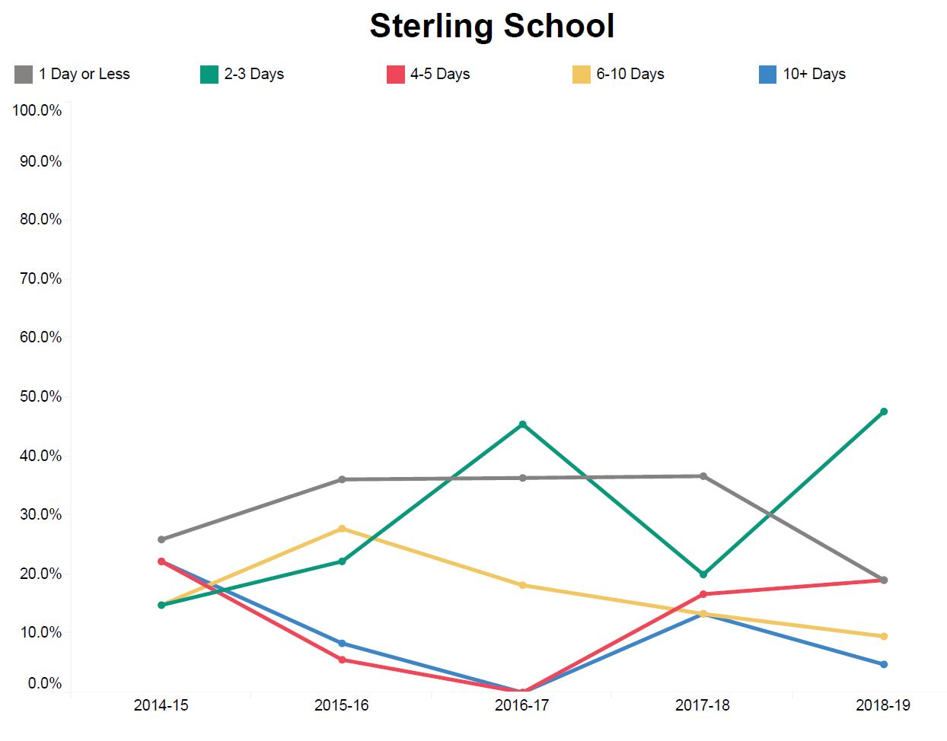
Review | 47 Safe School Incidents: 30% In house suspension 70% Home suspension  7th Grade 47% 6th Grade 38% 5th Grade 15%
Evaluate  Strengths  Challenges | 5th Grade had 18 incidents, 6th Grade had 16 incidents, and 7th Grade had 28 incidents for a total of 62. Half of the suspensions were 7th grade students. Implemented PBIS system in the 7th grade in March. Met with Grade levels bi-weekly to discuss problem areas and improve communication. Conducted reentry conferences on all student suspensions.
Change  Solutions | - Expand PBIS  - Professional development for staff in ACEs  - RTI interventions and increase parent communication with students who are at risk.  - Conduct quarterly behavior assemblies.  - Recognize positive behavior on a quarterly basis.

Extended Day/Intervention Participation

Review | Extended Day: Bilingual: 16 Elem. and 23 5-7th grade students.
Evaluate  Strengths  Challenges | High participation due to the snack program provided by Sodexo. Students loved attending the after-school programs. Highly effective results from the ELA programs but only marginal results from Math. D/F intervention focused on creating buy-in with limited results.
Change  Solutions | - Start the program in 2nd QTR.  - Supplement the Math intervention program.  - Run blue slips/ progress reports for the D/F students.  - Communicate with CORE teachers and require work from them.

