Call Forwarding

Calls can easily be forwarded to any local outside line as follows:

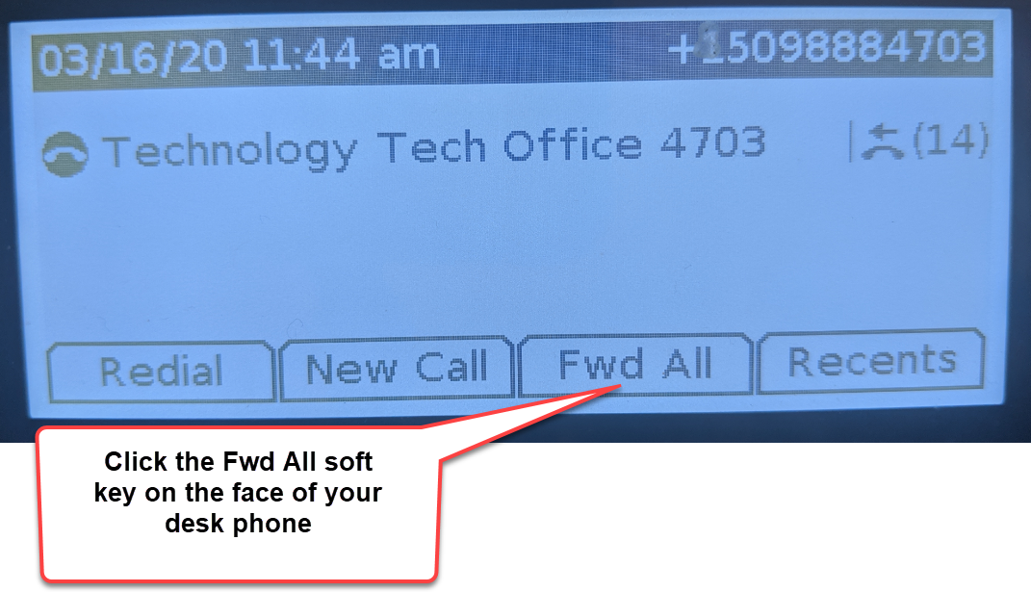

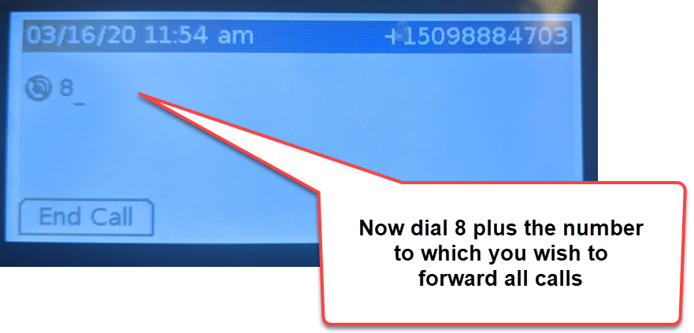
When you return to the office and wish to disable call forwarding:
